**Car Rental Portal**

# 

# **ACKNOWLEDGEMENTS**

Table of Contents

**ACKNOWLEDGEMENTS** 2

Table of Contents 3

List of Tables 7

List of Figures 10

Definitions, Acronyms, and Abbreviations 13

A. Introduction 14

1. Project Information 14

2. Introduction 14

3. Current Situation 14

4. Problem Definition 14

5. Proposed Solution 15

5.1. Featured functions 15

5.2. Advantages 15

5.3. Disadvantages: 15

6. Functional Requirements 15

7. Roles and Responsibility 16

B. Software Project Management Plan 17

1. Problem Definition 17

1.1. Name of this Capstone Project 17

1.2. Problem Abstract 17

1.3. Project Overview 17

2. Project organization 19

2.1. Software Process Model 19

2.2. Roles and responsibilities 20

2.3. Tools and Techniques 21

2.4. Dependencies 21

3. Project Management Plan 21

3.1. Tasks 21

3.2. Task sheet 24

3.3. All Meeting Minutes 24

4. Coding Convention 24

C. Software Requirement Specification 25

1. User Requirement Specification 25

1.1. Guest requirements: 25

1.2. Customer requirements: 25

1.3. Provider requirements: 25

1.4. Administrator requirements: 26

2. System Requirement Specification 27

2.1. External Interface Requirement 27

2.2. System Overview Use Case 27

2.3. Use Cases 29

3. Software System Attribute 70

3.1. Usability 70

3.2. Reliability 71

3.3. Availability 71

3.4. Security 71

3.5. Maintainability 71

3.6. Portability 71

3.7. Performance 71

4. Conceptual Diagram 72

D. Software Design Description 73

1. Design Overview 73

2. System Architecture Design 74

2.1. Web Application architecture description 74

3. Component Diagram 75

4. Detailed Description 76

4.1. Class Diagram 76

4.2. Class Diagram Explanation 78

4.3. Interactive Diagram 87

5. User Interface Design 99

5.1. Login page <Excluded> 99

5.2. Home page <Excluded> 99

5.3. Advanced search page 99

5.4. Vehicle Information page 101

5.5. Booking confirmation page 103

5.6. Booking history page 104

5.7. Become provider page 105

5.8. Manage vehicle page 106

5.9. Vehicle detail page 109

5.10. Manage booking page 112

5.11. Manage garage page 113

5.12. Garage detail page 116

5.13. Manage vehicle group page 120

5.14. Vehicle group details page 123

5.15. Admin’s dashboard 126

5.16. Manage user page <Excluded> 127

6. Database Design 128

6.1 Entity relationship diagram 128

6.2 Entity Dictionary 129

7. Algorithms 136

7.1. Recommender Engine 136

7.2. Rental payment procedure 143

E. システムの展開とテスト 145

1. はじめに 145

1.1 概要 145

1.2 テストアプローチ 145

2. データベース関係ダイアグラム 145

2.1 ウェブアプリケーション物理的なダイアグラム 145

2.2 ウェブアプリケーションデータ辞書 147

3. パフォーマンス対策 153

4. テスト計画 153

4.1 テストする機能 153

4.2 テストされない機能 153

5. コミュニケーションダイアグラムとシステムテストのテストケース 153

5.1 コミュニケーションダイアグラム 153

5.2 ウェブシステムのテストケース 158

F. 番６のレポート。ソフトウェアユーザーズマニュアル 171

1. インストレーションガイド 171

1.1. サーバ側の環境を設定 171

1.2. サーバ側で展開 171

1.3. クライアント側の環境の設定 177

2. ユーザーガイド 178

2.1. ログイン <Excluded> 178

2.2. ホームページ <Excluded> 178

2.3. サーチページ 178

2.4. 乗り物の情報 181

2.5. 予約確認 184

2.6. レシートページ 185

2.7. フィードバック 186

2.8. プロバイダー登録 187

2.9. ＜プロバイダー＞ガレージ作成 188

2.10. ＜プロバイダー＞ガレージを閉じる <Excluded> 190

2.11. ＜プロバイダー＞ガレージを削除する <Excluded> 190

2.12. ＜プロバイダー＞ガレージに乗り物を置く <Excluded> 190

2.13. ＜プロバイダー＞他のガレージへ移動する <Excluded> 190

2.14. ＜プロバイダー＞グループ作成 190

2.15. ＜プロバイダー＞グループを閉じる <Excluded> 192

2.16. ＜プロバイダー＞グループを削除する <Excluded> 192

2.17. ＜プロバイダー＞グループに乗り物を置く <Excluded> 192

2.18. ＜プロバイダー＞他のグループへ移動する <Excluded> 192

2.19. ＜プロバイダー＞このグループから削除する <Excluded> 192

2.20. ＜プロバイダー＞乗り物作成 192

2.21. ＜プロバイダー＞乗り物を削除する <Excluded> 195

2.22. ＜プロバイダー＞フィードバックを見る <Excluded> 195

2.23. ＜プロバイダー＞自己予約する 195

2.24. ＜プロバイダー＞借りる情報を見る 196

2.25. ＜プロバイダー＞ダッシュボード <Excluded> 198

G. Appendix 199

List of Tables

Table 1: Definitions, Acronyms, and Abbreviations 13

Table 2: Roles and Responsibility 16

Table 3: Hardware requirement for Web Server 18

Table 4: Hardware requirement for Web Server 19

Table 5 : Software requirement 19

Table 6: Roles and responsibilities 20

Table 7: Tools and Techniques 21

Table 8: Data dictionary 72

Table 9: Component dictionary 75

Table 10: Class dictionary 77

Table 11: AspNetUser class - Attributes 78

Table 12: AspNetUser class – Methods 79

Table 13: AspNetRole class - Attributes 79

Table 14: AspNetRole class - Methods 79

Table 15: AspNetUserClaim class - Attributes 79

Table 16: AspNetUserClaim class - Methods 79

Table 17: AspNetUserLogin class - Attributes 79

Table 18: AspNetUserLogin class - Methods 79

Table 19: Vehicle class - Attributes 80

Table 20: Vehicle class - Methods 80

Table 21: VehicleImage class - Attributes 81

Table 22: VehicleImage class - Methods 81

Table 23: VehicleModel class - Attributes 81

Table 24: VehicleModel class - Methods 81

Table 25: VehicleBrand class - Attributes 81

Table 26: VehicleBrand class - Methods 81

Table 27: VehicleBrand class - Attributes 82

Table 28: VehicleBrand class - Methods 82

Table 29: Garage class - Attributes 82

Table 30: Garage class - Methods 82

Table 31: GarageWorkingTime class - Attributes 83

Table 32: GarageWorkingTime class - Methods 83

Table 33: Location class - Attributes 83

Table 34: Location class - Methods 83

Table 35: Nation class - Attributes 83

Table 36: Nation class - Methods 83

Table 37: VehicleGroup class - Attributes 84

Table 38: VehicleGroup class - Methods 84

Table 39: PriceGroup class - Attributes 84

Table 40: PriceGroup class - Methods 84

Table 41: PriceGroupItem class - Attributes 85

Table 42: PriceGroupItem class - Methods 85

Table 43: BookingReceipt class - Attributes 86

Table 44: BookingReceipt class - Methods 86

Table 45 : Entity dictionary 129

Table 46: User entity – Attributes 130

Table 47: Role entity - Attributes 130

Table 48: Vehicle entity – Attributes 131

Table 49: VehicleImage entity - Attributes 131

Table 50: VehicleModel entity – Attributes 131

Table 51: VehicleBrand entity - Attributes 132

Table 52: VehicleBrand entity - Attributes 132

Table 53: Garage entity - Attributes 132

Table 54: GarageWorkingTime entity - Attributes 132

Table 55: Location entity - Attributes 133

Table 56: Nation entity - Attributes 133

Table 57: VehicleGroup entity - Attributes 133

Table 58: PriceGroup entity - Attributes 133

Table 59: PriceGroupItem entity - Attributes 134

Table 60: BookingReceipt entity - Attributes 135

Table 61 – Example of vehicle with 4 neighbor attributes 138

Table 62 – Example tf values of vehicles with 6 binary attributes 139

Table 63 – Example weight of 5 vehicles with 6 binary attributes 140

Table 64 – Example of 5 bookings with 4 attributes 140

Table 65 – Example tf of 5 bookings with 4 attributes applying like-dislike scheme 140

Table 66 – Example weight for attribute vectors of a customer profile 141

Table 67 – Example score for 5 vehicles with 4 attributes 142

Table 68 – Time complexity of **Build customer profile** step 142

Table 69 – Time complexity of **Build vehicle vectors** step 143

Table 70 – Time complexity of **Score vehicles** step 143

Table 71 : データ辞書 147

Table 72 : AspNetUsers テーブル 148

Table 73 : AspNetRoles テーブル 148

Table 74 : AspNetUserRolesテーブル 148

Table 75 : AspNetUserClaimsテーブル 148

Table 76 : AspNetUserLoginsテーブル 148

Table 77 : Vehiclesテーブル 149

Table 78 : VehicleImagesテーブル 149

Table 79 : VehicleModelsテーブル 149

Table 80 : VehicleBrandsテーブル 150

Table 81 : Categoriesテーブル 150

Table 82 : ModelCategoryMappingsテーブル 150

Table 83 : Garagesテーブル 150

Table 84 : GarageWorkingTimesテーブル 150

Table 85 : Locationsテーブル 151

Table 86 : Nationsテーブル 151

Table 87 : VehicleGroupsテーブル 151

Table 88 : PriceGroupsテーブル 151

Table 89 : PriceGroupItemsテーブル 151

Table 90 : BookingReceiptsテーブル 152

Table 91: 「乗り物を探索する」テストケース 158

Table 92:「乗り物を借りる」テストケース 159

Table 93:「サービスを評価する」テストケース 160

Table 94: 「予約を取り消す」テストケース 161

Table 95:「新しい乗り物グループを作成する」テストケース 164

Table 96:「新しいガレージを作成する」テストケース 167

Table 97:「新しい乗り物を作成する」テストケース 169

Table 98:「乗り物のイメージをアップロードする」テストケース 170

Table 99:「自己予約する」テストケース 170

Table 100 : ベーシックサーチ 178

Table 101 : アドバンスサーチ 180

Table 102 : 評価サーチ 180

Table 103 : 一般的な情報 181

Table 104 : 予約のスケジュール 183

Table 105 : レンタルの費 184

Table 106 : 予約確認 185

Table 107 : レシートページ 185

Table 108 : フィードバック 187

Table 109 : プロバイダー登録 188

Table 110 : ガレージ作成 190

Table 111 : グループ作成 192

Table 112 : 乗り物作成 194

Table 113 : 自己予約する 196

Table 114 : 借りる情報を見る 198

List of Figures

Figure 1: Modified Waterfall Development Model 19

Figure 2: System Overview Use Case 28

Figure 3: <Guest> Use Case Overview 29

Figure 4: <Authenticated user> Use Case Overview 29

Figure 5: < Authenticated User > Search vehicle Use Case 30

Figure 6 <Customer> Use Case Overview 34

Figure 7: < Customer > Book vehicle Use Case 34

Figure 8: < Customer > Cancel booking Use Case 37

Figure 9: < Customer > Comment and rate booking Use Case 38

Figure 10: < Customer > Register providership Use Case 40

Figure 11 <Provider> Use Case Overview 42

Figure 12: < Provider > Create vehicle Use Case 43

Figure 13: < Provider > Edit vehicle Use Case 46

Figure 14: < Provider > Book own vehicle Use Case 49

Figure 15: < Provider > Create garage Use Case 51

Figure 16: < Provider > Edit garage Use Case 54

Figure 17: < Provider > Add vehicle to garage Use Case 57

Figure 18: < Provider > Create vehicle group Use Case 58

Figure 19: < Provider > Edit vehicle group Use Case 62

Figure 20: < Provider > Add vehicle to group Use Case 67

Figure 21: < Provider > Extend providership Use Case 68

Figure 22: <Admin> Use Case Overview 70

Figure 23: Conceptual Diagram 72

Figure 24: System architecture design 74

Figure 25 : Component diagram 75

Figure 26: Class Diagram 76

Figure 27: Search vehicle sequence 87

Figure 28: Register/extend providership sequence 88

Figure 29: Book vehicle sequence 89

Figure 30: Comment and rate booking sequence 90

Figure 31: Cancel booking sequence 91

Figure 32: Create vehicle sequence 92

Figure 33: Edit vehicle sequence 93

Figure 34: Create garage sequence 94

Figure 35: Edit garage 95

Figure 36: Create vehicle group sequence 96

Figure 37: Edit vehicle group 97

Figure 38: Check providership expiration sequence 98

Figure 39 : Advanced search page UI design 99

Figure 40 : Vehicle information page UI design 101

Figure 41 : Booking confirmation page UI design 103

Figure 42 : Booking history page UI design 104

Figure 43 : Become provider page UI design 105

Figure 44 : Manage vehicle page UI design 106

Figure 45 : Create new vehicle popup UI design 108

Figure 46 : Vehicle detail page UI design 109

Figure 47 : Edit vehicle information UI design 110

Figure 48: Manage booking page UI design 112

Figure 49 : Manage garage page UI design 113

Figure 50 : Create new garage popup UI design 114

Figure 51 : Garage detail page UI design 116

Figure 52 : Edit garage information UI design 118

Figure 53: Manage vehicle group page UI design 120

Figure 54 : Create new vehicle group UI design 121

Figure 55: Vehicle group details page 123

Figure 56 : Edit vehicle group information UI design 124

Figure 57: Admin’s dashboard UI design 126

Figure 58 : Entity Relationship Diagram 128

Figure 59 – Example for 3-dimensional vector space 137

Figure 60 – Example for customer profile vector 138

Figure 61: ウェブサイトアプリケーション物理的なダイアグラム 146

Figure 62 : ＜ゲスト＞ログイン <Excluded> 153

Figure 63 : ＜ゲスト、顧客＞乗り物を探索すこと 154

Figure 64 : ＜顧客＞乗り物を借りること 155

Figure 65 : ＜顧客、プロバイダー＞プロバイダー登録 155

Figure 66 : ＜プロバイダー＞ガレージ管理 156

Figure 67 : ＜プロバイダー＞乗り物グループ管理 156

Figure 68 : ＜プロバイダー＞乗り物管理 157

Figure 69 : ベーシックサーチ 178

Figure 70 : アドバンスサーチ 179

Figure 71 : 評価サーチ 180

Figure 72 : 一般的な情報 181

Figure 73 : 予約のスケジュール 182

Figure 74 : レンタルの費 183

Figure 75 : 予約確認 184

Figure 76 : レシートページ 185

Figure 77 : 予約のヒストリ 186

Figure 78 : フィードバック 186

Figure 79 : パッケージ選択 187

Figure 80 : 支払形式 187

Figure 81 : ガレージ管理ページ 188

Figure 82 : ガレージ作成ポップアップ 189

Figure 83 : グループ管理ページ 190

Figure 84 : グループ作成ポップアップ 191

Figure 85 : 乗り物管理ページ 192

Figure 86 : 乗り物作成ポップアップ 193

Figure 87 : 乗り物管理ページの予約情報 195

Figure 88 : 選択ポップアップ 195

Figure 89 : 予約情報管理ページ 196

Figure 90 : ガレージ詳細ページ 196

Figure 91 : 乗り物詳細ページ 197

Definitions, Acronyms, and Abbreviations

|  |  |
| --- | --- |
| Name | Definition |
| CRP | Car Rental Portal |

Table 1: Definitions, Acronyms, and Abbreviations

# Introduction

## Project Information

* Project name: **Car Rental Portal**
* Project Code: **CRP**
* Product Type: **Website Application**
* Start Date: **September 1st, 2016**
* End Date: **December 1st, 2016**

## Introduction

In this document, we introduce a car rental portal solution – a website application to help car rental service provider to bring their business online. The solution allows providers to define their own rental policy and price. It also simplifies the providers’ rental management process. Our solution also allows customer to easily find and book the most suitable car for their trip.

## Current Situation

Nowadays, there are many car rental providers in Vietnam. However, only a small percent of them have utilized internet to promote their business. Part of them (Large rental companies, taxi companies) have their own website or mobile application, while some choose to become driver for online rental portal solution like Uber and Grab.

Many small and middle-sized providers cannot afford their own website or mobile application, and also find contract with Uber and Grab too rigid because they are not allowed to define their own rental price and policy. Uber’s and Grab’s solutions also do not apply well for long-period rental.

A new solution that has just appeared recently is Aleka, which they themselves claimed to be inspired by Uber and Airbnb. Their approach take a lot after Airbnb. They allow providers to post their vehicles on their website, and then helps customer to find and book the most suitable vehicle in their system. Their solution however does not offer any way for customer to rate and comment about the service of provider, as well as to read other customers’ ratings and reviews before deciding to book the vehicle.

## Problem Definition

The current situation has several problems:

* **Cost barrier:** The cost to develop an online rental application is too high for small rental providers.
* **Ill-suited rental portal solutions:** There are great rental services like Uber, Grab, or Aleka on the market. However, their solutions have yet to completely satisfy the user. Their shortcomings include limiting provider’s ability in deciding their own policies, cannot handle long-period rental very well, or lack of a mean for rating and reviewing provider’s service.

## Proposed Solution

Our proposed solution, named Car Rental Portal, is a car rental portal website application that takes after Airbnb. We provide a flexible mean for provider to promote their rental service online while still allows them to define their own rental policy. Our solution also allows customer to rate and comment about their past renting, as well as read others’ review on vehicles. Our solution also offers a searcher integrated with recommender engine that can help customer to find the best matched vehicle quickly and easily.

### Featured functions

* **Manage online rental service:** Provider can manage their vehicles’ and bookings’ information, as well as declare their own rental policies, including price contrainst, time constraint, travel distance constraint…
* **Advanced vehicle searcher with recommender engine:** System can help customers to find the most suitable vehicle fast and easily based on their booking history.
* **Review vehicle and read vehicle’s reviews:** Customer can comment and rate rental service after renting vehicle, as well as read reviews from other customer for a vehicle.
* **Book vehicle and cancel booking:** Customer can book and pay booking fee through NganLuong payment portal, as well as cancel their booking easily.

### Advantages

* Offer a cheap and easy online rental management solution.
* Allow provider to define their own rental policies.
* Support both hourly and daily rental.
* Offer vehicle searching with recommender engine.
* Offer rental service rating/reviewing function.
* Allow paying through NganLuong payment portal.

### Disadvantages:

* Since recommender works depending on customer’s booking history, customer must have booked at least once in the past to utilize it.
* Depends on NganLuong and has no alternative payment method in case NganLuong goes down.

## Functional Requirements

* Manage vehicles:
  + Provider can create, update, and delete vehicle.
* Manage vehicles’ bookings:
  + Provider can keep track of their vehicle’s booking schedule.
  + Provider can create self-booking to reserve their vehicle.
  + Provider can cancel self-booking.
* Manage garage:
  + Provider can create, update, and delete garage.
  + Provider can specify their garage’s rental policy.
  + Provider can group vehicle into garage.
  + Provider can close their garage temporary.
* Manage price group:
  + Provider can create, update, and delete price group.
  + Provider can group vehicle that he want to apply specific price options.
  + Provider can disable the group and every vehicle inside the group.
* Manage booking:
  + Customer can book vehicle.
  + Customer can cancel their booking.
  + Customer can keep track of their booking history.
  + Customer can rate and comment about their booking.
* Manage user account:
  + Administrator can lock and unlock user account.
* Search and view vehicle’s information.
* View report:
  + Administrator can view system’s business report in dashboard.
  + Provider can view personal business report in dashboard.
* Receive notification email:
  + Customer will receive notification email when he has booked a vehicle.
  + Provider will receive notification email when their vehicle has been booked.
  + Customer will receive notification email when he has canceled a booking.
  + Provider will receive notification email when their vehicle’s booking has been canceled.

## Roles and Responsibility

|  |  |  |  |  |
| --- | --- | --- | --- | --- |
| No | Full Name | Role | Position | Contact |
| 1 | Nguyễn Tường Tâm | Developer | Member | Tamntse61384@gmail.com |
| 3 | Huỳnh Công Thành | Developer | Member | thanhchse61297@gmail.com |
| 5 | Trần Hữu Đức | Developer | Member | ducthse61448@gmail.com |

Table 2: Roles and Responsibility

# Software Project Management Plan

## Problem Definition

### Name of this Capstone Project

* **Official name**: Car Rental Portal
* **Vietnamese name**: Cổng thông tin cho thuê xe
* **Abbreviation**: CRP

### Problem Abstract

Nowadays, there are many car rental providers in Vietnam. However, only a small percent of them have utilized internet to bring their business online. Aside from creating their own online rental applications, providers can also utilize rental solution services like Grab, Uber, or Aleka. These new services however still contain many flaws that keep a large number of providers away.

### Project Overview

#### Current Situation

Our project has the following problems:

* **Recommender engine is dependent on customer’s booking history:** The recommender engine cannot work on customer that has not placed any booking in the past.
* **Has no alternative payment method:** Our system depends completely on NganLuong for payment processing. There is currently no alternative payment method.

#### The Proposed System

The proposed system is a rental portal website application that can help car rental service provider to bring and manage their rental service online and allow customer to find and book vehicle easily. The system utilize NganLuongApi to process payment and has a recommender engine to improve vehicle searching.

Separated based on user’s role, the system offers the following functions:

* For guests:
  + Search vehicle.
  + View vehicle’s rental information.
* For customers:
  + Search vehicle.
  + View vehicle’s rental information.
  + Book vehicle and cancel booking.
  + Track booking history.
  + Register providership.
  + Receive notification email upon booking or canceling booking.
* For providers:
  + Manage vehicles.
  + Manage vehicles’ bookings.
  + Manage garages.
  + Manage price groups.
  + View personal business report.
  + Extend providership period.
  + Receive notification email upon receiving booking or booking was canceled.
* Administrator:
  + Manage user accounts.
  + View system’s business report.

#### Boundaries of the System

* The system targets mainly small and mid-sized car rental service providers, but can also handle the needs of large providers with large number of vehicles and multiple garages.
* The system supports both daily and hourly booking.
* The language of the system is Vietnamese.
* The completed product includes:
  + Booking system for customer.
  + Rental service managing system for provider.

#### Future Plans

* Offer pricing scheduler so that price group can change price during special events.
* Support self-driving rental.
* Support motorbike rental.
* Offer driver management functions.
* Support internationalization.
* Develop mobile version.

#### Development Environment

##### Hardware requirement

For web server:

| Hardware | Minimum Requirements | Recommended |
| --- | --- | --- |
| Network Bandwidth | 4 Mbps | 8 Mbps |
| Operating System | Window Server 2008 | Window Server 2008 |
| Computer Processor | Intel® Xeon Dual Core® 1.4GHz (4MB Cache) | Intel® Xeon® Quad Core (8M Cache, 2.40 GHz) |
| Computer Memory | 2GB RAM | 4GB or more |
| Hard disk | 40GB | 80GB |

Table 3: Hardware requirement for Web Server

For web development:

| Hardware | Minimum Requirements | Recommended |
| --- | --- | --- |
| Internet Connection | 512 Kbps | 8 Mbps |
| Operating System | Window Vista, 7, 8 | Window 7, 8 |
| Computer Processor | 1 GHz | Intel® Core™ i5 CPU 2.53 GHz |
| Computer Memory | 2GB RAM | 4GB or more |

Table 4: Hardware requirement for Web Server

##### Software requirement

| Software | Name / Version |
| --- | --- |
| Operating system | Windows 7 or above |
| Modeling tool | StarUML version 2.7.0 (UML2.0 standard1) |
| IDE | Microsoft Visual Studio 2015 Community |
| DBMS | SQL Server 2014 |
| Source control | Git 2.9.0.windows.1 |
| Web browser | Chrome (v.42 and above), Firefox (v.38 and above), and any equivalent web browser |

Table 5 : Software requirement

## Project organization

### Software Process Model

Modified waterfall model (Sashimi **2**) is applied in this project. This model was chosen because:

* The requirements of the project are well-defined and well-understood by all team members.
* The deliverables in each phase of the model can be corresponded with the reports that have to be submitted in each process of the capstone project.

Requirement

Design and Architecture

Development and Coding

QA and Testing

Maintenance

Figure 1: Modified Waterfall Development Model

### Roles and responsibilities

|  |  |  |  |
| --- | --- | --- | --- |
| No | Full name | Role in Group | Responsibilities |
| 1 | Lâm Hữu Khánh Phương | Supervisor / Project Manager | - Clarify user requirement  - Give technical support and business analysis  - Track development process  - Review document and product |
| 2 | Trần Hữu Đức | Team leader, Business Analyst, Developer, Tester | - Manage development process  - Analyze requirement  - Design database  - Prepare documents  - Design GUI  - Code  - Test  - Deploy product |
| 3 | Huỳnh Công Thành | Team member, Business Analyst, Developer, Tester | - Analyze requirement  - Design database  - Prepare documents  - Design GUI  - Code  - Test |
| 4 | Lê Vũ Đăng Khoa | Team member, Business Analyst, Developer, Tester | - Analyze requirement  - Design database  - Prepare documents  - Design GUI  - Code  - Test |
| 5 | Nguyễn Tường Tâm | Team member, Business Analyst, Developer, Tester | - Analyze requirement  - Design database  - Prepare documents  - Design GUI  - Code  - Test |

Table 6: Roles and responsibilities

### Tools and Techniques

| Tool / Technique | Name / version |
| --- | --- |
| Frontend | HTML5, CSS3, JavaScript, jQuery, Bootstrap |
| Backend | ASP.NET MVC 5, Entity Framework, NganLuong, Cloudinary |
| Web server | IIS 8 |
| Development tool | Microsoft Visual Studio 2015 Community, Sublime Text Editor 3, IntelliJ |
| DBMS | MSSQL Server 2014 |
| Source control | Git 2.9.0.windows.1, GitHub, SourceTree |
| Remote repository | <https://github.com/megafirzen/CarRentalPortal> |
| Package control | NuGet, NPM |
| Modeling tool | StarUML 2.7.0 |
| Document tool | Microsoft Word 2013 |

Table 7: Tools and Techniques

### Dependencies

Excluding the tools that has been listed above, this project has many other dependencies on various plug-ins and and libraries. Their list can be found in packages.config (For NuGet dependencies) and package.json (For NPM dependencies) in the CRP Visual Studio solution.

Their license files (if exist), is stored in their respective package folders or installation folders.

## Project Management Plan

### Tasks

#### Initiating

| Task name | Initiating |
| --- | --- |
| Description | - Clarify user requirements on the rental portal.  - Research business logic of car rental service.  - Research popular car rental solutions (Grab, Uber, Aleka) as well as other similar websites (Carmudi, Airbnb).  - Offer team’s solution, declare its pros and cons, introduce some core function of the new system. |
| Deliverables | Report No.1 – Introduction |
| Resource needed | 20 man-days |
| Dependencies and constraints | No |
| Risk | - Missing requirement  - Unclear project scope  - Lacking teamwork in new formed team |

#### Planning

| Task name | Planning |
| --- | --- |
| Description | - Review team’s solution  - Verify project’s scope  - Build project management plan |
| Deliverables | Report No.2 – Software Project Management Plan |
| Resource needed | 16 man-days |
| Dependencies and constraints | - Base on Report No.1 – Introduction.  - Planned project must be completed in the following 12 weeks |
| Risk | Impractical plan |

#### Specifying requirements

| Task name | Specifying requirements |
| --- | --- |
| Description | Identify and clarify software requirements. |
| Deliverables | Report No. 3 – Software Requirement Specification |
| Resource needed | 20 man-days |
| Dependencies and constraints | Base on Report No.2 – Software Project Management Plan. |
| Risk | Misunderstood or unclear system’s requirement |

#### Designing database

| Task name | Designing database |
| --- | --- |
| Description | - Create conceptual, logical and physical database designs  - Implement in SQL Server 2014 |
| Deliverables | Physical database and SQL script. |
| Resource needed | 12 man-days |
| Dependencies and constraints | Base on Report No. 3 Software Requirement Specification |
| Risk | Unreasonable database design |

#### Create Software Design Description

| Task name | Create Software Design Description |
| --- | --- |
| Description | Decide software architect and clarify software detail design. |
| Deliverables | Report No. 4 – Software Design Description |
| Resource needed | 40 man-days |
| Dependencies and constraints | Base on Report No. 3 Software Requirement Specification and designed database |
| Risk | Unreasonable software design |

#### Implementing

| Task name | Implementing |
| --- | --- |
| Description | Implements all functions of system. |
| Deliverables | Software package. |
| Resource needed | 80 man-days |
| Dependencies and constraints | - Base on Software Requirement Specification and Software Design Description.  - Follow coding convention. |
| Risk | Incorrect implementation |

#### Testing

| Task name | Testing |
| --- | --- |
| Description | - Create test plan  - Perform tests.  - Fix bugs |
| Deliverables | Report No. 5 – System Implementation & Test |
| Resource needed | 40 man-days |
| Dependencies and constraints | Implementation is finished |
| Risk | - Incompleted test plan  - Lacking time for iterative test and bug fixing |

#### Creating User’s Manual

| Task name | Creating User’s Manual |
| --- | --- |
| Description | Create user’s manuals |
| Deliverables | Report No.6 – Software User’s Manual |
| Resource needed | 12 man-days |
| Dependencies and constraints | Product has passed acceptance test. |
| Risk | Bad and unclear documenting |

### Task sheet

Please refer to “Tasksheet.xlsx” file in the attached CD.

### All Meeting Minutes

Please refer to “Meeting minutes” folder in the attached CD.

## Coding Convention

This project follows “C# coding conventions”.

* Naming Convention :
  + - For variable’s name, use camel case (numOfVehicle, currentDate…)
    - For function name, class name, use pascal case (SearchVehicle, VehicleInfoViewModel…)
* Layout Convention :
  + - Use the default Code Editor Settings (smart indenting, four-character indents, tabs saved as spaces).
    - Write only one statement/declaration per line.
    - Add at least one blank line between method definitions and property definitions.
    - Use parentheses to make clauses in an expression apparent
* Commenting Convention :
  + - Place the comment on a separate line, not at the end of a line of code.
    - Begin comment text with an uppercase letter.
    - End comment text with a period.
    - Insert one space between the comment delimiter (//) and the comment text.
* Language Guidelines :

<https://msdn.microsoft.com/en-us/library/vstudio/ff926074.aspx>

# Software Requirement Specification

## User Requirement Specification

### Guest requirements:

A guest is a person who has not been authenticated by the system. A guest has access to a limited number of system’s functions, which are:

* Log in
* Sign up
* Recover account’s password
* Search vehicle
* View rental information of vehicle

### Customer requirements:

A customer is an authenticated user that can utilize the system to find and book vehicle. A customer is able to:

* Log out
* Change personal information
* Change account’s password
* Search vehicle
* View rental information of vehicle
* Book vehicle
* Cancel booking
* Track booking history
* Comment and rate the car provider’s service after:
  + The booking has been canceled
  + The rental period has started
* Receive notification email when:
  + A booking has been placed successfully using this account
  + A booking has been canceled using this account

### Provider requirements:

A provider is an authenticated user that can use the system to manage their car rental business. A provider can:

* Log out
* Change personal information
* Change account’s password
* Search vehicle
* View rental information of vehicle
* Manage vehicles:
  + Register vehicle
  + Deregister vehicle
  + Update vehicle’s information
  + Group vehicles into garage
  + Group vehicles into vehicle group for price management
* Manage vehicles’ bookings:
  + Review booking schedule
  + Create self-booking to reserve vehicle
  + Cancel self-booking
* Manage garages:
  + Register new garage
  + Deregister garage
  + Edit garages’ information
  + Close garage
  + Reopen garage
  + Add vehicle to garage
  + Move vehicle to another garage
* Manage vehicle grouping for easier price management:
  + Register new group
  + Deregister group
  + Change group’s information and pricing
  + Deactivate group
  + Reactivate group
  + Add vehicle to group
  + Remove vehicle from group
* Extend providership period
* Receive notification email when
  + A vehicle has been booked.
  + A customer has canceled a booking.
* View personal business report

### Administrator requirements:

An administrator is an authenticated user that is tasked with managing the system and its users. Administrator is able to:

* Log out
* Change personal information
* Change account’s password
* Search vehicle
* View rental information of vehicle
* Deactivate customer/provider account
* Reactivate customer/provider account
* View system’s business report

## System Requirement Specification

### External Interface Requirement

#### User interface

* Graphics User Interface (GUI) should be simple, clear, intuitive, and reminiscent.
* GUI uses Vietnamese language.
* GUI uses consistent palette of colors between the text and the background.
* GUI displays best on screen with 1366x768 or higher resolution.

#### Hardware Interface

* N/A

#### Software Interface

The website works well on Chrome (v.42 and above), Firefox (v.38 and above), and any equivalent web browser.

#### Communication Protocol

Web server supports HTTP protocol v.1.1.

### System Overview Use Case

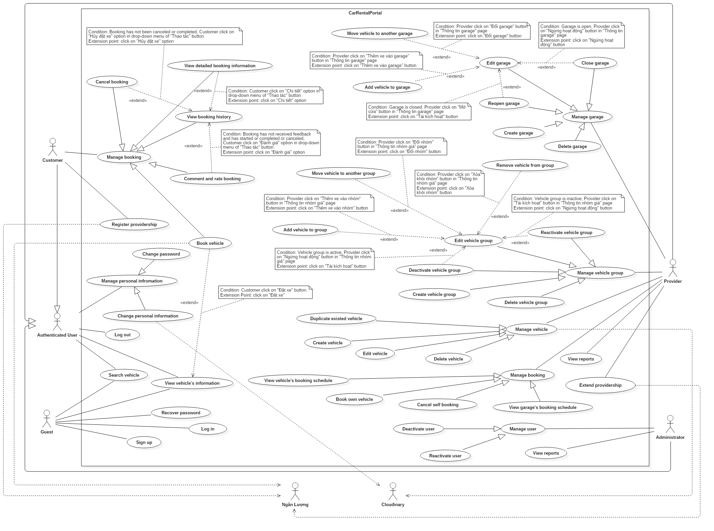

Figure 2: System Overview Use Case

### Use Cases

#### <Guest> Use Cases Overview



Figure 3: <Guest> Use Case Overview

##### <Guest> Log in (UC01) <Excluded>

##### <Guest> Sign up (UC02) <Excluded>

##### <Guest> Recover password (UC03) <Excluded>

##### <Guest> Search vehicle (UC04) <Excluded>

##### <Guest> View vehicle’s information (UC05) <Excluded>

#### <Authenticated user> Use Case Overview



Figure 4: <Authenticated user> Use Case Overview

##### < Authenticated User > Log out (UC06) <Excluded>

##### < Authenticated User > Change personal information (UC07) <Excluded>

##### < Authenticated User > Change password (UC08) <Excluded>

##### < Authenticated User > Search vehicle (UC09)



Figure 5: < Authenticated User > Search vehicle Use Case

|  |  |  |  |
| --- | --- | --- | --- |
| USE CASE – UC09 | | | |
| Use Case No. | 09 | **Use Case Version** | 1.0 |
| Use Case Name | Search vehicle | | |
| Author | TamNT | | |
| Date | 30/09/2016 | **Priority** | High |
| Actor:   * Authenticated User.   Summary:   * This use case allows authenticated user to search vehicle.   Goal:   * Authenticated user can search for the vehicle with their required.   Triggers:   * Authenticated user access search page.   Preconditions: N/A.  Post Conditions:   * Success: Shows vehicles that fit filtering conditions. * Fail: Show error message.   Main Success Scenario:   |  |  |  | | --- | --- | --- | | Step | Actor Action | System Response | | 1 | User access search page. | System shows search page with search result and various filters | | 2 | User changes a filter condition | System apply recommender’s scores and refresh search result.  [Alternative 1,2,3,4,5,6] |   Alternative Scenario:   |  |  |  | | --- | --- | --- | | No | Actor Action | System Response | | 1 | User select start time / end time for their trip | System filters out vehicles that has been booked in this time span. | | 2 | User select location where they want to rend vehicle | System shows only | | 3 | User checks seats box at “Số chỗ ngồi” | System shows vehicles which has seats corresponding with seats box user checked:   * 2 chỗ: 2 seats * 4 chỗ: 4 seats * 5 chỗ: 5 seats * 7 chỗ: 7 seats * 8 chỗ: 8 seats * 16 chỗ: 16 seats | | 4 | User pulls the slider at “Mức giá”.  User pulls the left slider to  User pulls the right slider | System shows vehicles with price that fit with user’s conditions.  System changes min pride up to the value of left slider.  System changes max pride up to the value of right slider. | | 5 | User choose options of the list “Sắp xếp theo” | System shows the result order by options user choose:   * Gói thời gian thuê xe phù hợp nhất: System will show vehicles in order of provided rental option that has rental time span closest to user’s rental time span (deduced from start time and end time) * Xe có điểm đánh giá tốt nhất: System will show vehicles order from high rating to lower. * Garage có điểm đánh giá tốt nhất: System will show vehicles order by their garage from high rating to lower   Giá từ thấp đến cao: System will show vehicles order from low pride to high pride.   * Giá từ cao đến thấp: System will show vehicles order from high pride to low pride. * Xe từ mới đến cũ: System will show vehicles order from new to old which define by the year they made * Xe từ cũ đến mới: System will show vehicles order from old to new which define by the year they made | | 6 | User clicks on “Lọc chi tiết hơn về xe” tab:  User choose an option in “Dòng xe” list  User pulls the slider at “Năm sản xuất”  User checks options at “Hộp số”  User choose options of “Loại nhiên liệu” list  User choose options of “Loại xe” list  User checks colors at “Màu xe” | System shows more detail options for user to find suitable vehicles.  System shows vehicles which has brand/model that fits with user’s condition  System shows vehicles fit with the year range user chose  System shows vehicles which has transmission type that fits with user’s choice:   * Số tự động: automatic * Số sàng: manual   System shows vehicles which has fuel type that fits with user’s choice:   * Xăng: gasoline * Dầu diesel: diesel * Điện: electric * Điện hybrid: hybrid electric * Điện plug-in hybrid: plug-in hybrid electric   System shows vehicles belongs to user selected categories.  System will show vehicles which has the color user chose. | | 7 | User clicks on “Lọc theo đánh giá” tab  User choose option of “Đánh giá xe” list.  User choose option of “Đánh giá cửa hàng xe” list. | System will show options for user to find vehicles by rating.  System will show vehicles which rated fit which option user choose:  : above 4 star  : above 3 star  : above 2 star  System will show vehicles which their garage’s rate fit which option user choose:  : above 4 star  : above 3 star  : above 2 star | | 8 | User clicks on “Xóa bỏ lọc” button. | System will reset all filtering conditions, except location, start time, and end time, back to default. |   Exceptions: N/A  Relationships: N/A  Business Rules:   * Start time cannot be sooner than 6 hours from now. * Start time cannot be later than 30 days from now. * End time cannot be sooner than 1 hours from start time. | | | |

##### < Authenticated User > View vehicle’s information (UC10) <Excluded>

#### <Customer> Use Case Overview



Figure 6 <Customer> Use Case Overview

##### < Customer > Book vehicle (UC11)



Figure 7: < Customer > Book vehicle Use Case

|  |  |  |  |
| --- | --- | --- | --- |
| USE CASE – UC11 | | | |
| Use Case No. | 11 | **Use Case Version** | 1.0 |
| Use Case Name | Book vehicle | | |
| Author | DucTH | | |
| Date | 30/09/2016 | **Priority** | Normal |
| Actor:   * Customer   Summary:   * This use case allows customer to book vehicle.   Goal:   * Customer books vehicle successfully.   Triggers:   * Customer clicks on “Đặt xe” button in vehicle’s rental information page.   Preconditions:   * Log in successfully as customer.   Post Conditions:   * Success: Vehicle is booked successfully. * Fail: Show error message.   Main Success Scenario:   |  |  |  | | --- | --- | --- | | Step | Actor Action | System Response | | 1 | Customer accesses vehicle’s rental information page. | System shows webpage of corresponding vehicle with options for rental plan (Hourly and daily). | | 2 | Customer select a rental plan, start time and end time, then clicks “Đặt xe” button. | System creates a pending booking receipt, then redirects customer to booking confirmation page, where customer can review the booking and select a payment method from the following methods:   * Thanh toán online bằng thẻ ngân hàng nội địa: purchase using bank’s card. * Thanh toán bằng thẻ tín dụng / ghi nợ: purchase using credit card. * Thanh toán bằng Ví điện tử NgânLượng: purchase using NgânLượng account.   [Exception 1] | | 3 | Customer selects payment method and clicks “Đặt xe” button.  [Alternative 1]  [Alternative 3] | System redirects customer to purchase page. | | 4 | Customer pays the booking.  [Alternative 2]  [Alternative 3] | System validates the booking receipt, sends alert email to related customer and provider, and then redirects customer to receipt page. |   Alternative Scenario:   |  |  |  | | --- | --- | --- | | No | Actor Action | System Response | | 1 | Customer presses “Thay đổi” button or “Hủy” button | System removes the pending booking and redirects user to vehicle’s information page. | | 2 | Customer clicks “Hủy” button. | System removes the pending booking and redirects user to vehicle’s information page. | | 3 | Customer does not pay the booking within 10 minutes | System removes the pending booking and redirects user to vehicle’s information page. |   Exceptions:   |  |  |  | | --- | --- | --- | | No | Actor Action | System Response | | 1 | Customer books vehicle during unavailable time | System alerts the customer. |   Relationships: Extend for “View vehicle’s information”  Business Rules:   * Booking’s start time must be after 6 hours from now. * Booking’s start time must be before 30 days from now. * Booking’s end time must be after 1 hours from start time. * Booking’s start time and end time must be within working time of garage. * Booking’s time must not conflict with any other booking of the booked vehicle. * Customer has to pay deposit specified by provider and system’s service fee (1% of total rental price) to book a vehicle. | | | |

##### < Customer > View booking history (UC12) <Excluded>

##### < Customer > View detailed booking information (UC13) <Excluded>

##### < Customer > Cancel booking (UC14)



Figure 8: < Customer > Cancel booking Use Case

|  |  |  |  |
| --- | --- | --- | --- |
| USE CASE – UC14 | | | |
| Use Case No. | 14 | **Use Case Version** | 1.0 |
| Use Case Name | Cancel booking | | |
| Author | DucTH | | |
| Date | 30/09/2016 | **Priority** | Normal |
| Actor:   * Customer   Summary:   * This use case allows customer to cancel their booking.   Goal:   * Customer can cancel their unfinished booking.   Triggers:   * Customer selects “Hủy đặt xe” option in drop-down menu of “Thao tác” button of a booking record.   Preconditions:   * Log in successful as customer. * The target booking has not been completed or canceled.   Post Conditions:   * Success: Booked vehicle will appears in “Lịch sử đặt xe” page. * Fail: Show error message.   Main Success Scenario:   |  |  |  | | --- | --- | --- | | Step | Actor Action | System Response | | 1 | Customer selects “Hủy đặt xe” option in drop-down menu of “Thao tác” button of a booking record. | System cancels the target booking, send alert email to the related customer and provider, then close the popup. | | 2 | Customer clicks on “Hủy” button  [Alternative 1] | System cancels the target booking, send alert email to the related customer and provider, then close the popup. |   Alternative Scenario:   |  |  |  | | --- | --- | --- | | Step | Actor Action | System Response | | 1 | Customer clicks on “Đóng” button, “X” button, or outside the popup. | System close the confirmation popup. |   Exceptions: N/A  Relationships: extend from “View booking history”.  Business Rules:   * The target booking has not been completed (End time has not passed) or canceled. | | | |

##### < Customer > Comment and rate booking (UC15)



Figure 9: < Customer > Comment and rate booking Use Case

|  |  |  |  |
| --- | --- | --- | --- |
| USE CASE – US15 | | | |
| Use Case No. | 15 | **Use Case Version** | 1.0 |
| Use Case Name | Comment and rate booking | | |
| Author | DucTH | | |
| Date | 30/09/2016 | **Priority** | Normal |
| Actor:   * Customer   Summary:   * This use case allows customer to feedback about their booked vehicle’s service.   Goal:   * Customer submits successfully rating and comment for their booking.   Triggers:   * Customer chooses “Đánh giá” option in drop-down menu of “Thao tác” button of a booking record in “Lịch sử đặt xe” page.   Preconditions:   * Log in successfully as a customer. * The target booking must not have received feedback and have either started (Start time of booking is before current time) or been canceled.   Post Conditions:   * Success: Comment and rating for booking is submitted successfully. * Fail: Show error message.   Main Success Scenario:   |  |  |  | | --- | --- | --- | | Step | Actor Action | System Response | | 1 | Customer chooses “Đánh giá” option in drop-down menu of “Thao tác” button of a booking record in “Lịch sử đặt xe” page. | System shows “Đánh giá xe” popup for customer to write comment and choose rating. | | 2 | Customer fills the form in the popup and clicks “Gởi” button.  [Alternative 1] | System will update booking’s comment and rating, as well as related vehicle’s and garage’s ratings, then show “Đã gửi đánh giá thành công” alert to customer.  [Exception 1]  [Exception 2]  [Exception 3]  [Exception 4] |   Alternative Scenario:   |  |  |  | | --- | --- | --- | | No | Actor Action | System Response | | 1 | Customer clicks “Đóng” button, “X” button, or clicks outside the popup box. | System will close “Đánh giá xe” popup. |   Exceptions:   |  |  |  | | --- | --- | --- | | No | Actor Action | System Response | | 1 | Customer don’t do anything and clicks “Gởi” button | System will display “Vui lòng nhập” alert above “Đánh giá” textbox. | | 2 | Customer choose rating but does not type anything in “Đánh giá” textbox. | System will display “Vui lòng nhập” alert above “Đánh giá” textbox. | | 3 | Customer type less than 20 words. | System will display “Vui lòng nhập ít nhất 20 chữ” alert above “Đánh giá” textbox. | | 4 | Customer type more than 200 words | System will display “Vui lòng nhập ít hơn 200 chữ” alert above “Đánh giá” textbox. |   Relationships: Extend from “View booking history”  Business Rules:   * The target booking must not have received feedback and have either started (Start time of booking is before current time) or been canceled. * The related vehicle’s and garage’s ratings must be updated accordingly. | | | |

##### < Customer > Register providership (UC16)



Figure 10: < Customer > Register providership Use Case

|  |  |  |  |
| --- | --- | --- | --- |
| USE CASE – US16 | | | |
| Use Case No. | 16 | **Use Case Version** | 1.0 |
| Use Case Name | Register providership | | |
| Author | DucTH | | |
| Date | 30/09/2016 | **Priority** | Normal |
| Actor:   * Customer   Summary:   * This use case allows customer to become provider.   Goal:   * Customer attains Provider role.   Triggers:   * Customer clicks on “Trở thành nhà cung cấp” link on navigation sidebar.   Preconditions:   * Log in successfully and account only has role customer.   Post Conditions:   * Success: User attains Provider role. * Fail: Show error message.   Main Success Scenario:   |  |  |  | | --- | --- | --- | | Step | Actor Action | System Response | | 1 | User clicks on “Trở thành nhà cung cấp” at navigation bar. | System shows providership registration page, which allows user to choose 1 in 3 subscription plans (1-month, 3-month, and 6-month). | | 2 | User clicks on “Đăng ký” button of a subscription plan. | System shows “Phương thức thanh toán” panel where user can choose payment method:   * Thanh toán online bằng thẻ ngân hàng nội địa: purchase using bank’s card. * Thanh toán bằng thẻ tín dụng / ghi nợ: purchase using credit card. * Thanh toán bằng Ví điện tử NgânLượng: purchase using NgânLượng account. | | 3 | User selects payment method and clicks on “Thanh toán” button.  [Alternative 1] | System redirects user to payment page. | | 4 | User pay for subscription.  [Alternative 2] | System adds role Provider for user and sets expiration day, sends alert email, then redirects user to success page |   Alternative Scenario:   |  |  |  | | --- | --- | --- | | No | Actor Action | System Response | | 1 | User clicks on “Hủy đơn hàng” button at become provider page. | System will redirect user to homepage. | | 2 | User clicks on “Hủy đơn hàng” button at purchase page. | System will redirect user to homepage. |   Exceptions: N/A  Relationships: N/A  Business Rules:   * Only user with role Customer and only role Customer can register new providership. | | | |

#### <Provider> Use Case Overview



Figure 11 <Provider> Use Case Overview

##### < Provider > Create vehicle (UC17)



Figure 12: < Provider > Create vehicle Use Case

|  |  |  |  |
| --- | --- | --- | --- |
| USE CASE – UC17 | | | |
| Use Case No. | 17 | **Use Case Version** | 1.0 |
| Use Case Name | Create vehicle | | |
| Author | KhoaLVD | | |
| Date | 30/09/2016 | **Priority** | Normal |
| Actor:   * Provider   Summary:   * This use case allows provider to create vehicle.   Goal:   * Provider can add vehicle for customer to book.   Triggers:   * Provider clicks “Thêm xe mới” button at “Quản lý xe” page.   Preconditions:   * User must login into the system with role “Provider”.   Post Conditions:   * Success: New vehicle appear at chosen garage. * Fail: Show error message.   Main Success Scenario:   |  |  |  | | --- | --- | --- | | Step | Actor Action | System Response | | 1 | Provider clicks “Thêm xe mới” button at “Quản lý xe” page. | System shows “Tạo xe mới” popup display all information needed to fill. | | 2 | Provider inputs vehicle information. | System require information:   * “Tên xe”: textbox, required, min length10, max length100. * “Biển số xe”: textbox, required, min length10, max length50. * “Dòng xe”: dropdownlist, required * “Năm sản xuất”: number, required, chosen from 1908 to current year. * “Garage”: dropdownlist, required * “Nhóm xe”: dropdownlist * “Loại hộp số”: radio button, required, choose between “Số tự động” or “Số sàng” * “Chi tiết về loại hộp số”: textbox, maxlenght50. * “Loại nhiên liệu”: dropdownlist * “Đặc tả về động cơ”: textbox, maxlenght50. * “Màu xe”: radio button, required * “Mô tả xe”: textarea, maxleght500. * “Hình ảnh”: dropzone, at least 4 images, max at 10 images. | | 3 | Provider send creation request.  [Alternative 1] | Popup close and “Tạo xe thành công” alert appear on the top right side.  [Exception 1]  [Exception 2]  [Exception 3]  [Exception 4]  [Exception 5]  [Exception 6]  [Exception 7]  [Exception 8]  [Exception 9]  [Exception 10]  [Exception 11]  [Exception 12]  [Exception 13]  [Exception 14]  [Exception 15]  [Exception 16]  [Exception 17] |   Alternative Scenario:   |  |  |  | | --- | --- | --- | | No | Actor Action | System Response | | 1 | Provider clicks an exit button or clicks outside the popup box. | System will close “Tạo xe mới” popup and back to “Quản lý xe” page. |   Exceptions:   |  |  |  | | --- | --- | --- | | No | Actor Action | System Response | | 1 | Provider does not fill anything and send request. | Show a message to notify that “Tên xe phải từ 10 đến 100 chữ cái” | | 2 | Provider missed to input “Tên xe” field. | Show error message “Tên xe phải từ 10 đến 100 chữ cái”. | | 3 | Provider inputs too long string in “Tên khách hàng” textbox | Show error message “Tên xe phải từ 10 đến 100 chữ cái”. | | 4 | Provider inputs too short string in “Tên khách hàng” textbox | Show error message “Tên xe phải từ 10 đến 100 chữ cái”. | | 5 | Provider missed to input “Biển số xe” field. | Show error message “Biển số xe phải từ 10 đến 50 ký tự”. | | 6 | Provider inputs too long string in “Biển số xe” textbox | Show error message “Biển số xe phải từ 10 đến 50 ký tự”. | | 7 | Provider inputs too short string in “Biển số xe” textbox | Show error message “Biển số xe phải từ 10 đến 50 ký tự”. | | 8 | Provider missed to choose “Dòng xe” list. | Show error message “Vui lòng chọn dòng xe”. | | 9 | Provider missed to input “Năm sản xuất” field. | Show error message “Vui lòng khai báo năm sản xuất của xe”. | | 10 | Provider input the year before 1908 | System will automatic change back the year to 1908 | | 11 | Provider input the year after current year. | System will automatic change back the year to the current year | | 12 | Provider missed to choose “Garage” list. | Show error message “Vui lòng chọn garage xe”. | | 13 | Provider missed to choose “Loại hộp số”. | Show error message “Vui lòng chọn loại hộp số”. | | 14 | Provider missed to choose “Màu xe”. | Show error message “Vui lòng chọn màu xe”. | | 15 | Provider missed to upload picture. | Show error message “Bạn phải upload ít nhất 4 hình”. | | 16 | Provider upload less than 4 pictures | Show error message “Bạn phải upload ít nhất 4 hình”. | | 17 | Provider upload more than 10 pictures | Only the first 10 pictures are uploaded |   Relationships: N/A  Business Rules:  - “Tên xe”: textbox, required, min length 10, max length 100.  - “Biển số xe”: textbox, required, min length 10, max length 50.  - “Dòng xe”: dropdownlist, required  - “Năm sản xuất”: number, required, chosen from 1908 to current year.  - “Garage”: dropdownlist, required  - “Nhóm xe”: dropdownlist  - “Loại hộp số”: radio button, required, choose between “Số tự động” or “Số sàng”  - “Chi tiết về loại hộp số”: textbox, max length 50.  - “Loại nhiên liệu”: dropdownlist  - “Đặc tả về động cơ”: textbox, max length 50.  - “Màu xe”: radio button, required  - “Mô tả xe”: textarea, max length 500.  - “Hình ảnh”: dropzone, at least 4 images, max at 10 images. | | | |

##### < Provider > Duplicate existed vehicle (UC18) <Excluded>

##### < Provider > Edit vehicle (UC19)



Figure 13: < Provider > Edit vehicle Use Case

|  |  |  |  |
| --- | --- | --- | --- |
| USE CASE – UC19 | | | |
| Use Case No. | 19 | **Use Case Version** | 1.0 |
| Use Case Name | Edit vehicle | | |
| Author | KhoaLVD | | |
| Date | 30/09/2016 | **Priority** | Normal |
| Actor:   * Provider   Summary:   * This use case allows provider to edit information of existed vehicle.   Goal:   * Provider can edit information of existed vehicle for customer to book.   Triggers:   * Provider clicks vehicle’s name at “Quản lý xe” page.   Preconditions:   * User must login into the system with role “Provider” still existed.   Post Conditions:   * Success: Save new information of the chosen vehicle. * Fail: Show error message.   Main Success Scenario:   |  |  |  | | --- | --- | --- | | Step | Actor Action | System Response | | 1 | Provider clicks vehicle’s name at “Quản lý xe” page. | System open “Thông tin chi tiết của xe” page display all information of chosen vehicle. | | 2 | Provider clicks “Chỉnh sửa thông tin” button | System shows form to edit vehicle’s information, which requires:   * “Tên xe”: textbox, required, min length 10, max length 100. * “Biển số xe”: textbox, required, min length 10, max length 50. * “Garage”: dropdownlist, required * “Nhóm xe”: dropdownlist * “Chi tiết về loại hộp số”: textbox, max length 50. * “Động cơ”: textbox, max length 50. * “Màu xe”: radio button, required * “Mô tả xe”: textarea, max length 500. * “Hình ảnh”: dropzone, at least 4 images, max at 10 images. | | 4 | Provider changes vehicle’s information and saves the changes.  [Alternative 1, 2, 3] | System save edited information and reload the page. |   Alternative Scenario:   |  |  |  | | --- | --- | --- | | No | Actor Action | System Response | | 1 | Provider clicks on “Hủy bỏ” button. | System closes the edit form. | | 2 | Provider uploads more pictures | System uploads new pictures sequecially. | | 3 | Provider click on “Xoá” button under a picture. | System deletes the target picture. |   Exceptions:   |  |  |  | | --- | --- | --- | | No | Actor Action | System Response | | 1 | Provider deletes all information in “Tên xe” field. | Show error message “Tên xe phải từ 10 đến 100 chữ cái”. | | 2 | Provider inputs too long string in “Tên xe” textbox | Show error message “Tên xe phải từ 10 đến 100 chữ cái”. | | 3 | Provider inputs too short string in “Tên xe” textbox | Show error message “Tên xe phải từ 10 đến 100 chữ cái”. | | 4 | Provider deletes all information in “Biển số xe” field. | Show error message “Biển số xe phải từ 10 đến 50 ký tự”. | | 5 | Provider inputs too long string in “Biển số xe” textbox | Show error message “Biển số xe phải từ 10 đến 50 ký tự”. | | 6 | Provider inputs too short string in “Biển số xe” textbox | Show error message “Biển số xe phải từ 10 đến 50 ký tự”. | | 7 | Provider missed to upload picture. | Show error message “Bạn phải upload ít nhất 4 hình”. | | 8 | Provider deleted pictures and make the total number of picture less than 4 | Show error message “Bạn phải upload ít nhất 4 hình”. | | 9 | Provider uploaded more pictures and make the total number of picture more than 10. | 11th and later pictures are not uploaded. |   Relationships: N/A  Business Rules:  - “Tên xe”: textbox, required, min length 10, max length 100.  - “Biển số xe”: textbox, required, min length 10, max length 50.  - “Garage”: dropdownlist, required  - “Nhóm xe”: dropdownlist  - “Chi tiết về loại hộp số”: textbox, max length 50.  - “Đặc tả về động cơ”: textbox, max length 50.  - “Màu xe”: radio button, required  - “Mô tả xe”: textarea, max length 500.  - “Hình ảnh”: dropzone, at least 4 images, max at 10 images. | | | |

##### < Provider > Delete vehicle (UC20) <Excluded>

##### < Provider > View vehicle’s booking schedule (UC21) <Excluded>

##### < Provider > View garage’s booking schedule (UC22) <Excluded>

##### < Provider > Book own vehicle (UC23)



Figure 14: < Provider > Book own vehicle Use Case

|  |  |  |  |
| --- | --- | --- | --- |
| USE CASE – UC23 | | | |
| Use Case No. | 23 | **Use Case Version** | 1.0 |
| Use Case Name | Book own vehicle | | |
| Author | KhoaLVD | | |
| Date | 30/09/2016 | **Priority** | Normal |
| Actor:   * Provider   Summary:   * This use case allows provider to book their own vehicle.   Goal:   * Provider can book their own vehicle in other to reserve it.   Triggers:   * Provider clicks on “Tạo đặt xe mới” button in “Thông tin chi tiết của xe” page of a vehicle.   Preconditions:   * User must login into the system with role “Provider”.   Post Conditions:   * Success: Provider successfully book the vehicle. * Fail: Show error message.   Main Success Scenario:   |  |  |  | | --- | --- | --- | | Step | Actor Action | System Response | | 1 | Provider clicks on “Tạo đặt xe mới” button in “Thông tin chi tiết của xe” page of a vehicle. | System shows popup to create new self-booking. | | 2 | Providers provides start time and end time of the booking, then submit.  [Alternative 1] | System create new self-booking for vehicle.  [Exception 1] |   Alternative Scenario:   |  |  |  | | --- | --- | --- | | No | Actor Action | System Response | | 1 | Provider clicks “Thoát” button, “X” button, or outside the popup box. | System closes the popup. |   Exceptions:   |  |  |  | | --- | --- | --- | | No | Actor Action | System Response | | 1 | Provider submits new booking that time is conflicts with another existed booking. | System shows error alert. |   Relationships: N/A  Business Rules:   * Booking’s start time must be after 6 hours from now. * Booking’s end time must be after 1 hours from start time. * The booked vehicle must not has any other booking in this booked time span. | | | |

##### < Provider > Cancel self-booking (UC24) <Excluded>

##### < Provider > Create garage (UC25)



Figure 15: < Provider > Create garage Use Case

|  |  |  |  |
| --- | --- | --- | --- |
| USE CASE – UC25 | | | |
| Use Case No. | 25 | **Use Case Version** | 1.0 |
| Use Case Name | Create garage | | |
| Author | ThanhHC | | |
| Date | 30/09/2016 | **Priority** | Normal |
| Actor:   * Provider   Summary:   * This use case allows provider to create a new garage.   Goal:   * Provider can create new garage.   Triggers:   * Provider send request in page “Quản lý garage” to create garage by click on “Tạo garage mới”.   Preconditions:   * Login as roles provider.   Post Conditions:   * Success: Provider has new garage. * Fail: Show error message.   Main Success Scenario:   |  |  |  | | --- | --- | --- | | Step | Actor Action | System Response | | 1 | Provider click “Tạo garage mới” button. | System show popup requires information :   * Tên garage: free text input, required, max length 100. * Địa điểm: dropdown list, required. * Địa chỉ: free text input, required, max length 200. * Email: free text input, required. * Số điện thoại (mặc định): numeric, required, min length 10, max length 20. * Số điện thoại (bổ sung): numeric, min length 10, max length 20. * Mô tả: free text input. * Điều khoản: free text input. * Thời gian mở cửa: text input with time format and checkbox “Nghỉ”. By default, from Monday to Friday open at 8:00, close at 17:00. Saturday and Sunday checkbox “Nghỉ” is checked. | | 2 | Provider inputs information. |  | | 3 | Provider click to button “Tạo garage” that sends request to create to system.  [Alternative 1] | Provider creates a new garage successfully.  [Exception 1]  [Exception 2]  [Exception 3]  [Exception 4]  [Exception 5]  [Exception 6]  [Exception 7]  [Exception 8]  [Exception 9] |   Alternative Scenario:   |  |  |  | | --- | --- | --- | | No | Actor Action | System Response | | 1 | Provider clicks on “Đóng” button, “X” button, or outside the popup. | Current popup will be closed. |   Exceptions:   |  |  |  | | --- | --- | --- | | No | Actor Action | System Response | | 1 | Provider missed to input “Tên garage” field. | System show error message “Vui lòng nhập tên garage”. | | 2 | Provider missed to input “Địa chỉ” field | System show error message “Vui lòng nhập địa chỉ” | | 3 | Provider missed to input “Email” field | System shows error message “Vui lòng nhập email” | | 4 | Provider missed to input “Số điện thoại (mặc định)” field | System shows error message “Vui lòng nhập số điện thoại” | | 5 | Provider input “Tên garage” is over length allowed | System shows error message “Xin lỗi. Tên của garage vượt quá độ dài quy định” | | 6 | Provider input “Địa chỉ” is over length allowed | System shows error message “Xin lỗi. Địa chỉ vượt quá độ dài quy định” | | 7 | Provider input “Email” is wrong format | System shows error message “Email không hợp lệ” | |  | Provider input “Số điện thoại” is wrong format.  Valid format:  ^[0-9-+]+$ | System shows error message “Số điện thoại không hợp lệ” | | 8 | Provider input “Thời gian mở cửa” textfield “Từ” has higher value than textfield “Đến”. | System shows error message “Xin lỗi, thời gian đóng cửa không được sớm hơn thời gian mở cửa” | | 9 | Provider input “Thời gian mở cửa”wrong time format | System shows error message “Xin lỗi, giá trị thời gian không hợp lệ” |   Relationships: N/A  Business Rules: N/A | | | |

##### < Provider > Delete garage (UC26) <Excluded>

##### < Provider > Edit garage (UC27)



Figure 16: < Provider > Edit garage Use Case

|  |  |  |  |
| --- | --- | --- | --- |
| USE CASE – UC27 | | | |
| Use Case No. | 27 | **Use Case Version** | 1.0 |
| Use Case Name | Edit garage | | |
| Author | ThanhHC | | |
| Date | 30/09/2016 | **Priority** | Normal |
| Actor:   * Provider   Summary:   * This use case allows provider to edit garage’s information.   Goal:   * Garage’s information will be updated.   Triggers:   * Provider clicks “Chỉnh sửa thông tin” button in garage’s details page.   Preconditions:   * Login as roles provider.   Post Conditions:   * Success: Garage’s information will be updated in system. * Fail: Show error message.   Main Success Scenario:   |  |  |  | | --- | --- | --- | | Step | Actor Action | System Response | | 1 | Provider clicks “Chỉnh sửa thông tin” button in garage’s details page. | System shows a form to edit garage, which requires:   * Tên garage: free text input, required, max length 100. * Địa điểm: dropdown list, required * Địa chỉ: free text input, required, max length 200 * Email: free text input, required * Số điện thoại (mặc định): free text input, required, min length 10, max length 20 * Số điện thoại (bổ sung): free text input, min length 10, max length 20 * Mô tả: free text input * Điều khoản: free text input * Thời gian mở cửa: text input with time format and checkbox “Nghỉ”. By default, from Monday to Friday open at 8:00, close at 17:00. Saturday and Sunday checkbox “Nghỉ” is checked. | | 2 | Provider updates garage’s information and saves the updates  [Alternative 1] | System updates garage.  [Exception 1]  [Exception 2]  [Exception 3]  [Exception 4]  [Exception 5]  [Exception 6]  [Exception 7]  [Exception 8]  [Exception 9] |   Alternative Scenario:   |  |  |  | | --- | --- | --- | | No | Actor Action | System Response | | 1 | Provider click to “Hủy bỏ” button. | All display controls will be closed. |   Exceptions:   |  |  |  | | --- | --- | --- | | No | Actor Action | System Response | | 1 | Provider missed to input “Tên garage” field | System show error message “Vui lòng nhập tên garage” | | 2 | Provider missed to input “Địa chỉ” field | System show error message “Vui lòng nhập địa chỉ” | | 3 | Provider missed to input “Email” field | System shows error message “Vui lòng nhập email” | | 4 | Provider missed to input “Số điện thoại (mặc định)” field | System shows error message “Vui lòng nhập số điện thoại” | | 5 | Provider input “Tên garage” is over length allowed | System shows error message “Xin lỗi. Tên của garage vượt quá độ dài quy định” | | 6 | Provider input “Địa chỉ” is over length allowed | System shows error message “Xin lỗi. Địa chỉ vượt quá độ dài quy định” | | 7 | Provider input “Email” is wrong format | System shows error message “Email không hợp lệ” | |  | Provider input “Số điện thoại” is wrong format.  Valid format:  ^[0-9-+]+$ | System shows error message “Số điện thoại không hợp lệ” | | 8 | Provider input “Thời gian mở cửa” textfield “Từ” has higher value than textfield “Đến”. | System shows error message “Xin lỗi, thời gian đóng cửa không được sớm hơn thời gian mở cửa” | | 9 | Provider input “Thời gian mở cửa” wrong time format | System shows error message “Xin lỗi, giá trị thời gian không hợp lệ” |   Relationships: extended by “Close garage”, “Reopen garage”, “Add vehicle to garage” and “Move vehicle to another garage”  Business Rules: N/A | | | |

##### < Provider > Close garage (UC28) <Excluded>

##### < Provider > Reopen garage (UC29) <Excluded>

##### < Provider > Add vehicle to garage (UC30)



Figure 17: < Provider > Add vehicle to garage Use Case

|  |  |  |  |
| --- | --- | --- | --- |
| USE CASE – UC30 | | | |
| Use Case No. | 30 | **Use Case Version** | 1.0 |
| Use Case Name | Add vehicle to garage | | |
| Author | ThanhHC | | |
| Date | 30/09/2016 | **Priority** | Normal |
| Actor:   * Provider   Summary:   * This use case allows provider to add vehicle to current garage.   Goal:   * The selected vehicle will be moved into the target garage.   Triggers:   * Provider click on “Thêm xe vào garage” at “thông tin garage” page.   Preconditions:   * Login as roles provider.   Post Conditions:   * Success: Vehicle added to garage successfully. * Fail: Show error message.   Main Success Scenario:   |  |  |  | | --- | --- | --- | | Step | Actor Action | System Response | | 1 | Provider clicks “Thêm xe vào Garage” button. | System shows popup for choosing vehicle to add to garage. | | 2 | Provider select vehicle to add to garage and click “Thêm” button  [Alternative 1] | System add vehicle to garage. |   Alternative Scenario:   |  |  |  | | --- | --- | --- | | No | Actor Action | System Response | | 1 | Provider clicks on exist buttons from click outside the popup. | Current popup will be closed. |   Exceptions: N/A  Relationships: Extend from “Edit garage”.  Business Rules: N/A | | | |

##### < Provider > Move vehicle to another garage (UC31) <Excluded>

##### < Provider > Create vehicle group (UC32)



Figure 18: < Provider > Create vehicle group Use Case

|  |  |  |  |
| --- | --- | --- | --- |
| USE CASE – UC32 | | | |
| Use Case No. | 32 | **Use Case Version** | 2.0 |
| Use Case Name | Create vehicle group | | |
| Author | ThanhHC | | |
| Date | 30/09/2016 | **Priority** | Normal |
| Actor:   * Provider   Summary:   * This use case allows provider to create a new vehicle group.   Goal:   * Provider has a group to manage price, info and vehicles belong to this group.   Triggers:   * Provider click button “Thêm nhóm mới” in page “Quản lý nhóm giá”.   Preconditions:   * Login as roles provider.   Post Conditions:   * Success: Provider has new vehicle group to manage price. In default, this vehicle group has 0 vehicles. Provider can add vehicle to this group at later. * Fail: Show error message.   Main Success Scenario:   |  |  |  | | --- | --- | --- | | Step | Actor Action | System Response | | 1 | Provider click “Thêm nhóm mới” button.  [Alternative 1]  [Alternative 2] | System show popup requires information :   * Tên nhóm: free text input, required, max length 50. * Đặt cọc: number input, required, value must in range [0..100] * Giá theo ngày: number input, required, not allow negative number. * Không giới hạn: checkbox. Default checked box, when uncheck, provider can input at “Kỳ hạn thuê tối đa”, “Số km tối đa một ngày” and “Số tiền trả thêm” text box. * Kỳ hạn thuê tối đa: number input, not allow negative number, can’t input when “Không giới hạn” is checked. * Số Km tối đa một ngày: number input, not allow negative number, can’t input when “Không giới hạn” is checked. * Số tiền trả thêm: number input, not allow negative number. Display with hint text “Được áp dụng khi vượt số Km quy định”, can’t input when “Không giới hạn” is checked and “Số km tối đa một ngay” not yet input. * Bảng giá theo giờ: In default, table is hided, and only button “Thêm hàng mới” is displayed. | | 2 | Provider click “Thêm hàng mới” button.  [Alternative 3]  [Alternative 4] | On current popup show a table with columns:   * Thời gian (giờ): number input, value must in range [1..23] * Giá tiền (VNĐ): number input, not allow negative number * Số Km tối đa (Km): number input, not allow negative number. | | 3 | Provider inputs information. |  | | 4 | Provider click to button “Tạo nhóm” that sends request to create to system.  [Alternative 5] | Provider create a new garage successfully.  [Exception 1]  [Exception 2]  [Exception 3]  [Exception 4]  [Exception 5]  [Exception 6]  [Exception 7]  [Exception 8]  [Exception 9]  [Exception 10]  [Exception 11]  [Exception 12]  [Exception 13]  [Exception 14]  [Exception 15]  [Exception 16] |   Alternative Scenario:   |  |  |  | | --- | --- | --- | | No | Actor Action | System Response | | 1 | Provider uncheck “Không giới hạn” at “Kỳ hạn thuê tối đa” | System allows provider to input “Kỳ hạn thuê tối đa” textbox. | | 2 | Provider uncheck “Không giới hạn” at “Số km tối đa một ngày” | System allows provider to input “Số km tối đa một ngày” textbox. | | 3 | Provider uncheck “Không giới hạn số km tối đa” | System allows provider to input “Số km tối đa” textbox. | | 4 | Provider click to minus icon button. | A row in “Bảng giá theo giờ” table will be deleted. | | 5 | Provider click to “Đóng” button. | Current popup will be closed. |   Exceptions:   |  |  |  | | --- | --- | --- | | No | Actor Action | System Response | | 1 | Provider missed to input “Tên nhóm” field | System show error message “Vui lòng nhập tên nhóm” | | 2 | Provider missed to input “Đặt cọc” field | System show error message “Vui lòng nhập giá trị đặt cọc” | | 3 | Provider missed to input “Giá theo ngày” field | System shows error message “Xin vui lòng nhập giá thuê theo ngày” | | 4 | Providerinput “Tên nhóm” is over length allowed | System shows error message “Xin lỗi. Tên nhóm vượt quá độ dài quy định” | | 5 | Provider input “Đặt cọc” is out of range | System shows error message “Xin lỗi. giá trị đặt cọc phải từ 0% đến 100%” | | 6 | Provider input “Giá theo ngày” is a negative number. | System shows error message “Xin lỗi. Số tiền không được âm” | | 7 | Provider input “Kì hạn thuê tối đa” is a negative number | System shows error message “Xin lỗi. Kì hạn thuê tối đa không được âm” | | 8 | Provider input “Số Km tối đa một ngày” is a negative number. | System shows error message “Xin lỗi số km tối đa không được âm” | | 9 | Provider input “Số tiền trả thêm” is a negative number | System shows error message “Xin lỗi. Số tiền không được âm” | | 10 | Provider input “Thời gian (giờ)” but not input “Giá tiền (VNĐ)” | System shows error message “Vui lòng nhập giá tiền” | | 11 | Provider input “Giá tiền (VNĐ)” but not input “Thời gian (giờ)” | System shows error message “Vui lòng nhập giờ” | | 12 | Provider input “Số Km tối đa (Km)” but not input “Thời gian (giờ)” and “Giá tiền (VNĐ)” | System shows error message “Vui lòng nhập giờ và giá tiền” | | 13 | Provider input “Thời gian (giờ)” is out of range. | System shows error message “Xin lỗi. Số giờ bị sai” | | 14 | Provider input “Thời gian (giờ)” is duplicated. | System shows error message “Xin lỗi. Không được cấu hình giá một khung giờ nhiều lần” | | 15 | Provider input “Giá tiền (VNĐ)” is a negative number. | System shows error message “Xin lỗi. Số tiền không được âm” | | 16 | Provider input “Số Km tối đa (Km)” is a negative number. | System shows error message “Xin lỗi. Số tiền Km tối đa theo giờ không được âm” |   Relationships: N/A  Business Rules:   * After vehicle group is created, group has no vehicle inside and status “Đang hoạt động”. | | | |

##### < Provider > Delete vehicle group (UC33) <Excluded>

##### < Provider > Edit vehicle group (UC34)



Figure 19: < Provider > Edit vehicle group Use Case

|  |  |  |  |
| --- | --- | --- | --- |
| USE CASE – UC34 | | | |
| Use Case No. | 34 | **Use Case Version** | 1.0 |
| Use Case Name | Edit vehicle group | | |
| Author | ThanhHC | | |
| Date | 30/09/2016 | **Priority** | Normal |
| Actor:   * Provider   Summary:   * This use case allows provider to update vehicle group’s information.   Goal:   * New information of group will be updated.   Triggers:   * Provider click button “Chỉnh sửa thông tin” in page “Thông tin nhóm giá”.   Preconditions:   * Login as roles provider.   Post Conditions:   * Success: Provider has a vehicle group with new information. * Fail: Show error message.   Main Success Scenario:   |  |  |  | | --- | --- | --- | | Step | Actor Action | System Response | | 1 | Provider click “Chỉnh sửa thông tin” button.  [Alternative 1]  [Alternative 2] | System show popup requires information :   * Tên nhóm: free text input, required, max length 50. * Đặt cọc: number input, required, value must in range [0..100] * Giá theo ngày: number input, required, not allow negative number. * Không giới hạn: checkbox. Default checked box, when uncheck, provider can input at “Kỳ hạn thuê tối đa”, “Số km tối đa một ngày” and “Số tiền trả thêm” text box. * Kỳ hạn thuê tối đa: number input, not allow negative number, can’t input when “Không giới hạn” is checked. * Số Km tối đa một ngày: number input, not allow negative number, can’t input when “Không giới hạn” is checked. * Số tiền trả thêm: number input, not allow negative number. Display with hint text “Được áp dụng khi vượt số Km quy định”, can’t input when “Không giới hạn” is checked and “Số km tối đa một ngay” not yet input. * Bảng giá theo giờ: In default, table is hided, and only button “Thêm hàng mới” is displayed. | | 2 | Provider click “Thêm hàng mới” button.  [Alternative 3]  [Alternative 4] | Add a row on current table “Bảng giá theo giờ” with columns:   * Thời gian (giờ): number input, value must in range [1..23] * Giá tiền (VNĐ): number input, not allow negative number * Số Km tối đa (Km): number input, not allow negative number. | | 3 | Provider inputs information. |  | | 4 | Provider click to button “Lưu lại” that sends request to create to system.  [Alternative 5] | Provider create a new garage successfully.  [Exception 1]  [Exception 2]  [Exception 3]  [Exception 4]  [Exception 5]  [Exception 6]  [Exception 7]  [Exception 8]  [Exception 9]  [Exception 10]  [Exception 11]  [Exception 12]  [Exception 13]  [Exception 14]  [Exception 15]  [Exception 16] |   Alternative Scenario:   |  |  |  | | --- | --- | --- | | No | Actor Action | System Response | | 1 | Provider missed to input “Tên nhóm” field | System show error message “Vui lòng nhập tên nhóm” | | 2 | Provider missed to input “Đặt cọc” field | System show error message “Vui lòng nhập giá trị đặt cọc” | | 3 | Provider missed to input “Giá theo ngày” field | System shows error message “Xin vui lòng nhập giá thuê theo ngày” | | 4 | Providerinput “Tên nhóm” is over length allowed | System shows error message “Xin lỗi. Tên nhóm vượt quá độ dài quy định” | | 5 | Provider input “Đặt cọc” is out of range | System shows error message “Xin lỗi. giá trị đặt cọc phải từ 0% đến 100%” |   Exceptions:   |  |  |  | | --- | --- | --- | | No | Actor Action | System Response | | 1 | Provider missed to input “Tên nhóm” field | System show error message “Vui lòng nhập tên nhóm” | | 2 | Provider missed to input “Đặt cọc” field | System show error message “Vui lòng nhập giá trị đặt cọc” | | 3 | Provider missed to input “Giá theo ngày” field | System shows error message “Xin vui lòng nhập giá thuê theo ngày” | | 4 | Providerinput “Tên nhóm” is over length allowed | System shows error message “Xin lỗi. Tên nhóm vượt quá độ dài quy định” | | 5 | Provider input “Đặt cọc” is out of range | System shows error message “Xin lỗi. giá trị đặt cọc phải từ 0% đến 100%” | | 6 | Provider input “Giá theo ngày” is a negative number. | System shows error message “Xin lỗi. Số tiền không được âm” | | 7 | Provider input “Kì hạn thuê tối đa” is a negative number | System shows error message “Xin lỗi. Kì hạn thuê tối đa không được âm” | | 8 | Provider input “Số Km tối đa một ngày” is a negative number. | System shows error message “Xin lỗi số km tối đa không được âm” | | 9 | Provider input “Số tiền trả thêm” is a negative number | System shows error message “Xin lỗi. Số tiền không được âm” | | 10 | Provider input “Thời gian (giờ)” but not input “Giá tiền (VNĐ)” | System shows error message “Vui lòng nhập giá tiền” | | 11 | Provider input “Giá tiền (VNĐ)” but not input “Thời gian (giờ)” | System shows error message “Vui lòng nhập giờ” | | 12 | Provider input “Số Km tối đa (Km)” but not input “Thời gian (giờ)” and “Giá tiền (VNĐ)” | System shows error message “Vui lòng nhập giờ và giá tiền” | | 13 | Provider input “Thời gian (giờ)” is out of range. | System shows error message “Xin lỗi. Số giờ bị sai” | | 14 | Provider input “Thời gian (giờ)” is duplicated. | System shows error message “Xin lỗi. Không được cấu hình giá một khung giờ nhiều lần” | | 15 | Provider input “Giá tiền (VNĐ)” is a negative number. | System shows error message “Xin lỗi. Số tiền không được âm” | | 16 | Provider input “Số Km tối đa (Km)” is a negative number. | System shows error message “Xin lỗi. Số tiền Km tối đa theo giờ không được âm” |   Relationships: Extended by “Deactivate vehicle group”, “Reactivate vehicle group”, “Add vehicle to group”, “Move vehicle to another group”, “Remove vehicle from group”  Business Rules: N/A | | | |

##### < Provider > Deactivate vehicle group (UC35) <Excluded>

##### < Provider > Reactivate vehicle group (UC36) <Excluded>

##### < Provider > Add vehicle to group (UC37)



Figure 20: < Provider > Add vehicle to group Use Case

|  |  |  |  |
| --- | --- | --- | --- |
| USE CASE – UC37 | | | |
| Use Case No. | 37 | **Use Case Version** | 1.0 |
| Use Case Name | Add vehicle to group | | |
| Author | TamNT | | |
| Date | 30/09/2016 | **Priority** | Normal |
| Actor:   * Provider.   Summary:   * This use case allows provider to add vehicle to group.   Goal:   * Provider can add vehicle to group.   Triggers:   * Provider clicks on “Thêm xe vào nhóm” button in “Thông tin nhóm giá” page.   Preconditions:   * Login to system as role “Provider”.   Post Conditions:   * Success: Add vehicle to group successfully. * Fail: Show error message.   Main Success Scenario:   |  |  |  | | --- | --- | --- | | Step | Actor Action | System Response | | 1 | Provider clicks on “Thêm xe vào nhóm” button in “Thông tin nhóm giá” page. | System shows popup for provider to select vehicle to add into the target vehicle group. | | 2 | Provider selects vehicle and send adding request.  [Alternative 1] | System adds selected vehicle into target vehicle group. |   Alternative Scenario:   |  |  |  | | --- | --- | --- | | Step | Actor Action | System Response | | 1 | Provider click “Đóng” button | System will cancel operation. |   Exceptions: N/A  Relationships: Extend from “edit vehicle group”.  Business Rules: N/A | | | |

##### < Provider > Remove vehicle from group (UC38) <Excluded>

##### < Provider > Move vehicle to another group (UC39) <Excluded>

##### < Provider > View reports (UC40) <Excluded>

##### < Provider > Extend providership (UC41)



Figure 21: < Provider > Extend providership Use Case

|  |  |  |  |
| --- | --- | --- | --- |
| USE CASE – UC41 | | | |
| Use Case No. | 41 | **Use Case Version** | 1.0 |
| Use Case Name | Extend providership | | |
| Author | KhoaLVD | | |
| Date | 30/09/2016 | **Priority** | Normal |
| Actor:   * Provider   Summary:   * This use case allows provider to extend their providership.   Goal:   * Provider successfully extends their providership.   Triggers:   * Provider clicks on “Trở thành nhà cung cấp” at navigation bar.   Preconditions:   * Log in successful as role provider.   Post Conditions:   * Success: Provider successfully extends their providership. * Fail: Show error message.   Main Success Scenario:   |  |  |  | | --- | --- | --- | | Step | Actor Action | System Response | | 1 | User clicks on “Gia hạng quyền cung cấp” at navigation bar. | System shows providership prolongation page, which allows user to choose 1 in 3 subscription plans (1-month, 3-month, and 6-month). | | 2 | User clicks on “Gia hạn” button of a subscription plan. | System shows “Phương thức thanh toán” panel where user can choose payment method:   * Thanh toán online bằng thẻ ngân hàng nội địa: purchase using bank’s card. * Thanh toán bằng thẻ tín dụng / ghi nợ: purchase using credit card. * Thanh toán bằng Ví điện tử NgânLượng: purchase using NgânLượng account. | | 3 | User selects payment method and clicks on “Thanh toán” button.  [Alternative 1] | System redirect user to payment page. | | 4 | User pay for subscription.  [Alternative 2] | System sets new expiration day for user’s providership, send alert email, then redirect him to success page |   Alternative Scenario:   |  |  |  | | --- | --- | --- | | No | Actor Action | System Response | | 1 | User clicks on “Hủy đơn hàng” button at become provider page. | System will redirect user to homepage. | | 2 | User clicks on “Hủy đơn hàng” button at purchase page. | System will redirect user to homepage. |   Exceptions: N/A  Relationships: N/A  Business Rules: N/A | | | |

#### <Admin> Use Case Overview



Figure 22: <Admin> Use Case Overview

##### < Admin > View reports (UC42) <Excluded>

##### < Admin > Deactivate user (UC43) <Excluded>

##### < Admin > Reactivate user (UC44) <Excluded>

## Software System Attribute

### Usability

#### Graphic User Interface

GUI must use Vietnamese as main language and should be simple, clear, intuitive, and, reminiscent.

#### Usability

* Rental service provider should be able to operate the system properly in the matter of hours.
* The system must be simple and intuitive so that customer can start using without any taking any tutorial or training.

#### Installation

The system should be easy and fast to deploy following installation guide.

### Reliability

The system must not have any inconsistency in booking processing.

### Availability

The system should not have any downtime beside 6 hours of monthly maintenance.

### Security

* System must implement strict authorization and authentication.
* Passwords have to be encrypted before saving into database.

### Maintainability

* The system must be divided into separated, high-cohesive, and low-coupling modules.
* Code should be clear, DRY, and have helpful commends.

### Portability

* The web server can be deployed in any server machine that supports IIS8.
* Website should be able to run on Chrome (v.42 and above), Firefox (v.38 and above), and any equivalent web browser.

### Performance

Server must respond to user’s request from machine with minimum 4 Mbps connection and 1GHz CPU in less than 5 seconds.

## Conceptual Diagram



Figure 23: Conceptual Diagram

|  |  |
| --- | --- |
| Entity Data dictionary | |
| Entity Name | **Description** |
| User | Abstract entity, represent user in system |
| Provider | User with provider role |
| Customer | User with customer role |
| Vehicle | Represent vehicle in system |
| VehicleImage | Represent image of vehicle |
| VehicleModel | Represent vehicle model |
| VehicleBrand | Represent vehicle brand |
| Category | Represent vehicle category |
| Garage | Represent garage |
| GarageWorkingTime | Describe working time constraints of garage each day of week |
| Location | Represent location inside a country |
| Nation | Represent nation |
| VehicleGroup | Represent group of vehicles with the same rental constraints |
| PriceGroup | Describe rental constraints of a vehicle group |
| PriceGroupItem | Describe rental constraints of each daily rental option of price group |
| BookingReceipt | Represent booking receipt in system |

Table 8: Data dictionary

# Software Design Description

## Design Overview

This document describes the technical and user interface design of CRP System. The document includes architectural design, detailed design of core functions and business functions, and database design.

The architectural design describes the overall architecture of the system and relations between components and sub-systems inside.

The detailed design describes static and dynamic structure of each component and function. The design includes class diagram, class explanations, and sequence diagrams of each of the important use case.

The database design describes the relationships between system entities and details about attributes of each entity.

**Document overview:**

* Section 2: System architectural design.
* Section 3: Component diagrams describes the connections and integration of components inside the system.
* Section 4: Detailed design description including class diagram, class explanations, and sequence diagrams.
* Section 5: User interface design.
* Section 6: Database design.
* Section 7: Algorithms.

## System Architecture Design

|  |
| --- |
| HTTP Request (1)    **CRP**  HTTP Response (11)  (10)  (3)  View  (9)  Business  (4)  Controller  **Annotation**  Call / Send  Dependency  (5)  Object Relational Mapping (ORM)  Return data (7)  Query (6)  (8)  View Model  Model  Entity Framework 6.0  ADO.NET Data Provider  Database  Web browser  Select (2)  URL Routing |

Figure 24: System architecture design

### Web Application architecture description

The system is developed using ASP.NET MVC5 and Entity Framework 6.0 (EF6). The system has 5 important parts:

* **Model** is the part that acts as a data transfer object between the system and database. Models are generated using Object relational mapping (ORM) offered by EF6.
* **View** is the part that handles the display of data. A view renders the display using data from the model or view model that is passed down by controller.
* **Controller** is the part that acts as event handler to handle the user interaction. Typically, a controller reads data from the request, calls the appropriate Business’s method, then selects view to render display and then send response back to user.
* **Business** is the part that contains all business handling methods.
* **View Model** is the part that acts like value object. Typically controller passes view model to view and view uses view model as data source for display rendering.

NganLuong’s web-service is utilized for payment processing while Cloudinary’s web-service is used for image management.

## Component Diagram

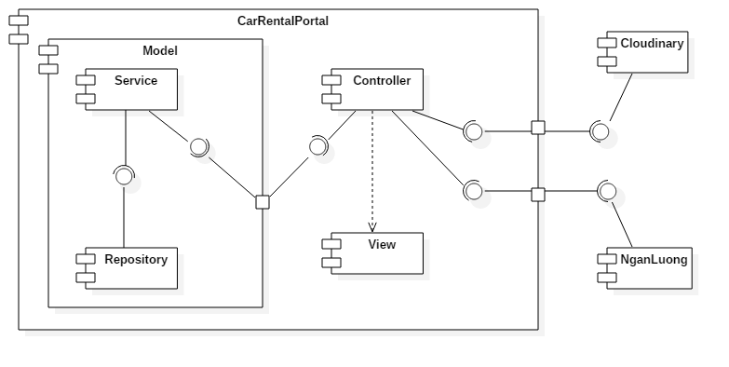

Figure 25 : Component diagram

|  |  |
| --- | --- |
| Component | Description |
| Controller | Represent all controllers in the system. |
| View | Represent all views in the system. |
| Model | Represent all models mapped by Entity Framework. |
| Repository | Are components that provide simple CRUD operations to interact with database. |
| Service | Are components that provide more complex, business-related operations, implemented using repository’s simple functionality. |
| Clodinary | Online file management solution |
| NganLuong | Online payment gateway |

Table 9: Component dictionary

## Detailed Description

### Class Diagram

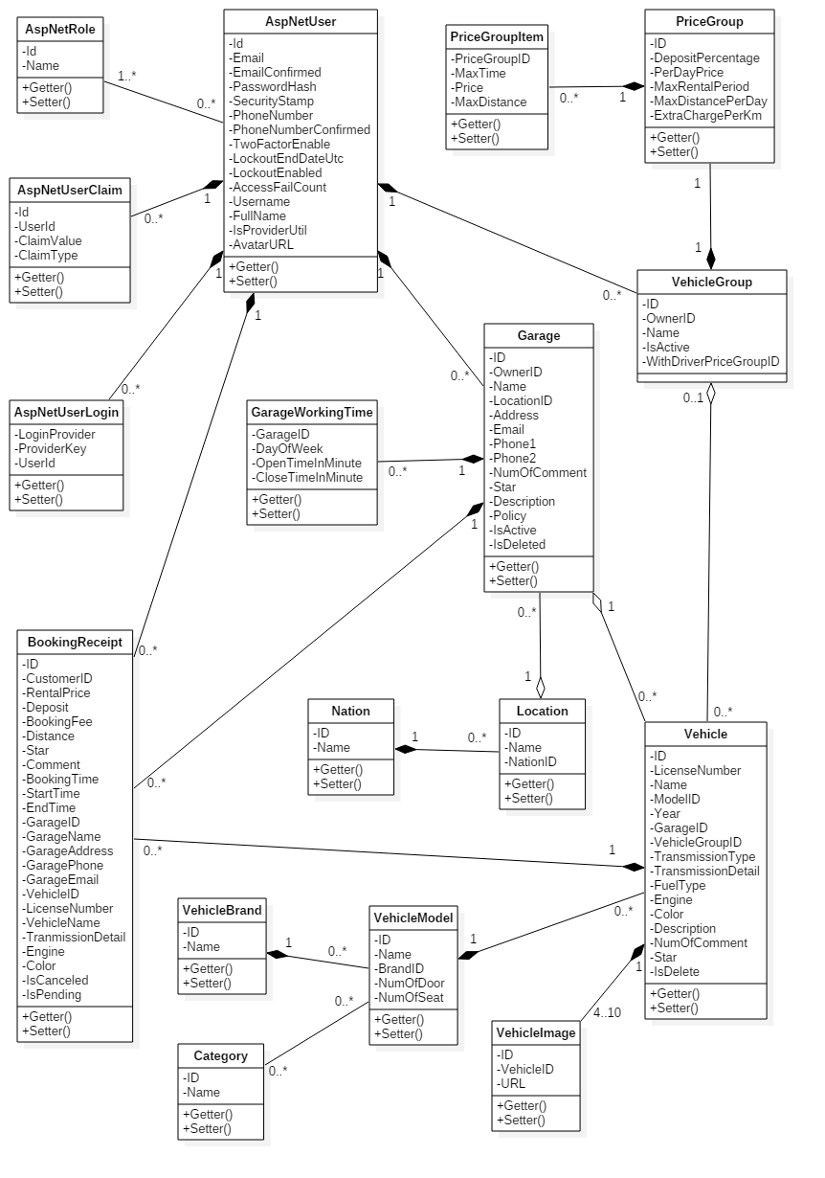

Figure 26: Class Diagram

|  |  |  |
| --- | --- | --- |
| Class dictionary | | |
| Class Name | **Mapping column with Conceptual diagram** | **Description** |
| AspNetUser | User | Generated by ASP.NET MVC5. Describe all user in system |
| AspNetRole | N/A | Generated by ASP.NET MVC5. Describe existing user’s roles in system. |
| AspNetUserClaim | N/A | Generated by ASP.NET MVC5. Describe all stored claims (Special attributes) of AspNetUsers. |
| AspNetUserLogin | N/A | Generated by ASP.NET MVC5. Describe information about 3rd party/external logins allowed for each AspNetUsers. |
| Vehicle | Vehicle | Describe all vehicles in system. |
| VehicleImage | VehicleImage | Describe all images of each vehicle. |
| VehicleModel | VehicleModel | Describe all vehicle models in system. |
| VehicleBrand | VehicleBrand | Describe all vehicle brands in system. |
| Category | Category | Describe all vehicle categories in system. |
| VehicleGroup | VehicleGroup | Describe all vehicle groups in system |
| PriceGroup | PriceGroup | Describe rental constraints (Pricing, travel distance…) of each VehicleGroup. |
| PriceGroupItem | PriceGroupItem | Describe detailed constraints for hourly rental options of each PriceGroup in system. |
| Garage | Garage | Describe all garages in system |
| GarageWorkingTime | GarageWorkingTime | Describe working time constraints of each Garage in system. |
| Location | Location | Describe all locations in system. |
| Nation | Nation | Describe all nations in system. |
| BookingReceipt | BookingReceipt | Describe all booking receipts in system. |

Table 10: Class dictionary

### Class Diagram Explanation

#### AspNetUser

|  |  |  |  |
| --- | --- | --- | --- |
| **Attribute** | **Type** | **Visibility** | **Description** |
| Id | String | Private | Unique identifier of AspNetUser. |
| Email | String | Private | Email of user. |
| EmailConfirmed | Boolean | Private | Status indicating whether email has been confirmed. |
| PasswordHash | String | Private | Encoded password of user. |
| SecurityStamp | String | Private | Stamp used to authenticate user’s cookies and session. |
| PhoneNumber | String | Private | Phone number of user. |
| PhoneNumberConfirmed | Boolean | Private | Status indicating whether phone number has been confirmed. |
| TwoFactorEnabled | Boolean | Private | Status indicating whether two-factor sign-in is enabled. |
| LockoutEndDateUtc | Nullable<DateTime> | Private | Date until which this user is locked out if lockoutEnable is true. |
| LockoutEnable | Boolean | Private | Status indicating whether lockout is enabled. |
| AccessFailedCount | Integer | Private | Number of failed access for this account. |
| UserName | String | Private | Username |
| FullName | String | Private | Full name of user |
| IsProviderUntil | Nullable<DateTime> | Private | Date until which this user has provider role. |
| AvatarURL | String | Private | URL of user’s avatar |

Table 11: AspNetUser class - Attributes

|  |  |  |  |
| --- | --- | --- | --- |
| **Method** | **Return type** | **Visibility** | **Description** |
| Getter | Attribute type | Public | Get value of attribute |
| Setter | Void | Public | Set value of attribute |

Table 12: AspNetUser class – Methods

#### AspNetRole

|  |  |  |  |
| --- | --- | --- | --- |
| **Attribute** | **Type** | **Visibility** | **Description** |
| Id | String | Private | Unique identifier of AspNetRole |
| Name | String | Private | Name of role |

Table 13: AspNetRole class - Attributes

|  |  |  |  |
| --- | --- | --- | --- |
| **Method** | **Return type** | **Visibility** | **Description** |
| Getter | Attribute type | Public | Get value of attribute |
| Setter | Void | Public | Set value of attribute |

Table 14: AspNetRole class - Methods

#### AspNetUserClaim

|  |  |  |  |
| --- | --- | --- | --- |
| **Attribute** | **Type** | **Visibility** | **Description** |
| Id | Integer | Private | Unique identifier of claim |
| UserId | String | Private | ID of AspNetUser whom this claim belongs to |
| ClaimType | Stirng | Private | Type of claim |
| ClaimValue | String | Private | Value of claim |

Table 15: AspNetUserClaim class - Attributes

|  |  |  |  |
| --- | --- | --- | --- |
| **Method** | **Return type** | **Visibility** | **Description** |
| Getter | Attribute type | Public | Get value of attribute |
| Setter | Void | Public | Set value of attribute |

Table 16: AspNetUserClaim class - Methods

#### AspNetUserLogin

|  |  |  |  |
| --- | --- | --- | --- |
| **Attribute** | **Type** | **Visibility** | **Description** |
| LoginProvider | String | Private | Name of third-party login provider |
| ProviderKey | String | Private | Login key of user provided by third-party service |
| UserId | String | Private | ID of AspNetUser who can log in using this login |

Table 17: AspNetUserLogin class - Attributes

|  |  |  |  |
| --- | --- | --- | --- |
| **Method** | **Return type** | **Visibility** | **Description** |
| Getter | Attribute type | Public | Get value of attribute |
| Setter | Void | Public | Set value of attribute |

Table 18: AspNetUserLogin class - Methods

#### Vehicle

|  |  |  |  |
| --- | --- | --- | --- |
| **Attribute** | **Type** | **Visibility** | **Description** |
| ID | String | Private | Unique identifier of vehicle |
| LicenseNumber | String | Private | License number of vehicle |
| Name | String | Private | Name of vehicle |
| ModelID | Integer | Private | Model of vehicle |
| Year | Integer | Private | Year in which this vehicle was produced |
| GarageID | Integer | Private | ID of Garage containing this vehicle |
| VehicleGroupID | Nullable<Integer> | Private | ID of VehicleGroup containing this vehicle |
| TransmissionType | Integer | Private | Transmission type of vehicle |
| TransmissionDetail | String | Private | Detailed description about transmisson of vehicle |
| FuelType | Nullable<Integer> | Private | Fuel type of vehicle |
| Engine | String | Private | Description about engine of vehicle |
| Color | Integer | Private | Color of vehicle |
| Description | String | Private | Description about vehicle |
| NumOfComment | Integer | Private | Number of customer’s feedback this vehicle has received |
| Star | Decimal | Private | Rating of vehicle |
| IsDeleted | Boolean | Private | Status indicating whether this vehicle was deleted |

Table 19: Vehicle class - Attributes

|  |  |  |  |
| --- | --- | --- | --- |
| **Method** | **Return type** | **Visibility** | **Description** |
| Getter | Attribute type | Public | Get value of attribute |
| Setter | Void | Public | Set value of attribute |

Table 20: Vehicle class - Methods

#### VehicleImage

|  |  |  |  |
| --- | --- | --- | --- |
| **Attribute** | **Type** | **Visibility** | **Description** |
| ID | String | Private | Unique identifier of image returned by cloudinary |
| VehicleID | Integer | Private | ID of Vehicle which this image belongs to |
| URL | String | Private | URL of image |

Table 21: VehicleImage class - Attributes

|  |  |  |  |
| --- | --- | --- | --- |
| **Method** | **Return type** | **Visibility** | **Description** |
| Getter | Attribute type | Public | Get value of attribute |
| Setter | Void | Public | Set value of attribute |

Table 22: VehicleImage class - Methods

#### VehicleModel

|  |  |  |  |
| --- | --- | --- | --- |
| **Attribute** | **Type** | **Visibility** | **Description** |
| ID | Integer | Private | Unique identifier of vehicle model |
| Name | String | Private | Name of role |
| BrandID | Integer | Private | ID of Brand of this model |
| NumOfDoor | Integer | Private | Number of door on this vehicle |
| NumOfSeat | Integer | Private | Number of seat in this vehicle |

Table 23: VehicleModel class - Attributes

|  |  |  |  |
| --- | --- | --- | --- |
| **Method** | **Return type** | **Visibility** | **Description** |
| Getter | Attribute type | Public | Get value of attribute |
| Setter | Void | Public | Set value of attribute |

Table 24: VehicleModel class - Methods

#### VehicleBrand

|  |  |  |  |
| --- | --- | --- | --- |
| **Attribute** | **Type** | **Visibility** | **Description** |
| ID | Integer | Private | Unique identifier of vehicle brand |
| Name | String | Private | Name of brand |

Table 25: VehicleBrand class - Attributes

|  |  |  |  |
| --- | --- | --- | --- |
| **Method** | **Return type** | **Visibility** | **Description** |
| Getter | Attribute type | Public | Get value of attribute |
| Setter | Void | Public | Set value of attribute |

Table 26: VehicleBrand class - Methods

#### Category

|  |  |  |  |
| --- | --- | --- | --- |
| **Attribute** | **Type** | **Visibility** | **Description** |
| ID | Integer | Private | Unique identifier of category |
| Name | String | Private | Name of category |

Table 27: VehicleBrand class - Attributes

|  |  |  |  |
| --- | --- | --- | --- |
| **Method** | **Return type** | **Visibility** | **Description** |
| Getter | Attribute type | Public | Get value of attribute |
| Setter | Void | Public | Set value of attribute |

Table 28: VehicleBrand class - Methods

#### Garage

|  |  |  |  |
| --- | --- | --- | --- |
| **Attribute** | **Type** | **Visibility** | **Description** |
| ID | Integer | Private | Unique identifier of garage |
| OwnerID | String | Private | ID of AspNetUser owing this garage |
| Name | String | Private | Name of garage |
| LocationID | Integer | Private | ID of Location of garage |
| Address | String | Private | Address of garage |
| Email | String | Private | Email of garage |
| Phone1 | String | Private | Primary phone number of garage |
| Phone2 | String | Private | Secondary phone number of garage |
| NumOfComment | Integer | Private | Number of customer’s feedback this garage has received |
| Star | Decimal | Private | Rating of garage |
| Description | String | Private | Description of garage |
| Policy | String | Private | Policy of garage |
| IsActive | Boolean | Private | Status indicating whether this garage is active. |
| IsDeleted | Boolean | Private | Status indicating whether this garage was deleted. |

Table 29: Garage class - Attributes

|  |  |  |  |
| --- | --- | --- | --- |
| **Method** | **Return type** | **Visibility** | **Description** |
| Getter | Attribute type | Public | Get value of attribute |
| Setter | Void | Public | Set value of attribute |

Table 30: Garage class - Methods

#### GarageWorkingTime

|  |  |  |  |
| --- | --- | --- | --- |
| **Attribute** | **Type** | **Visibility** | **Description** |
| GarageID | Integer | Private | ID of Garage which this working time constraint is applied to. |
| DayOfWeek | Integer | Private | Day of week which this working time constraint represents. |
| OpenTimeInMinute | Integer | Private | Opening time of this garare in this day of week. |
| CloseTimeInMinute | Integer | Private | Closing time of this garage in this day of week. |

Table 31: GarageWorkingTime class - Attributes

|  |  |  |  |
| --- | --- | --- | --- |
| **Method** | **Return type** | **Visibility** | **Description** |
| Getter | Attribute type | Public | Get value of attribute |
| Setter | Void | Public | Set value of attribute |

Table 32: GarageWorkingTime class - Methods

#### Location

|  |  |  |  |
| --- | --- | --- | --- |
| **Attribute** | **Type** | **Visibility** | **Description** |
| ID | Integer | Private | Unique identifier of location. |
| Name | String | Private | Name of location. |
| NationID | Integer | Private | ID of Nation to which this location belongs. |

Table 33: Location class - Attributes

|  |  |  |  |
| --- | --- | --- | --- |
| **Method** | **Return type** | **Visibility** | **Description** |
| Getter | Attribute type | Public | Get value of attribute |
| Setter | Void | Public | Set value of attribute |

Table 34: Location class - Methods

#### Nation

|  |  |  |  |
| --- | --- | --- | --- |
| **Attribute** | **Type** | **Visibility** | **Description** |
| ID | Integer | Private | Unique identifier of nation |
| Name | String | Private | Name of nation |

Table 35: Nation class - Attributes

|  |  |  |  |
| --- | --- | --- | --- |
| **Method** | **Return type** | **Visibility** | **Description** |
| Getter | Attribute type | Public | Get value of attribute |
| Setter | Void | Public | Set value of attribute |

Table 36: Nation class - Methods

#### VehicleGroup

|  |  |  |  |
| --- | --- | --- | --- |
| **Attribute** | **Type** | **Visibility** | **Description** |
| ID | Integer | Private | Unique identifier of vehicle group |
| OwnerID | String | Private | ID of AspNetUser whom this group belongs to |
| Name | String | Private | Name of group |
| IsActive | Boolean | Private | Status indicating whether this group is active |
| WithDriverPriceGroupID | Integer | Private | ID of default PriceGroup which is applied for driver-included rent. |

Table 37: VehicleGroup class - Attributes

|  |  |  |  |
| --- | --- | --- | --- |
| **Method** | **Return type** | **Visibility** | **Description** |
| Getter | Attribute type | Public | Get value of attribute |
| Setter | Void | Public | Set value of attribute |

Table 38: VehicleGroup class - Methods

#### PriceGroup

|  |  |  |  |
| --- | --- | --- | --- |
| **Attribute** | **Type** | **Visibility** | **Description** |
| ID | Integer | Private | Unique identifier of price group. |
| DepositPercentage | Decimal | Private | Percentage of total rental price which customer has to pay to provider when booking. |
| PerDayPrice | Double | Private | Pricing of daily rental. |
| MaxRentalPeriod | Nullable<Integer> | Private | Maximum days a rental can last. |
| MaxDistancePerDay | Nullable<Integer> | Private | Maximum km that customer can travel in 1 days without being charged extra fee with the rented vehicle. |
| ExtraChargePerKm | Nullable<Double> | Private | Extra fee for every 1 km outside allowed travel distance. |

Table 39: PriceGroup class - Attributes

|  |  |  |  |
| --- | --- | --- | --- |
| **Method** | **Return type** | **Visibility** | **Description** |
| Getter | Attribute type | Public | Get value of attribute |
| Setter | Void | Public | Set value of attribute |

Table 40: PriceGroup class - Methods

#### PriceGroupItem

|  |  |  |  |
| --- | --- | --- | --- |
| **Attribute** | **Type** | **Visibility** | **Description** |
| PriceGroupID | Integer | Private | ID of PriceGroup to which this hourly rental option belongs. |
| MaxTime | Integer | Private | Rental duration of this rental option. |
| Price | Double | Private | Rental price of this rental option. |
| MaxDistance | Integer | Private | Maximum km that customer can travel without being charged extra fee with the rented vehicle using this rental option. |

Table 41: PriceGroupItem class - Attributes

|  |  |  |  |
| --- | --- | --- | --- |
| **Method** | **Return type** | **Visibility** | **Description** |
| Getter | Attribute type | Public | Get value of attribute |
| Setter | Void | Public | Set value of attribute |

Table 42: PriceGroupItem class - Methods

#### BookingReceipt

|  |  |  |  |
| --- | --- | --- | --- |
| **Attribute** | **Type** | **Visibility** | **Description** |
| ID | Integer | Private | Unique identifier of receipt. |
| CustomerID | String | Private | ID of AspNetUser who is the customer of this receipt. |
| RentalPrice | Double | Private | Total rental price. |
| Deposit | Double | Private | Deposit paid by customer to provider when booking. |
| BookingFee | Double | Private | Fee paid by customer to system when booking. |
| Distance | Nullable<Integer> | Private | Maximum distance customer can travel without being charged extra fee with the rented vehicle. |
| Star | Nullable<Integer> | Private | Rating from customer for this rental period. |
| Comment | String | Private | Feedback from customer about this rental reriod. |
| BookingTime | DateTime | Private | Time when this booking is made. |
| StartTime | DateTime | Private | Time when rental period starts. |
| EndTime | DateTime | Private | Time when rental period ends. |
| GarageID | Integer | Private | ID of Garage to which this booking belongs. |
| GarageName | String | Private | Name of Garage at booking moment. |
| GarageAddress | String | Private | Address of Garage at booking moment. |
| GaragePhone | String | Private | Phone1 of Garage at booking moment. |
| GarageEmail | String | Private | Email of Garage at booking moment. |
| VehicleID | Integer | Private | ID of booked Vehicle. |
| LicenseNumber | String | Private | License number of Vehicle at booking moment. |
| VehicleName | String | Private | Name of Vehicle at booking moment. |
| TransmissionDetail | String | Private | TransmissionDetail of Vehicle at booking moment. |
| Engine | String | Private | Engine of Vehicle at booking moment. |
| Color | Integer | Private | Color of Vehicle at booking moment. |
| IsCanceled | Boolean | Private | Status indicating whether this booking has been canceled. |
| IsPending | Boolean | Private | Status indicating whether this booking has not been paid. |

Table 43: BookingReceipt class - Attributes

|  |  |  |  |
| --- | --- | --- | --- |
| **Method** | **Return type** | **Visibility** | **Description** |
| Getter | Attribute type | Public | Get value of attribute |
| Setter | Void | Public | Set value of attribute |

Table 44: BookingReceipt class - Methods

### Interactive Diagram

#### Common

##### Search vehicle

**Summary:** This diagram illustrates the process of searching vehicle

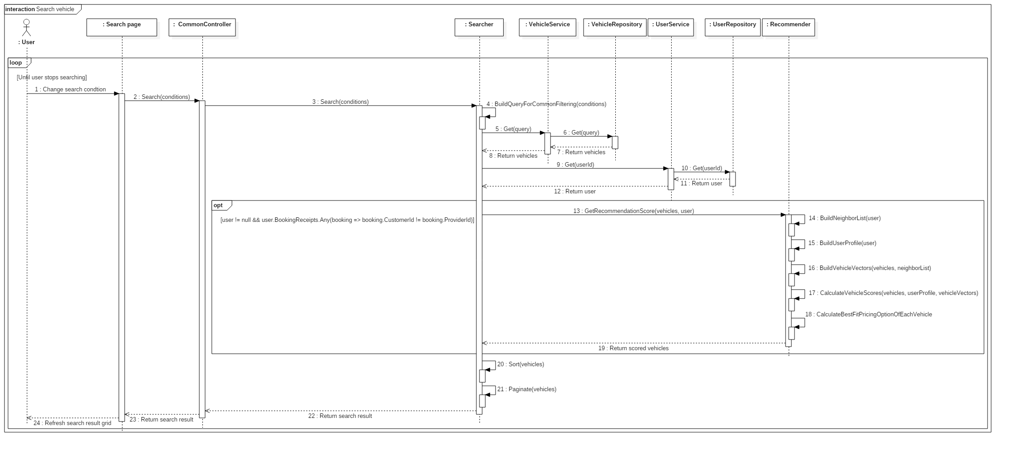

Figure 27: Search vehicle sequence

##### Register/extend providership

**Summary:** This diagram illustrates the process of registering providership of customer or extending providership of provider.

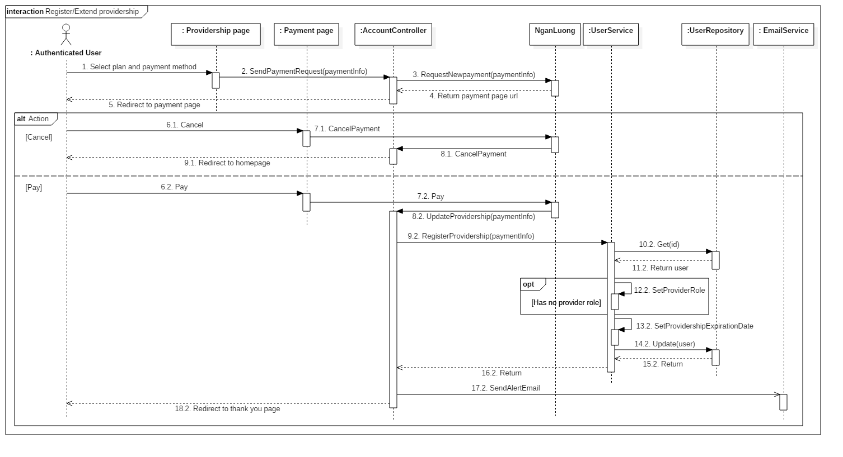

Figure 28: Register/extend providership sequence

#### Customer

##### Book vehicle

**Summary**: This diagram illustrates the process allowing customer to book a vehicle.

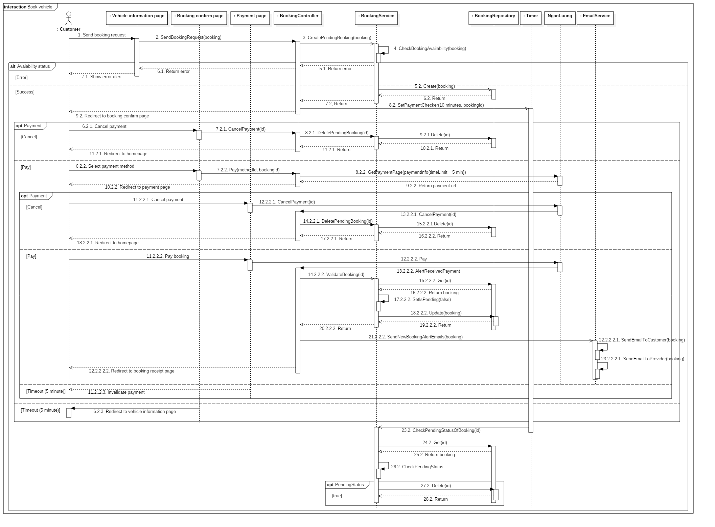

Figure 29: Book vehicle sequence

##### Comment and rate booking

**Summary**: This diagram illustrates the process allowing customer to comment and rate about their rental experience.

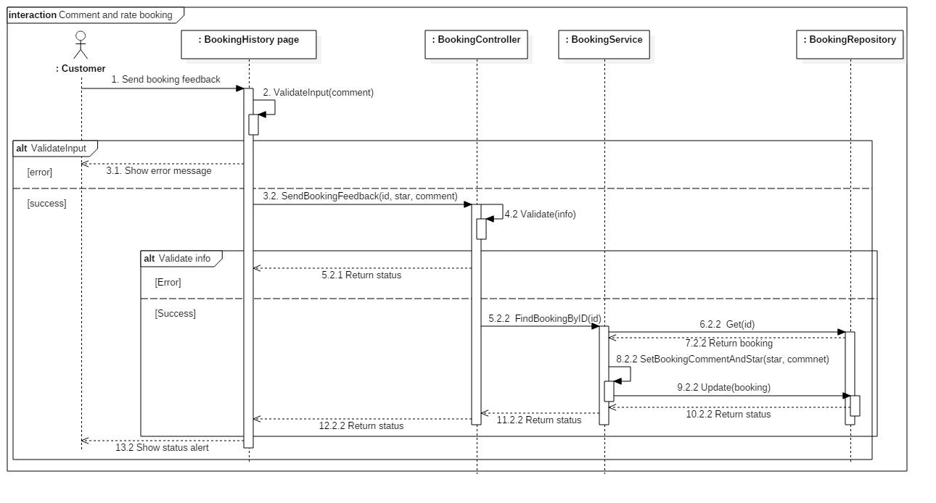

Figure 30: Comment and rate booking sequence

##### Cancel booking

**Summary**: This diagram illustrates the process allowing customer to cancel a booking.

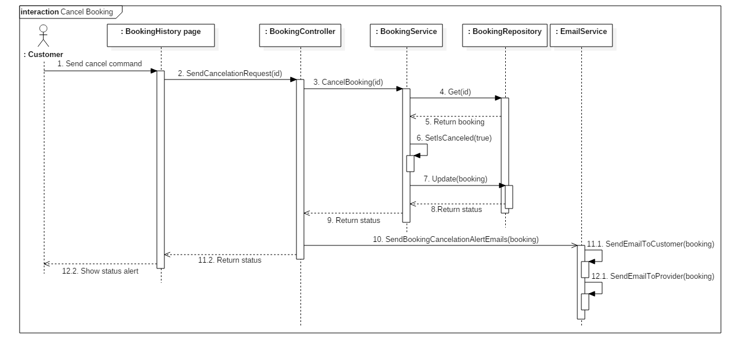

Figure 31: Cancel booking sequence

#### Provider

##### Create vehicle

**Summary**: This diagram illustrates the process allowing provider to create a new vehicle.

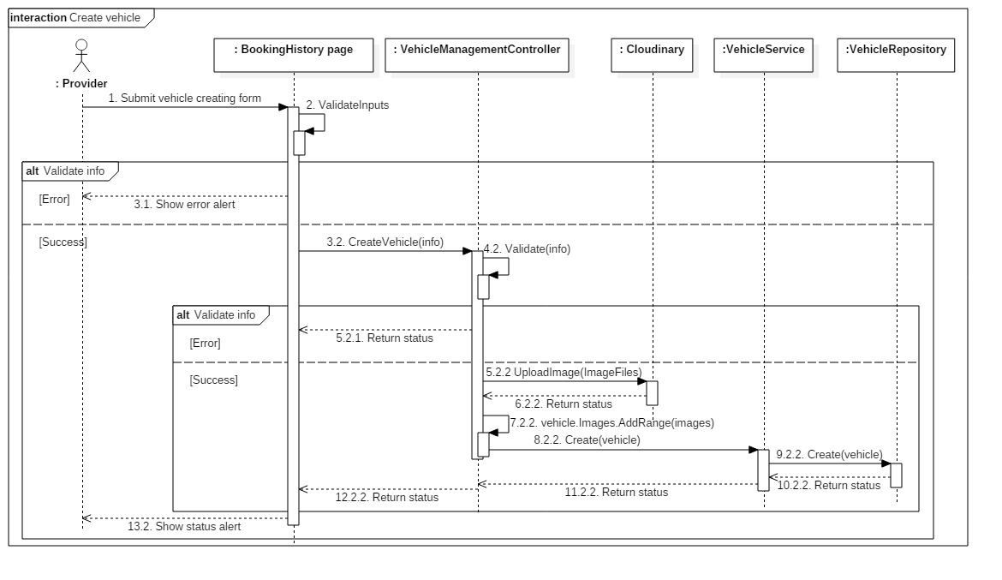

Figure 32: Create vehicle sequence

##### Edit vehicle

**Summary**: This diagram illustrates the process allowing provider to edit a vehicle.

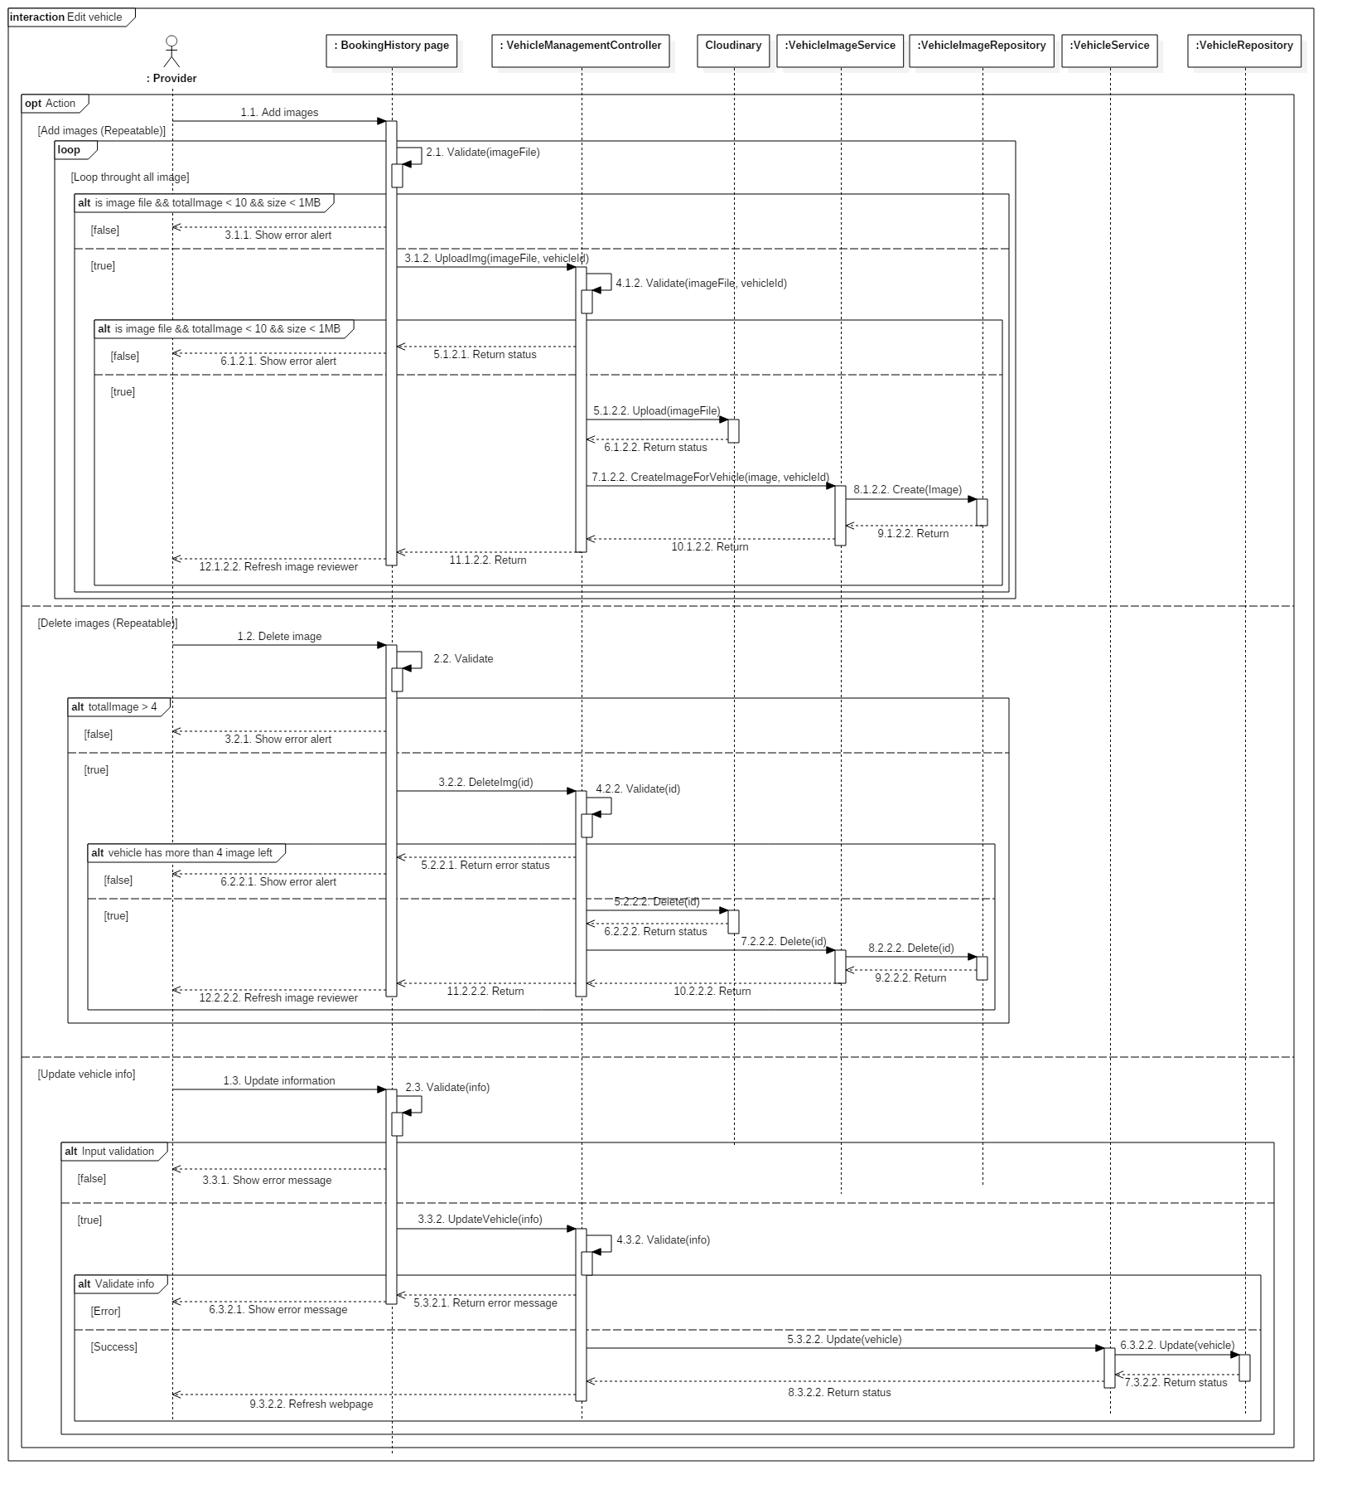

Figure 33: Edit vehicle sequence

##### Create garage

**Summary**: This diagram illustrates the process allowing provider to create a new garage.

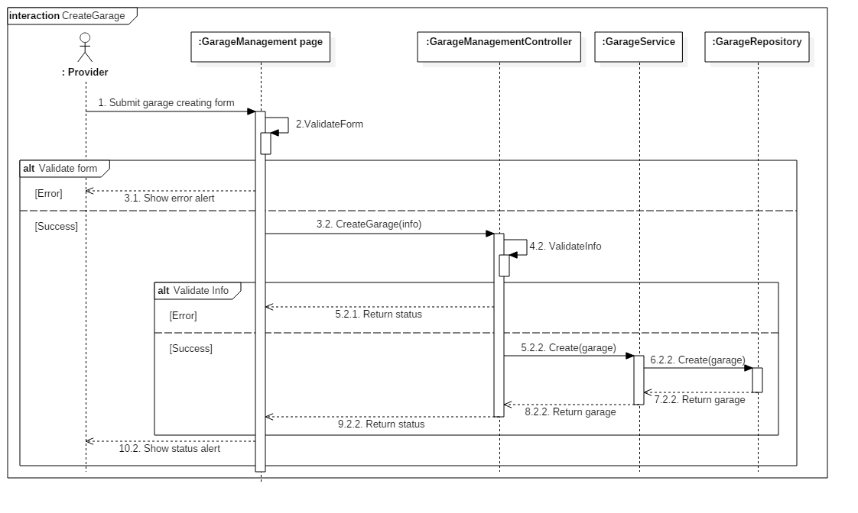

Figure 34: Create garage sequence

##### Edit garage

**Summary**: This diagram illustrates the process allowing customer to edit a garage.

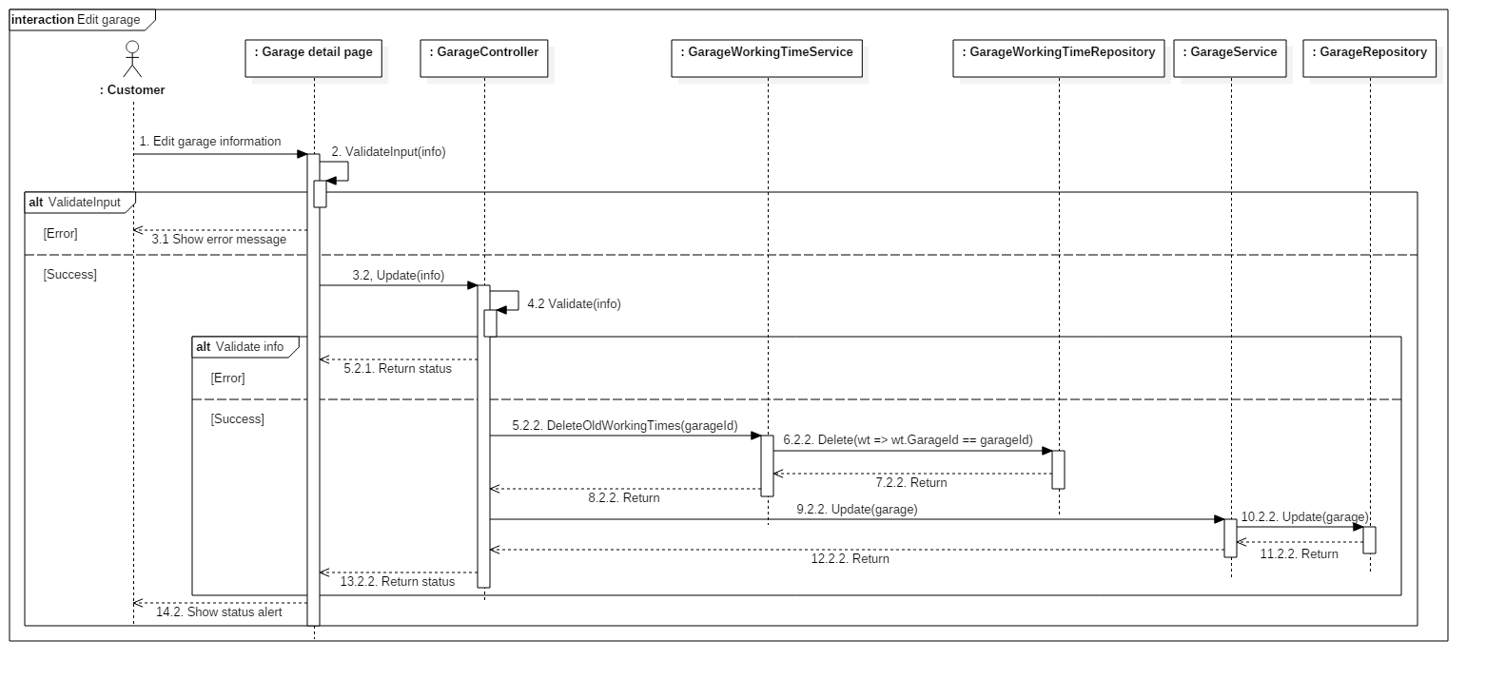

Figure 35: Edit garage

##### Create vehicle group

**Summary**: This diagram illustrates the process allowing provider to create a new vehicle group.

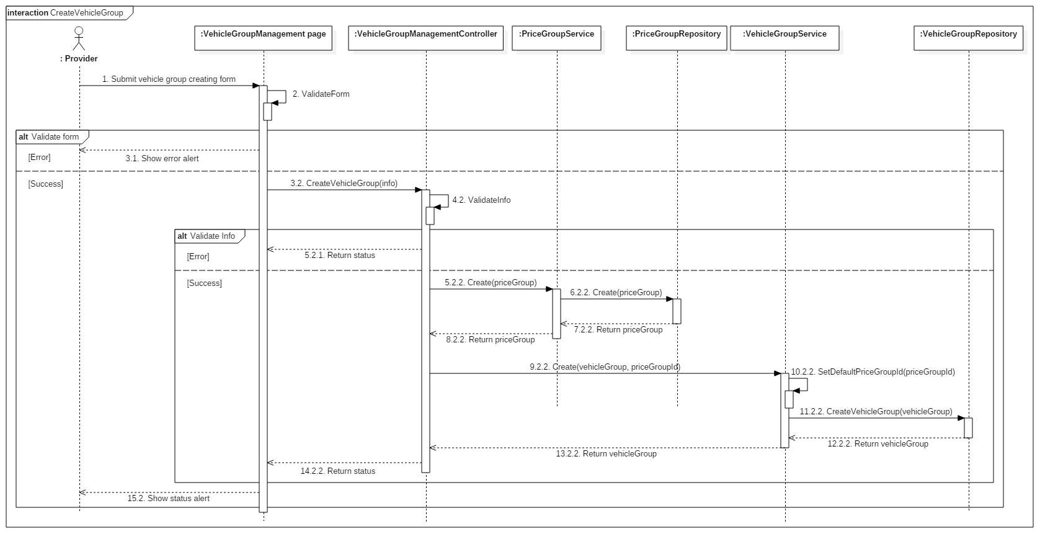

Figure 36: Create vehicle group sequence

##### Edit vehicle group

**Summary**: This diagram illustrates the process allowing provider to edit a vehicle group.

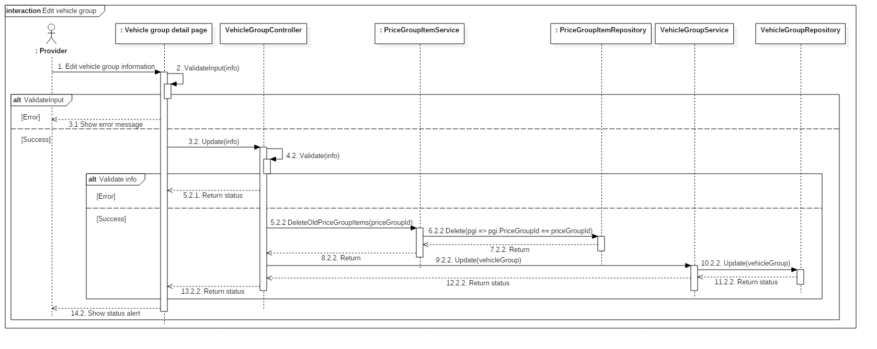

Figure 37: Edit vehicle group

#### System

##### Check providership expiration

**Summary**: This diagram illustrates the process allowing the system to warn provider about their almost expired providership and to expirate their providership.

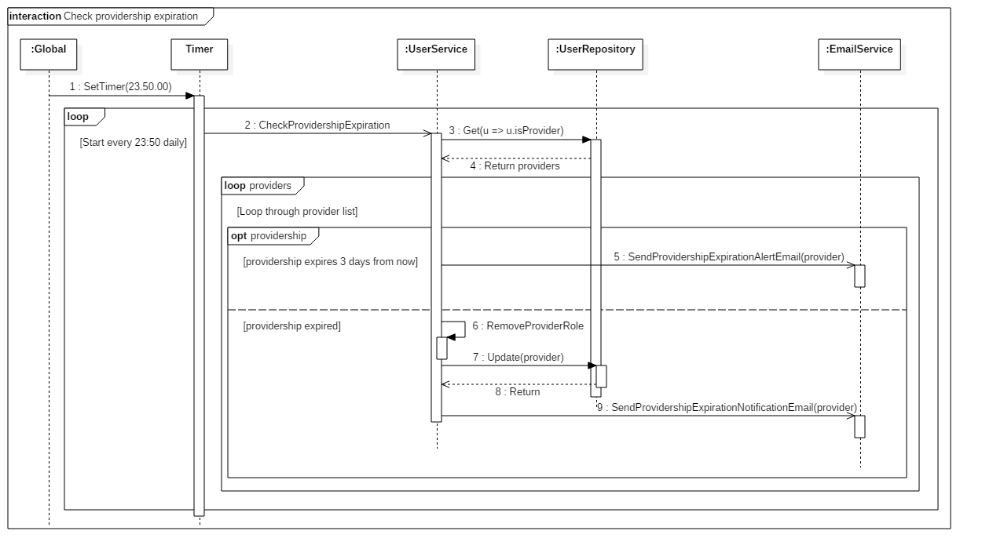

Figure 38: Check providership expiration sequence

## User Interface Design

### Login page <Excluded>

### Home page <Excluded>

### Advanced search page

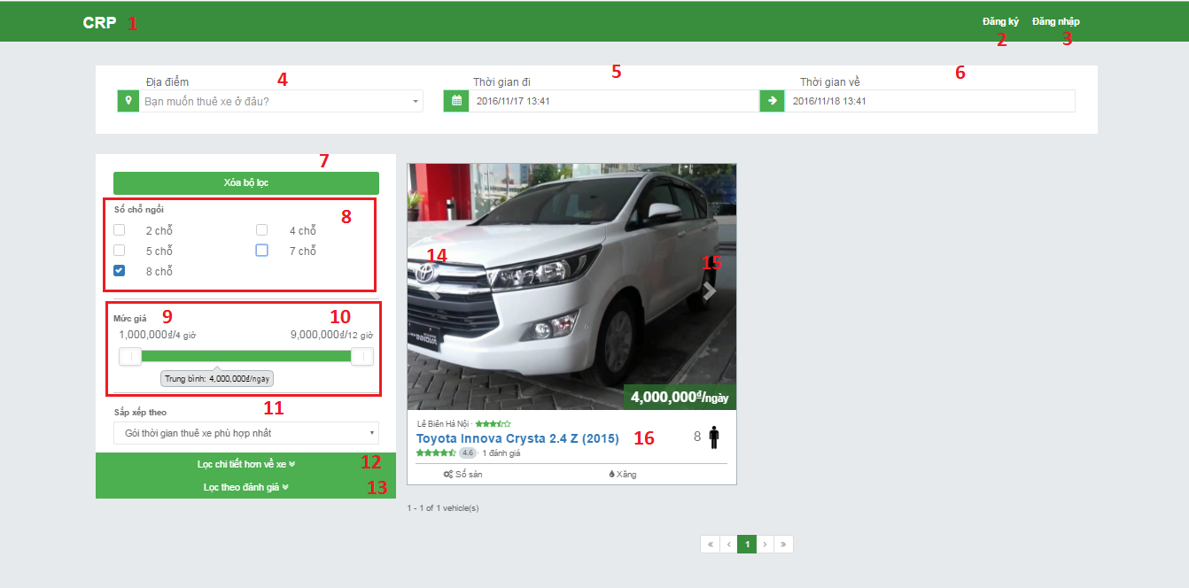

Figure 39 : Advanced search page UI design

**Fields**

|  |  |  |  |  |  |  |
| --- | --- | --- | --- | --- | --- | --- |
| No | Field Name | Description | Read Only | Mandatory | Control Type | Data Type |
| 4 | location | Choose rent location | Yes | No | Dropdownlist | String |
| 5 | startTime | Choose start rent time | Yes | No | DateTimePicker | String |
| 6 | endTime | Choose end rent time | Yes | No | DateTimePicker | String |
| 8 | Seats | Choose how many seats for wanted vehicle | Yes | No | Combobox | String |
| 9 | leftSlider | Pull to higher the min price for search | Yes | No | Slider | String |
| 10 | rightSlider | Pull to lower the max price for search | Yes | No | Slider | String |
| 11 | Sort | Choose ways to show result | Yes | No | Dropdownlist | String |

**Buttons/Hyperlinks**

|  |  |  |  |  |
| --- | --- | --- | --- | --- |
| No | Function | Description | Validation | Outcome |
| 1 | logoButton | Clicks to go to homepage | N/A | Homepage |
| 2 | signUp | Clicks to sign up | N/A | Register page |
| 3 | logIn | Clicks to login | N/A | Login page |
| 7 | resetFilters | Clicks to reset filters | N/A | Clear all input user did |
| 12 | additionFilter | Clicks to show more addition search | N/A | Show search by brand, year, transaction type, fuel type, vehicle type, color |
| 13 | ratingFilter | Clicks to show search by rating of vehicle and garage | N/A | Show search by rating of vehicle and garage |
| 14 | leftArrow | Clicks to show image on the left side | N/A | Show image on the left side |
| 15 | rightArrow | Clicks to show image on the right side | N/A | Show image on the right side |
| 16 | vehicleName | Clicks to show vehicle information and booking | N/A | Show vehicle info page |

### Vehicle Information page

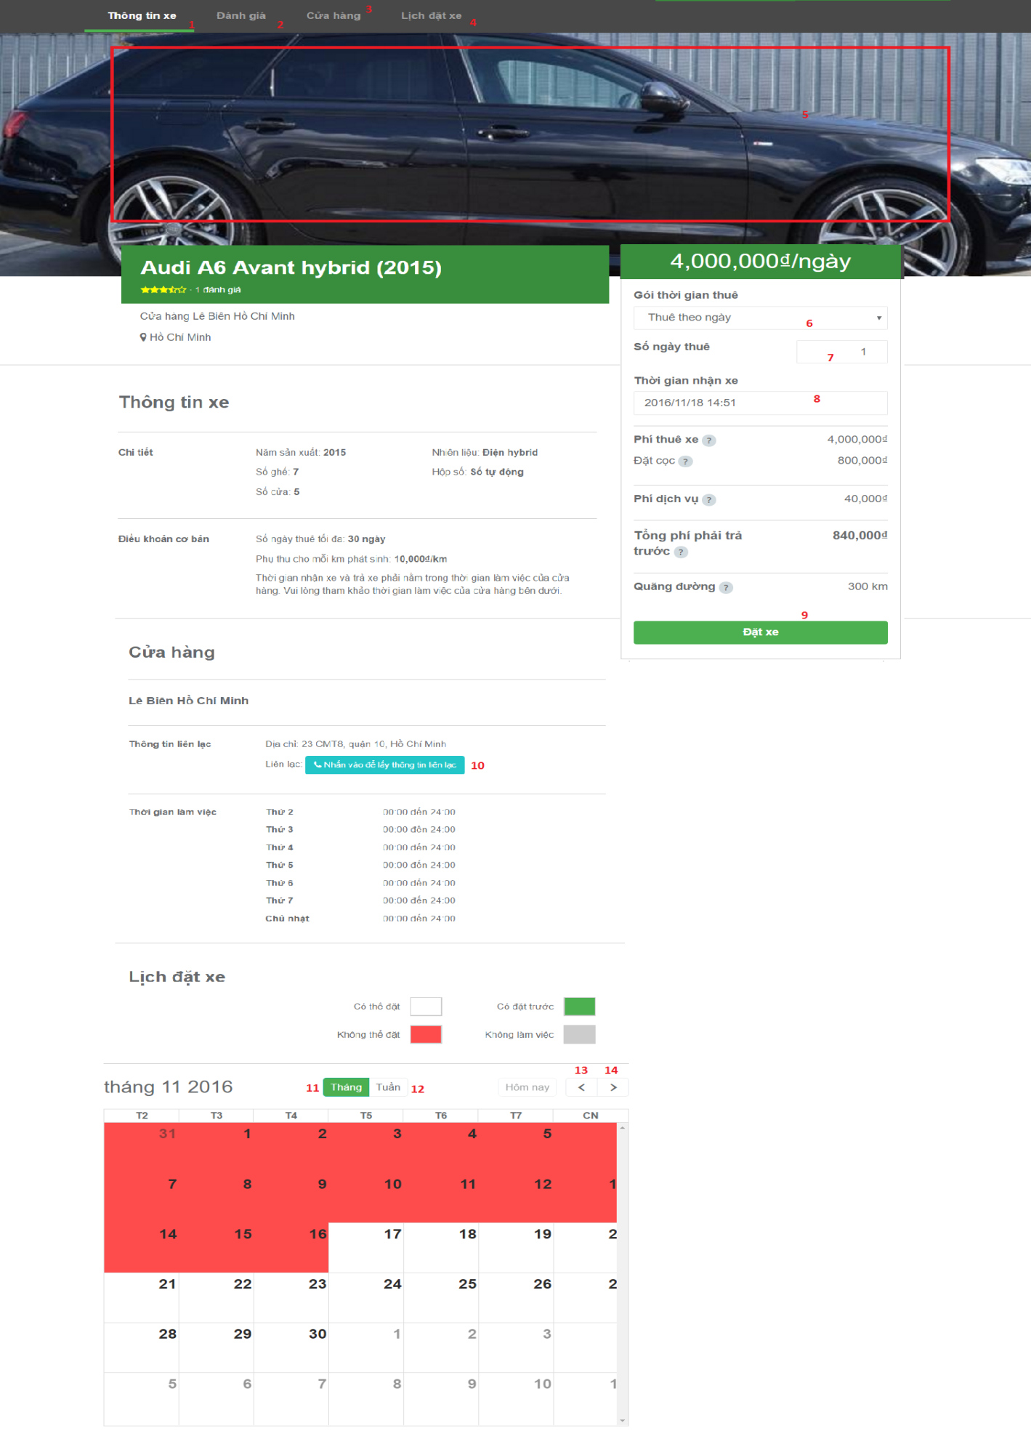

Figure 40 : Vehicle information page UI design

**Fields**

|  |  |  |  |  |  |  |
| --- | --- | --- | --- | --- | --- | --- |
| No | Field Name | Description | Read Only | Mandatory | Control Type | Data Type |
| 6 | Type rent vehicle | Choose type rent vehicle, such as day or hour | Yes | Yes | Drop down list | String |
| 7 | Number day/hour for rent | Input time will rent vehicle | No | Yes | Text box | Number |
| 8 | Date will pick up vehicle | Input date and time will pick up vehicle | No | Yes | Text Box | Date time |

**Buttons/Hyperlinks:**

|  |  |  |  |  |
| --- | --- | --- | --- | --- |
| No | Function | Description | Validation | Outcome |
| 1 | Moving main screen view to information of vehicle area | Main screen view switch to information of vehicle area. | N/A | Main screen view switch to information of vehicle area. |
| 2 | Moving main screen view to comment area | Main screen view to comment area. | N/A | Main screen view to comment area. |
| 3 | Moving main screen view to garage area | Main screen view to garage area. | N/A | Main screen view to garage area. |
| 4 | Moving main screen view to booking history area | Main screen view to booking history area. | N/A | Main screen view to booking history area. |
| 5 | View images of vehicle | View all images of vehicle | N/A | Show all images of vehicle |
| 9 | Booking request command | Send booking information to controller | N/A | Redirect to booking confirm page. |
| 10 | Show information of garage in detail | Show information of garage | N/A | Show pop up information of garage |
| 11 | Filter calendar view with month | Calendar of booking will represented by month | N/A | Calendar of booking will represented by month |
| 12 | Filter calendar view with week | Calendar of booking will represented by week | N/A | Calendar of booking will represented by week |
| 9 | Show Previous data of Calendar | Show previous data of calendar | N/A | Show previous data of calendar |
| 11 | Show Next data of Calendar | Show next data of calendar record of table | N/A | Show next data of calendar |

### Booking confirmation page

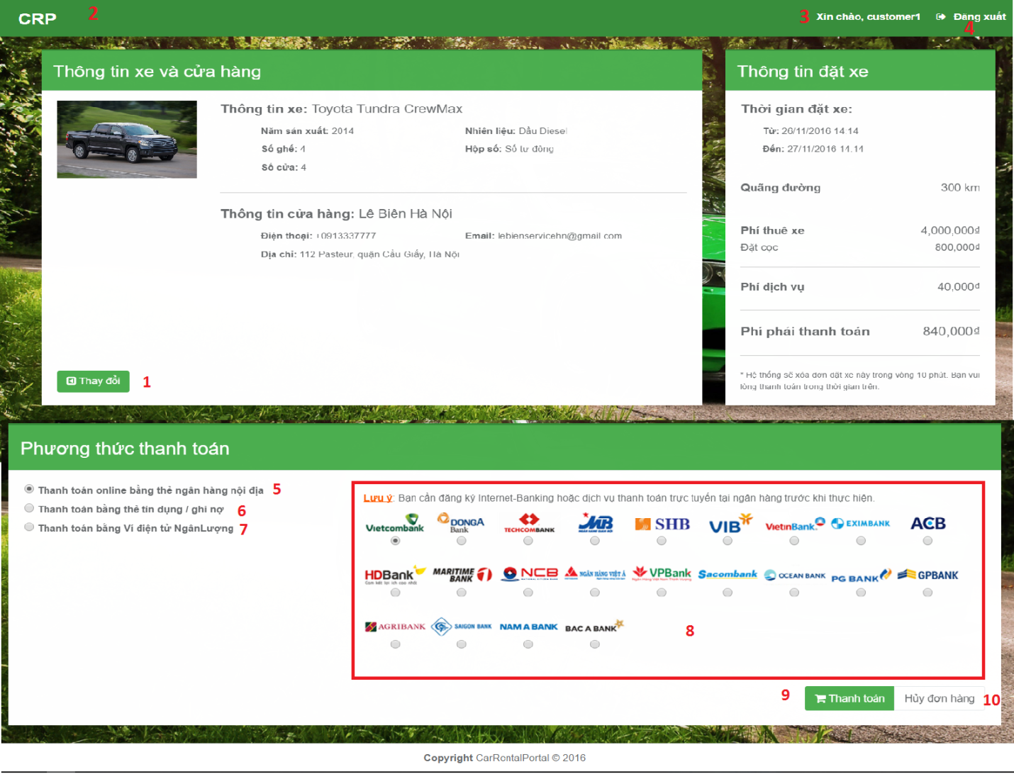

Figure 41 : Booking confirmation page UI design

**Fields**

|  |  |  |  |  |  |  |  |
| --- | --- | --- | --- | --- | --- | --- | --- |
| No. | Field name | Description | Read only | Mandatory | Control type | Data type | Length |
| 8 | Name of Bank | Allow user choose bank which want to payment. | No | Yes | Radio button group | String | N/A |

**Buttons/Hyperlinks**

|  |  |  |  |  |
| --- | --- | --- | --- | --- |
| No. | Function | Description | Validation | Outcome |
| 1 | Change booking’s information | Click “Thay đổi” button to back vehicle’s information. | N/A | Redirect to view vehicle’s information page. |
| 2 | Redirect to homepage | Click “CRP” icon to redirect to homepage. | N/A | Redirect to homepage. |
| 3 | Redirect to manager personal information | Click “Xin chào” to come manage personal information | N/A | Redirect to manage personal information page. |
| 4 | Log out | Click “Đăng xuất” button to delete session and redirect to homepage. | N/A | Delete session then redirect to homepage. |
| 5 | Online payment type | Choose radio button belong to online payment. | N/A | Show banks for online payment. |
| 6 | Credit card payment type | Choose radio button belong to credit card payment. | N/A | Show banks for credit card payment. |
| 7 | Digital wallet payment type | Choose radio button belong to digital wallet payment. | N/A | Show banks for credit digital wallet payment. |
| 9 | Pay | Click “Pay” to redirect “Ngân lượng” page. | N/A | Redirect to “Ngân lượng” website. |
| 10 | Cancel payment | Click “Hủy đơn hàng” to cancel payment. | N/A | Redirect to “Homepage”. |

### Booking history page

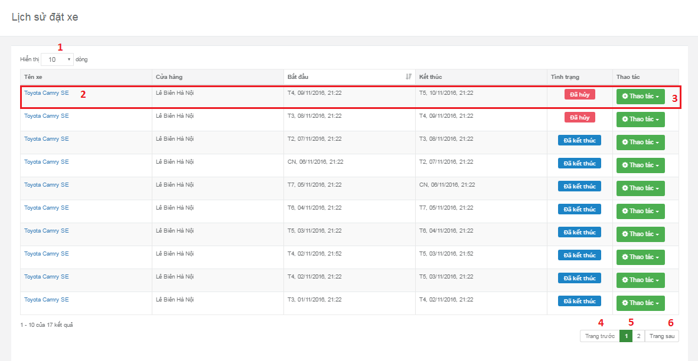

Figure 42 : Booking history page UI design

**Fields**

|  |  |  |  |  |  |  |
| --- | --- | --- | --- | --- | --- | --- |
| No | Field Name | Description | Read Only | Mandatory | Control Type | Data Type |
| 1 | numberOfDataShow | List of how many result user want to see in table | No | No | Dropdownlist | Integer |

**Buttons/Hyperlinks**

|  |  |  |  |  |
| --- | --- | --- | --- | --- |
| No | Function | Description | Validation | Outcome |
| 2 | linkToVehicleDetail | Go to vehicle detail page | N/A | Go to vehicle detail page |
| 3 | showOptionUserCanDoToVehicle | Show option user can choose: detail information, rating, cancel booking | User can’t rate rated vehicle or cancel book ended booking | Show option user can choose: detail information, rating, cancel booking |
| 4 | previousButton | Show previous data page | N/A | Show previous data page |
| 5 | numberPage | Clicks to show data in choose page | N/A | Show data in choose page |
| 6 | nextButton | Show next page | N/A | Show next data page |

#### Booking receipt’s details popup <Excluded>

#### Feedback popup <Excluded>

### Become provider page

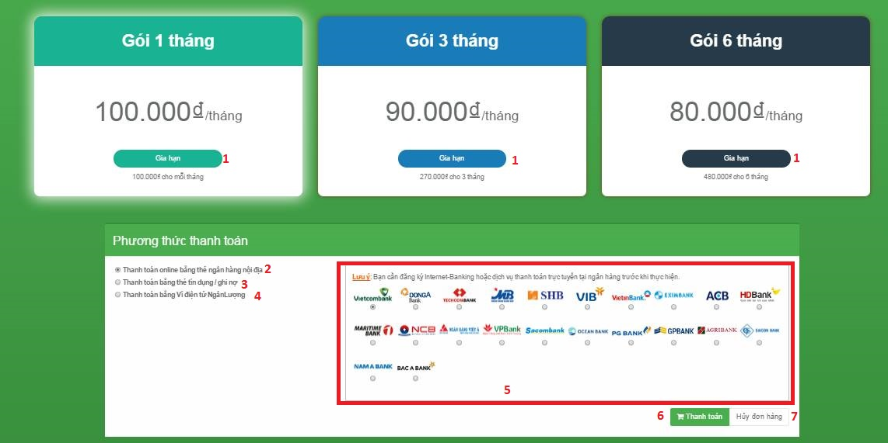

Figure 43 : Become provider page UI design

**Fields**

|  |  |  |  |  |  |  |  |
| --- | --- | --- | --- | --- | --- | --- | --- |
| No. | Field name | Description | Read only | Mandatory | Control type | Data type | Length |
| 5 | Name of Bank | Allow user choose bank which want to payment. | No | Yes | Area radio button | String | N/A |

**Buttons/Hyperlinks**

|  |  |  |  |  |
| --- | --- | --- | --- | --- |
| No. | Function | Description | Validation | Outcome |
| 1 | Choose type price which want to payment | Show payment methods pop up if click any “Gia hạn” button. | N/A | Show payment methods pop up. |
| 2 | Online payment type | Choose radio button belong to online payment. | N/A | Show banks for online payment. |
| 3 | Credit card payment type | Choose radio button belong to credit card payment. | N/A | Show banks for credit card payment. |
| 4 | Digital wallet payment type | Choose radio button belong to digital wallet payment. | N/A | Show banks for credit digital wallet payment. |
| 6 | Pay | Click “Pay” to redirect “Ngân lượng” page. | N/A | Redirect to “Ngân lượng” website. |
| 7 | Cancel payment | Click “Hủy đơn hàng” to cancel payment. | N/A | Redirect to “Homepage”. |

### Manage vehicle page

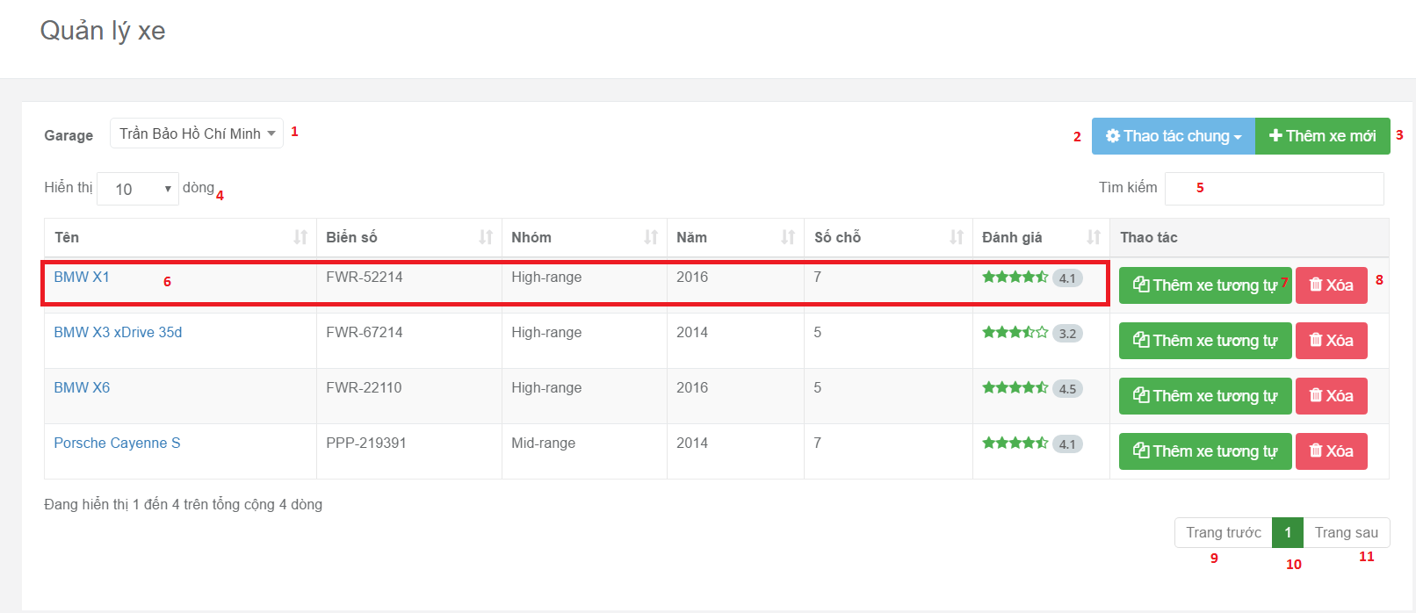

Figure 44 : Manage vehicle page UI design

**Fields**

|  |  |  |  |  |  |  |
| --- | --- | --- | --- | --- | --- | --- |
| No | Field Name | Description | Read Only | Mandatory | Control Type | Data Type |
| 1 | Garage name | Filter vehicle belong to garage | Yes | No | Dropdown | String |
| 2 | Number record in data table | Filter number record be showed in data table | Yes | No | Dropdown | Number |
| 5 | Key search | Filter vehicle belong to key word | No | No | Text Box | String |
| 6 | Specific Record Content | Contain all fields of specific record | Yes | No | Text Box | String |
| 10 | Current Page Of Table | Current page of table | Yes | No | Text Box | String |

**Buttons/Hyperlinks**

|  |  |  |  |  |
| --- | --- | --- | --- | --- |
| No | Function | Description | Validation | Outcome |
| 2 | Move vehicles to another group or garage. | Show pop up for move vehicles to another. | N/A | Show pop up with 2 action is move to another group or garage. |
| 3 | Create new vehicle | Show pop up for require fields to create a new vehicle | N/A | Show require input field to create a new vehicle. |
| 6 | View detail vehicle’s information | Redirect vehicle detail page | N/A | Show information of vehicle. |
| 7 | Duplicate vehicle | Create new vehicle with same information. | N/A | Create new vehicle faster |
| 8 | Delete vehicle | Delete vehicle | N/A | Show pop up confirm then delete vehicle |
| 9 | Show Previous Record Of Table | Show previous record of table | N/A | Show previous record of table |
| 11 | Show Next Record Of Table | Show next record of table | N/A | Show next record of table |

#### Create new vehicle popup

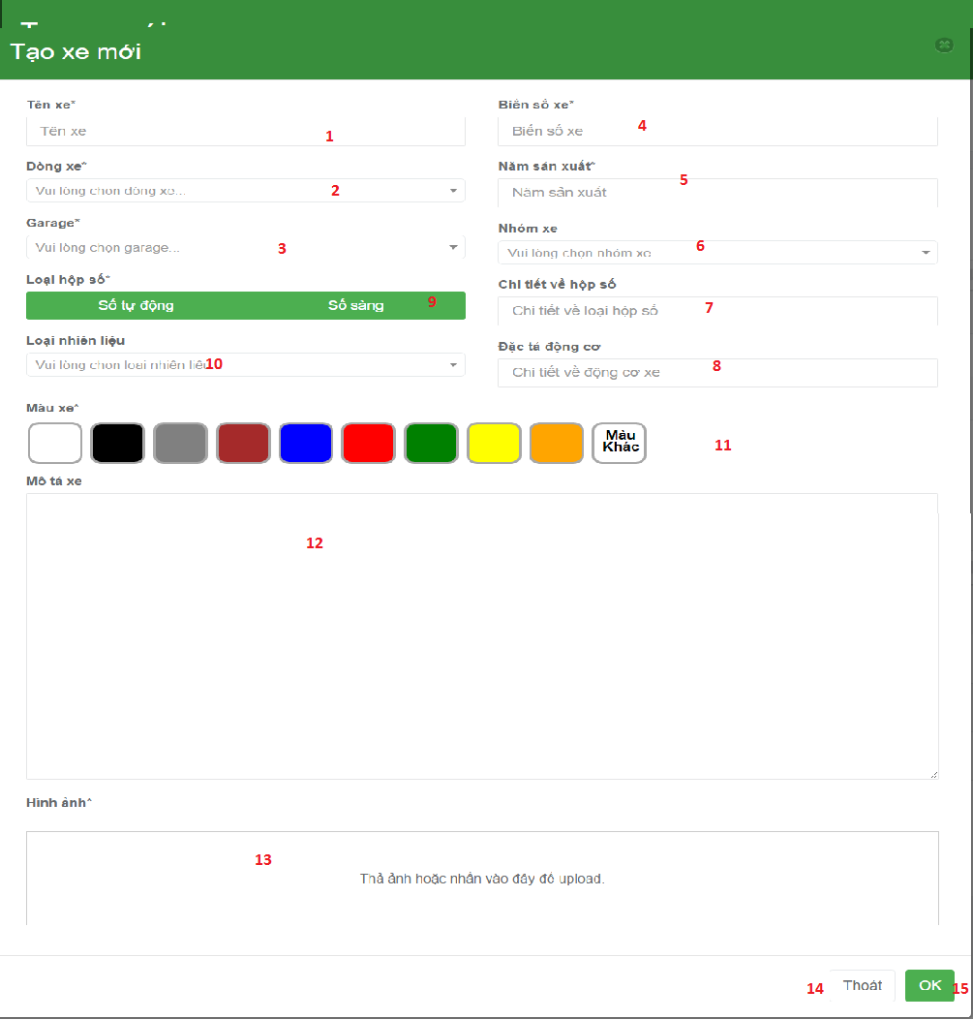

Figure 45 : Create new vehicle popup UI design

**Fields**

|  |  |  |  |  |  |  |
| --- | --- | --- | --- | --- | --- | --- |
| No | Field Name | Description | Read Only | Mandatory | Control Type | Data Type |
| 1 | Vehicle name | Allow user input name of vehicle | No | Yes | Tex box | String |
| 2 | Model of vehicle | Allow user choose model of car. | No | Yes | Dropdown | String |
| 3 | Garage of vehicle | Allow user choose garage of vehicle | No | Yes | Dropdown | String |
| 4 | License number of vehicle | Input license number of vehicle | No | Yes | Text Box | String |
| 5 | Year produced of vehicle | Input year of vehicle | No | Yes | Text Box | Number |
| 6 | Vehicle group | Choose vehicle group | Yes | No | Drop down | String |
| 7 | Transition type detail | Input transition type detail | No | No | Text box | String |
| 8 | Engine detail | Input engine detail | No | No | Text box | String |
| 9 | Transition type | Choose transition type | Yes | Yes | Radio button | String |
| 10 | Fuel type | Choose fuel type | Yes | Yes | Drop down | String |
| 11 | Color | Choose color of vehicle | Yes | Yes | Radio button | String |
| 12 | Description | Input description for vehicle | No | No | Text are | String |
| 13 | Images | Input images of vehicle | Yes | Yes | Dropzone | File |

**Buttons/Hyperlinks**

|  |  |  |  |  |
| --- | --- | --- | --- | --- |
| No | Function | Description | Validation | Outcome |
| 14 | Cancel create new vehicle | Close pop up and cancel command | N/A | Pop up will be hided. |
| 15 | OK | Send command create new vehicle to controler | N/A | Create a new vehicle |

### Vehicle detail page

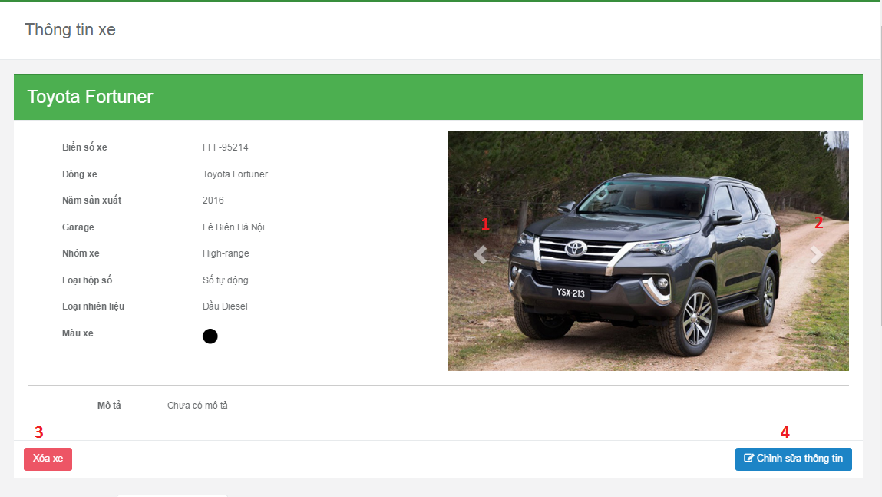

Figure 46 : Vehicle detail page UI design

**Buttons/Hyperlinks**

|  |  |  |  |  |
| --- | --- | --- | --- | --- |
| No | Function | Description | Validation | Outcome |
| 1 | leftArrow | Clicks to show image on the left side | N/A | Show image on the left side |
| 2 | rightArrow | Clicks to show image on the right side | N/A | Show image on the right side |
| 3 | deleteVehicle | Clicks to delete vehicle | N/A | Show delete vehicle confirm popup |
| 4 | editVehicleInfo | Clicks to edit vehicle information | N/A | Show edit field top edit. |

#### Edit vehicle information

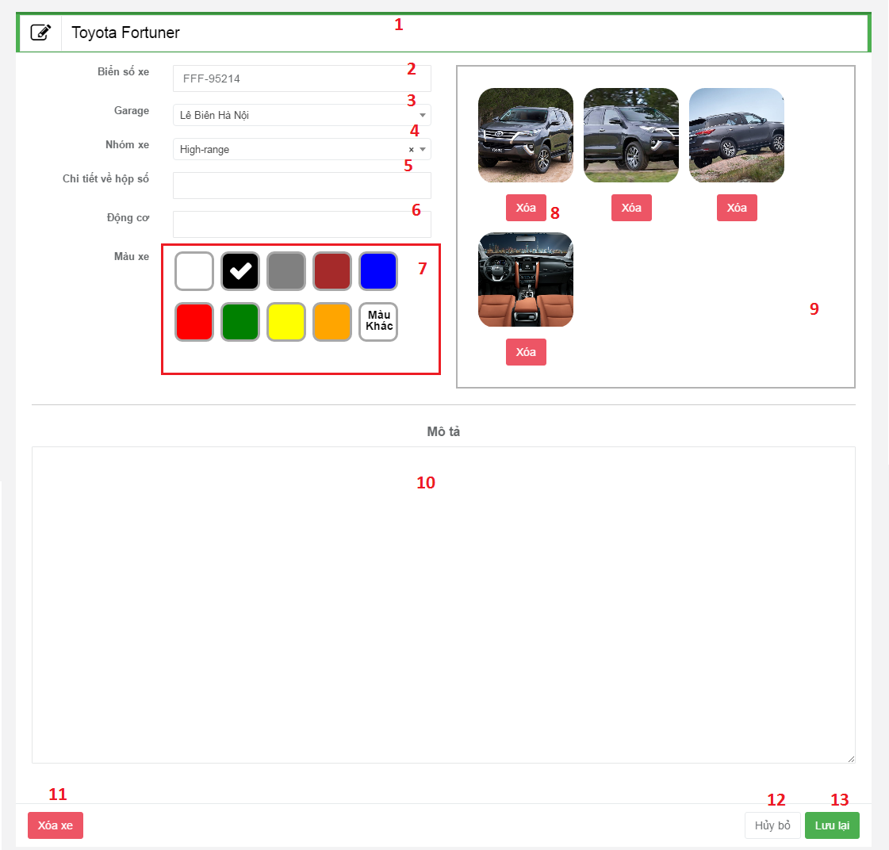

Figure 47 : Edit vehicle information UI design

**Fields**

|  |  |  |  |  |  |  |
| --- | --- | --- | --- | --- | --- | --- |
| No | Field Name | Description | Read Only | Mandatory | Control Type | Data Type |
| 1 | vehicleNameField | Input vehicle name | No | No | Textbox | String |
| 2 | licenseNumber | Input license number | No | No | Textbox | String |
| 3 | garageList | Choose garage that vehicle belong | Yes | No | Dropdownlist | String |
| 4 | vehicleGroupList | Choose vehicle group that vehicle belong | Yes | No | Dropdownlist | String |
| 5 | transitionTypeDetail | Input more information of the vehicle transition type detail | No | No | Richtextbox | String |
| 6 | Engine | Input engine of the vehicle | No | No | Textbox | String |
| 7 | Color | Choose vehicle’s color | Yes | No | Radio button | String |
| 10 | Description | Input description of the vehicle | Yes | No | Richtextbox | String |

**Buttons/Hyperlinks**

|  |  |  |  |  |
| --- | --- | --- | --- | --- |
| No | Function | Description | Validation | Outcome |
| 8 | deleteImage | Delete vehicle’s image | Can’t delete when current pictures less than 4 | Show the remain image |
| 9 | uploadImage | Choose new images to upload | Can’t upload more than 10 pictures | Show explorer where user can choose image from their computer |
| 11 | deleteVehicle | Clicks to delete this vehicle | N/A | Show delete vehicle confirm popup |
| 12 | cancelButton | Clicks to cancel edit view | N/A | Show back vehicle information |
| 13 | saveButton | Clicks to save the change user make to the vehicle | Validate all require field | Refresh current page to show new information |

### Manage booking page

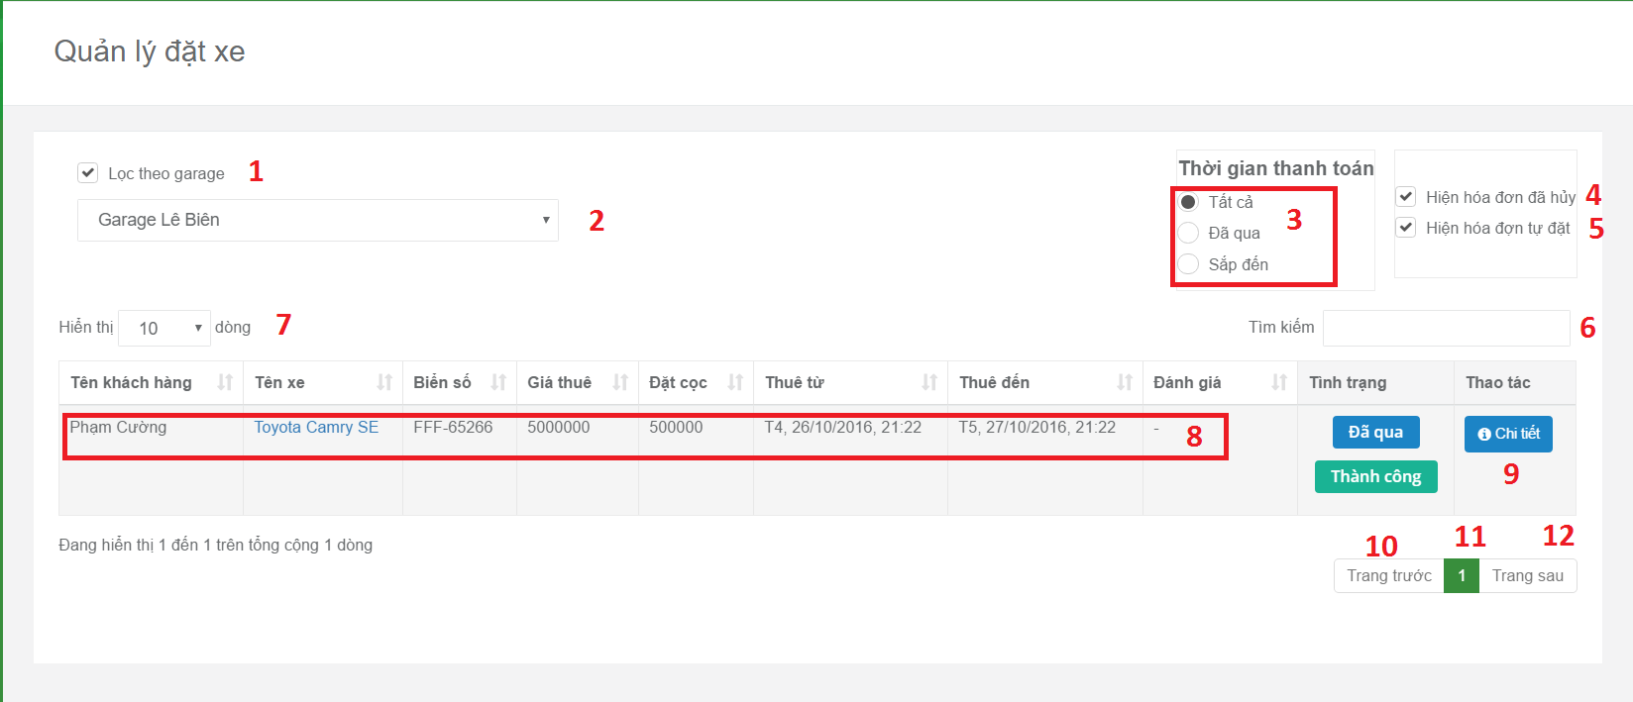

Figure 48: Manage booking page UI design

**Fields:**

|  |  |  |  |  |  |  |
| --- | --- | --- | --- | --- | --- | --- |
| No | Field Name | Description | Read Only | Mandatory | Control Type | Data Type |
| 1 | Disable/enable filter record belong to garage | Filter vehicle belong to garage be disabled/enabled | Yes | No | Checkbox | String |
| 2 | Garage name | Filter vehicle belong to garage | Yes | No | Dropdown | String |
| 3 | Status of booking sorted by time | Filter record of booking be showed in data table belong to status of booking | Yes | No | Radiobox | String |
| 4 | Status of booking sorted by action | Filter record of booking be showed in data table belong to status of sorted by action | Yes | No | Checkbox | String |
| 6 | Key search | Filter record belong to key word | No | No | Textbox | String |
| 7 | Number record in data table | Filter number record be showed in data table | Yes | No | Dropdown | Number |
| 11 | Current Page Of Table | Current page of table | Yes | No | Text Box | String |

**Buttons/Hyperlinks:**

|  |  |  |  |  |
| --- | --- | --- | --- | --- |
| No | Function | Description | Validation | Outcome |
| 8 | Redirect to vehicle detail page | Show information of vehicle | N/A | Vehicle detail page. |
| 9 | Show booking in detail | Show pop up to show booking information | N/A | Show pop up to show booking information |
| 10 | Show Previous Record Of Table | Show previous record of table | N/A | Show previous record of table |
| 12 | Show Next Record Of Table | Show next record of table | N/A | Show next record of table |

#### Create self-booking popup <Excluded>

### Manage garage page

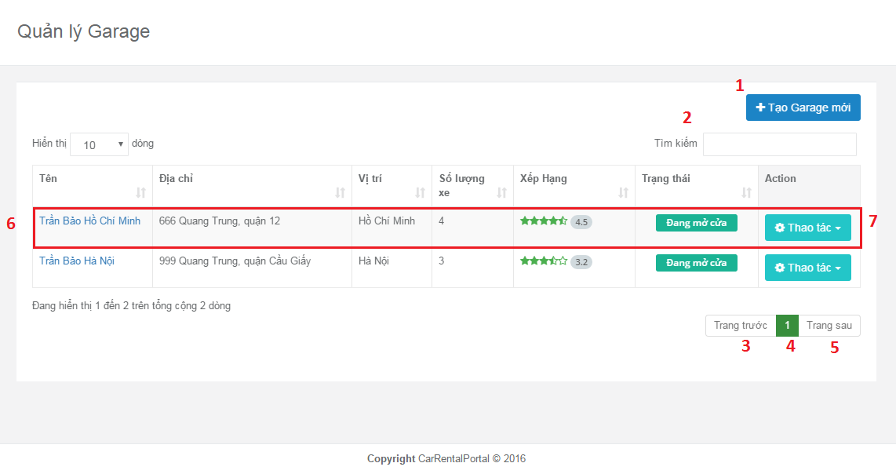

Figure 49 : Manage garage page UI design

**Buttons/Hyperlinks**

|  |  |  |  |  |
| --- | --- | --- | --- | --- |
| No | Function | Description | Validation | Outcome |
| 1 | showCreateNewGarage | Show create new garage | N/A | Show create new garage popup |
| 7 | showOptionUserCanDoToGarage | Show options for user choose: detail information, open/close garage, delete | N/A | Show options for user choose: detail information, open/close garage, delete |
| 3 | showPreviousRecordOfTable | Show previous record of table | N/A | Show previous record of table |
| 5 | showNextRecordOfTable | Show next record of table | N/A | Show next record of table |

#### Create new garage popup

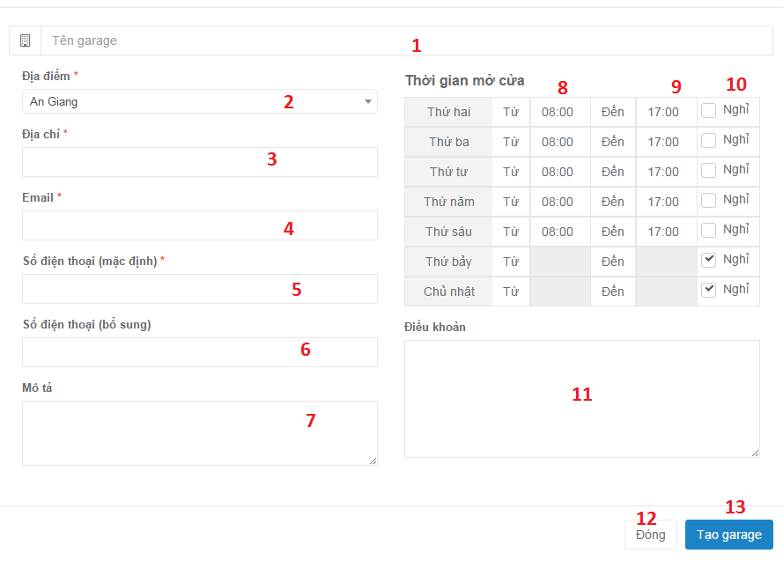

Figure 50 : Create new garage popup UI design

**Fields**

|  |  |  |  |  |  |  |
| --- | --- | --- | --- | --- | --- | --- |
| No | Field Name | Description | Read Only | Mandatory | Control Type | Data Type |
| 1 | garageName | Field for input garage name | No | No | Textbox | String |
| 2 | location | Search data from table | Yes | No | Dropdownlist | String |
| 3 | address | Field for input garage address | No | No | Textbox | String |
| 4 | email | Field for input garage email | No | No | Textbox | String |
| 5 | phoneNumberMain | Field for input main phone number | No | No | Textbox | String |
| 6 | phoneNumberSub | Field for input sub phone number | No | No | Textbox | String |
| 7 | detailInformation | Filed for input detail information | No | No | Textbox | String |
| 8 | openTime | Field for input open time | No | No | Textbox | Integer |
| 9 | closeTime | Field for input close time | No | No | Textbox | Integer |
| 11 | policy | Field for input policy of garage | No | No | Textbox | String |

**Buttons/Hyperlinks**

|  |  |  |  |  |
| --- | --- | --- | --- | --- |
| No | Function | Description | Validation | Outcome |
| 10 | indicateDayOff | Indicate day off | N/A |  |
| 12 | cancel | Cancel | N/A | Garage management page |
| 3 | createGarage | Save information to database | Validate all require field | Create success |

### Garage detail page

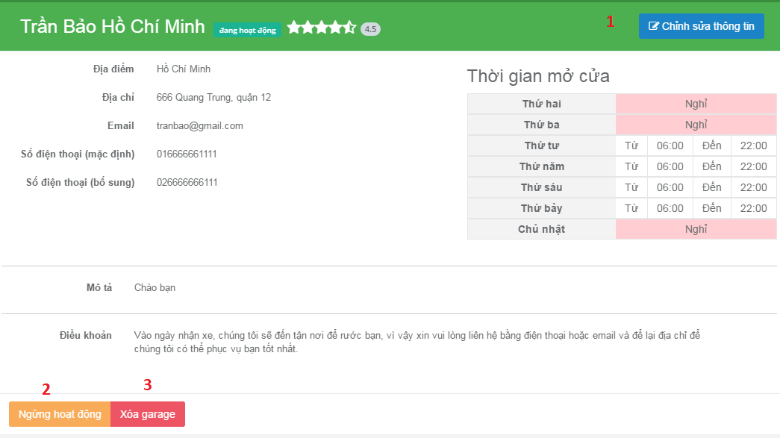

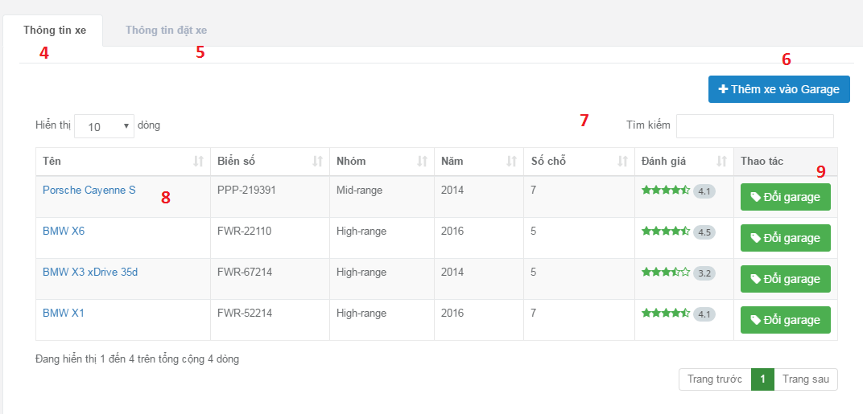

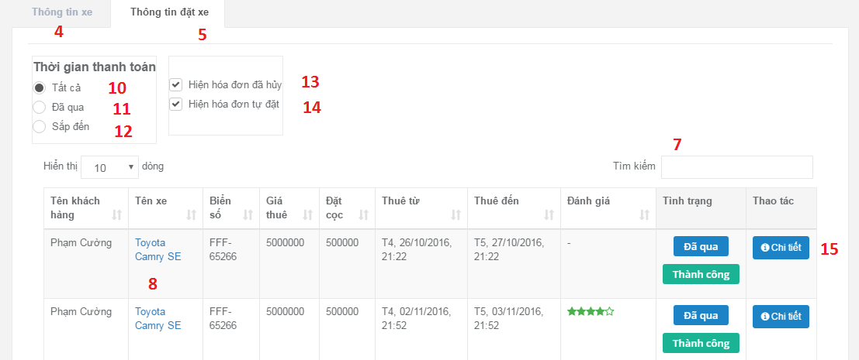

Figure 51 : Garage detail page UI design

**Fields**

|  |  |  |  |  |  |  |
| --- | --- | --- | --- | --- | --- | --- |
| No | Field Name | Description | Read Only | Mandatory | Control Type | Data Type |
| 4 | garageName | Field for input garage name | No | No | Textbox | String |
| 7 | searchData | Search data from table | Yes | No | Textbox | String |
| 10 | allRadio | Checks to choose all time | Yes | No | Radio | String |
| 11 | pastRadio | Checks to choose pass time | Yes | No | Radio | String |
| 12 | comingRadio | Checks to choose in coming | Yes | No | Radio | String |
| 13 | canceledReceipt | Checks to choose cancel receipt | Yes | No | Combobox | String |
| 14 | selfBookingReceipt | Checks to choose self-booking receipt | Yes | No | Combobox | String |

**Buttons/Hyperlinks**

|  |  |  |  |  |
| --- | --- | --- | --- | --- |
| No | Function | Description | Validation | Outcome |
| 1 | editGarageInformation | Edit garage information | N/A | Show field for edit |
| 2 | Active/deactiveGarage | Active or deactive garage | N/A | Garage become deactive/active |
| 3 | deleteGarage | Delete garage | N/A | Delete confirm |
| 4 | vehicleInfoTab | Clicks to show vehicle information tab | N/A | Show vehicle information tab |
| 5 | bookingInfoTab | Clicks to show booking information tab | N/A | Show booking information tab |
| 6 | addVehicleToGarage | Add vehicle to this garage | N/A | Show add vehicle confirm popup |
| 8 | linkToVehicleDetail | Clicks to go to that vehicle detail page | N/A | Go to vehicle detail page |
| 9 | changeGarage | Clicks to transfer the vehicle to another garage | N/A | Show change garage confirm popup |
| 15 | detailButton | Clicks to show detail information | N/A | Show detail information |

#### Edit garage information

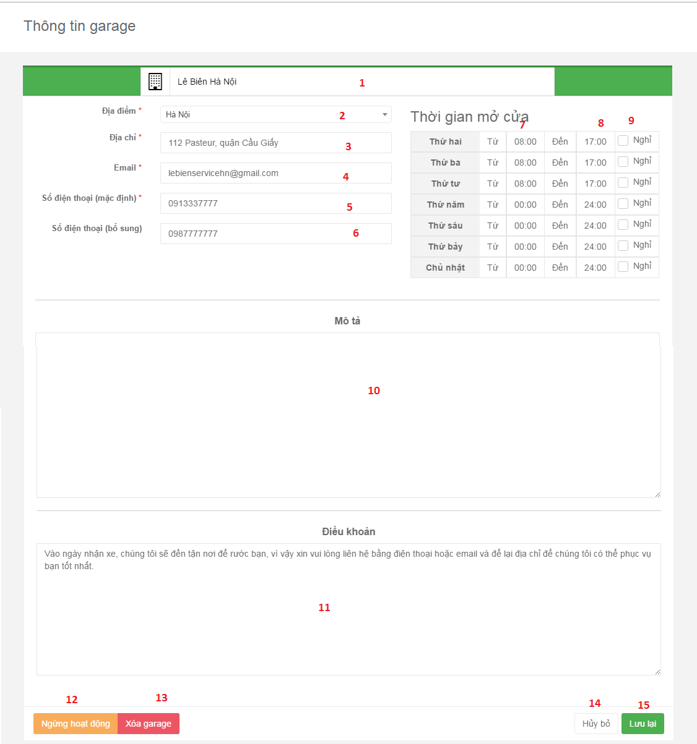

Figure 52 : Edit garage information UI design

**Fields**

|  |  |  |  |  |  |  |
| --- | --- | --- | --- | --- | --- | --- |
| No | Field Name | Description | Read Only | Mandatory | Control Type | Data Type |
| 1 | garageName | Field for input garage name | No | No | Textbox | String |
| 2 | Location | Field for input location | No | No | Textbox | String |
| 3 | address | Field for input garage address | No | No | Textbox | String |
| 4 | email | Field for input garage email | No | No | Textbox | String |
| 5 | phoneNumberMain | Field for input main phone number | No | No | Textbox | String |
| 6 | phoneNumberSub | Field for input sub phone number | No | No | Textbox | String |
| 10 | detailInformation | Filed for input detail information | No | No | Textbox | String |
| 7 | openTime | Field for input open time | No | No | Textbox | Integer |
| 8 | closeTime | Field for input close time | No | No | Textbox | Integer |
| 9 | dayOff | Choose day off day | Yes | No | Combobox | String |
| 11 | policy | Field for input policy of garage | No | No | Textbox | String |

**Buttons/Hyperlinks**

|  |  |  |  |  |
| --- | --- | --- | --- | --- |
| No | Function | Description | Validation | Outcome |
| 12 | Active/deactiveGarage | Active or deactive garage | N/A | Garage become deactive/active |
| 13 | deleteGarage | Delete garage | Must be no vehicle in that garage | Delete confirm |
| 6 | addVehicleToGarage | Add vehicle to this garage | N/A | Show add vehicle confirm popup |
| 14 | cancelButton | Clicks to cancel | N/A | Go to garage detail page |
| 15 | saveButton | Clicks to save | Validate all require field | Reload page |

### Manage vehicle group page

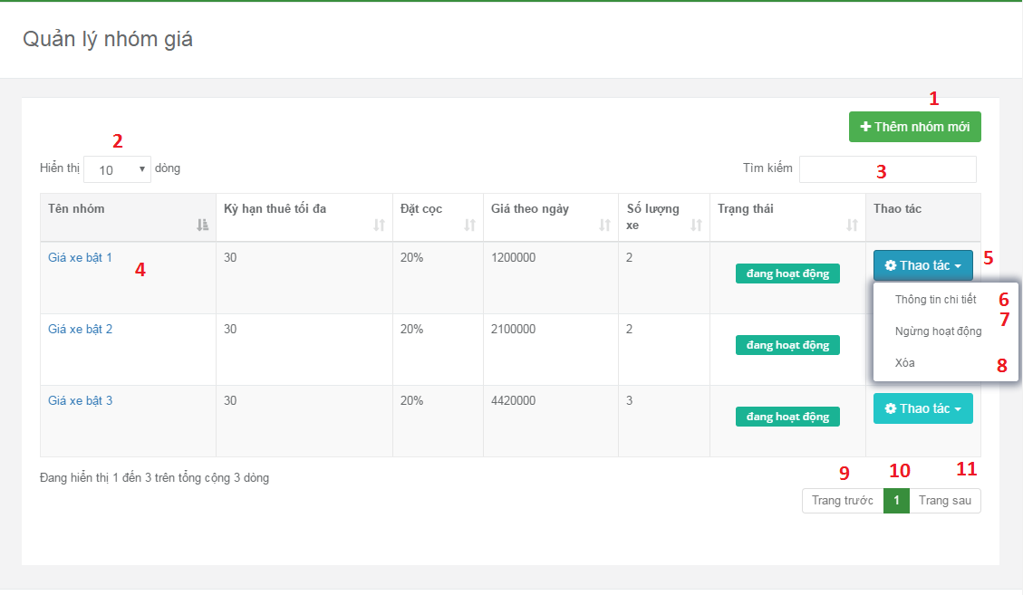

Figure 53: Manage vehicle group page UI design

**Fields**

|  |  |  |  |  |  |  |
| --- | --- | --- | --- | --- | --- | --- |
| No | Field Name | Description | Read Only | Mandatory | Control Type | Data Type |
| 2 | numberOfDataShow | List of how many result user want to see in table | No | No | Dropdownlist | Integer |
| 5 | showOptionUserCanDo | List things provider can do to that vehicle group | No | No | Dropdownlist | Integer |

**Buttons/Hyperlinks**

|  |  |  |  |  |
| --- | --- | --- | --- | --- |
| No | Function | Description | Validation | Outcome |
| 1 | createNewVehicleGroup | Create new vehicle group | N/A | Create vehicle group popup |
| 4 | linkToVehicleGroupDetail | Go to vehicle group detail page | N/A | Go to vehicle group detail page |
| 6 | showVehicleGroupDetail | Go to vehicle group detail page | N/A | Go to vehicle group detail page |
| 7 | deActiveVehicleGroup | Deactive vehice group | N/A | Deactive vehice group |
| 8 | deleteVehicleGroup | Delete vehicle group | N/A | Delete vehicle group |
| 9 | previousButton | Show previous data page | N/A | Show previous data page |
| 10 | numberPage | Clicks to show data in choose page | N/A | Show data in choose page |
| 11 | nextButton | Show next page | N/A | Show next data page |

#### Create new vehicle group popup

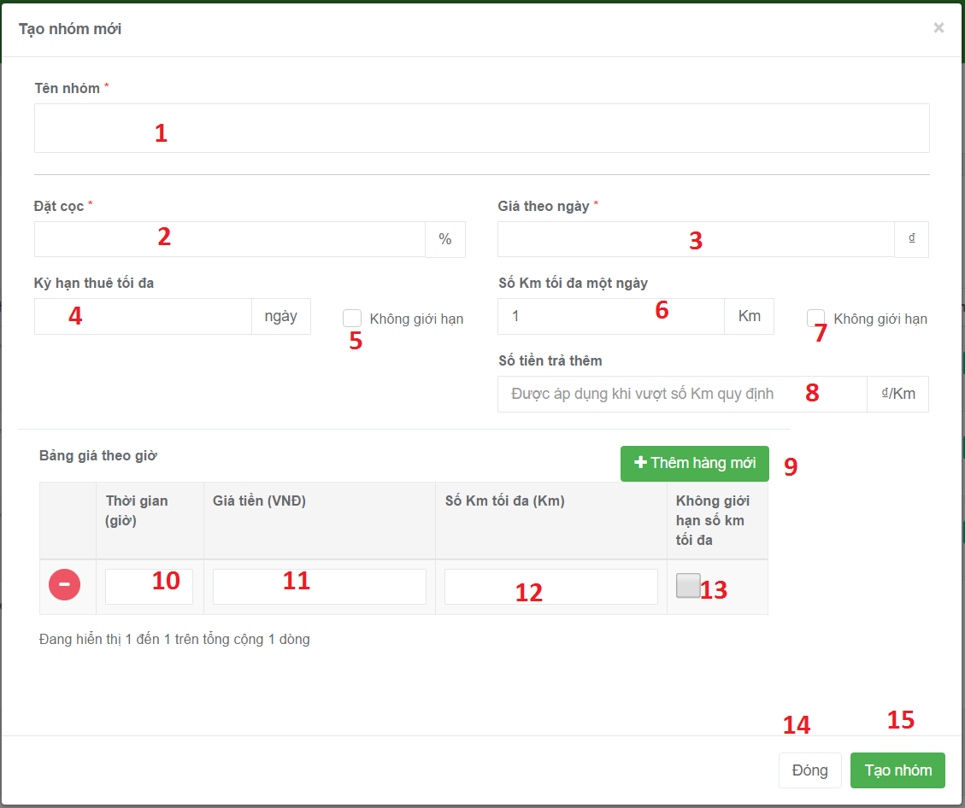

Figure 54 : Create new vehicle group UI design

**Fields**

|  |  |  |  |  |  |  |
| --- | --- | --- | --- | --- | --- | --- |
| No | Field Name | Description | Read Only | Mandatory | Control Type | Data Type |
| 1 | Vehicle group name | Allow user input name of vehicle group | No | Yes | Textbox | String |
| 2 | Deposit | Input deposit for booking vehicle | No | Yes | Textbox | Number |
| 3 | Price per day | Input money per day | No | Yes | Textbox | Number |
| 4 | Limit time | Input number day for rent vehicle | No | Yes | Textbox | Number |
| 6 | Limit Km | Input number km for rent vehicle | No | Yes | Textbox | Number |
| 8 | Money will pay by over the limit km. | Input money by over the limit km | No | Yes | Textbox | Number |
| 9 | Time(hours) | Input time (hour) to apply price for hours | No | No | Textbox | Number |
| 10 | Price for hour | Input price per hour to apply price for hours | No | No | Textbox | Number |
| 11 | Limit Km of price for hour | Input limit KM to apply price for hours | No | No | Textbox | Number |

**Buttons/Hyperlinks**

|  |  |  |  |  |
| --- | --- | --- | --- | --- |
| No | Function | Description | Validation | Outcome |
| 14 | Cancel add new command | Cancel action add new vehicle group | N/A | Close pop up add new vehicle group |
| 15 | Create new vehicle group | Send create command to controller | N/A | Create new vehicle group. |
| 9 | To add price per hour | Allow user input price per hour. | N/A | Show field allow user input price per hour. |
| 5 | Disable Limit time | Disable limit time field | N/A | limit time field will be disabled |
| 7 | Disable Limit Km | Disable Limit Km | N/A | Limit Km field will be disabled |
| 13 | Disable Limit Km of price for hour | Disable Limit Km of price for hour | N/A | Limit Km of price for hour field will be disabled |

### Vehicle group details page

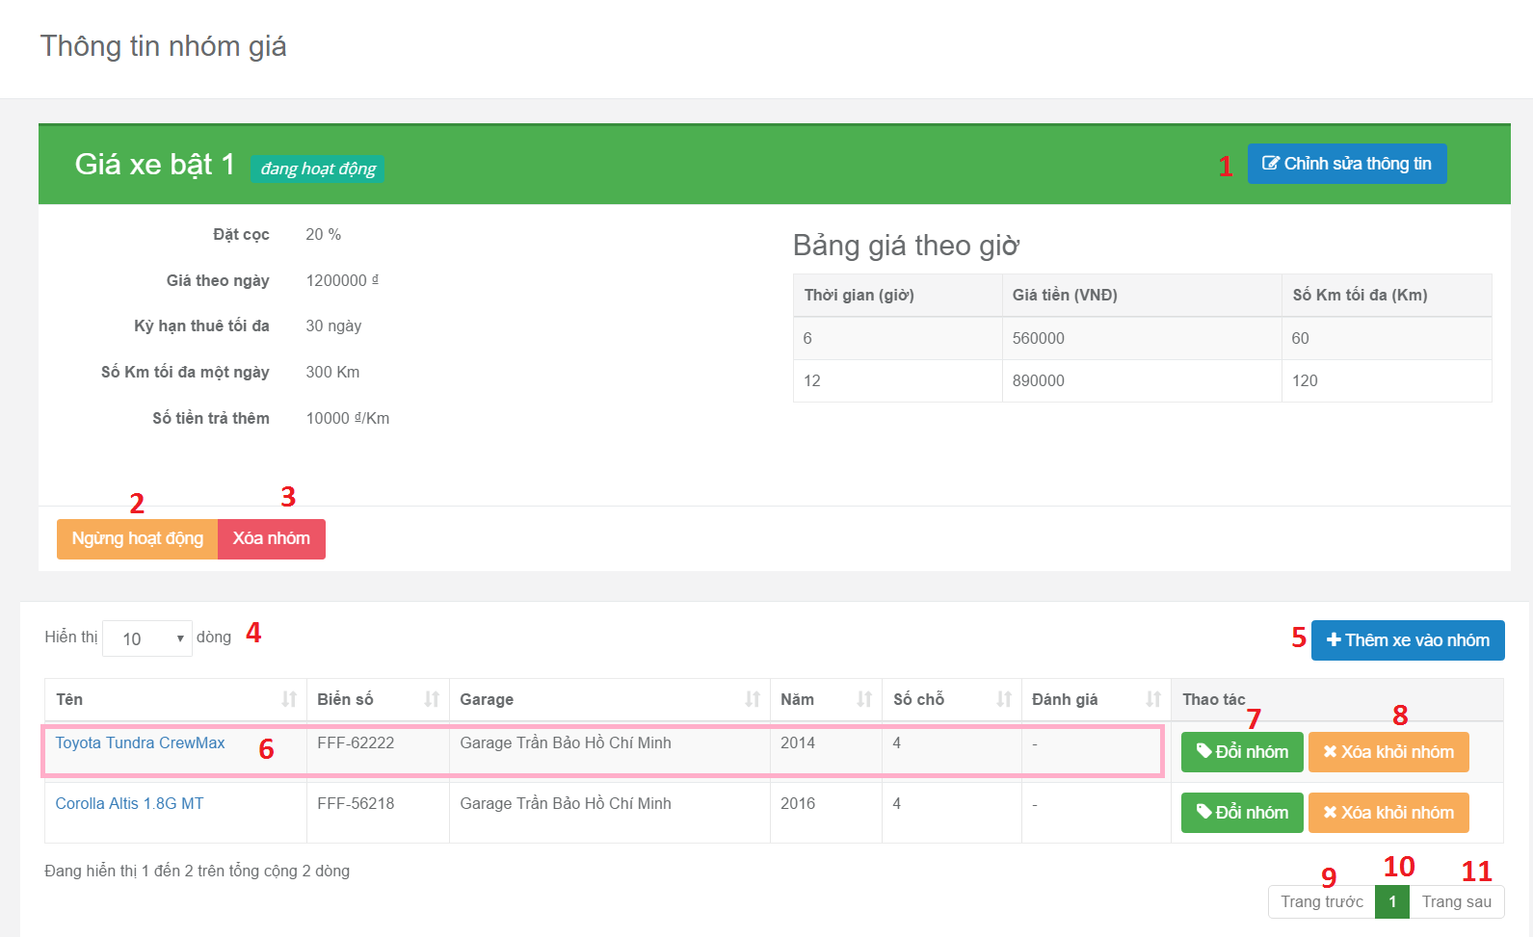

Figure 55: Vehicle group details page

**Fields:**

|  |  |  |  |  |  |  |
| --- | --- | --- | --- | --- | --- | --- |
| No | Field Name | Description | Read Only | Mandatory | Control Type | Data Type |
| 4 | Filter number of record in data table | Choose the number will be displayed in data table | Yes | No | Drop down list | Number |
| 10 | Current Page Of Table | Current page of table | Yes | No | Text Box | String |

**Buttons/Hyperlinks:**

|  |  |  |  |  |
| --- | --- | --- | --- | --- |
| No | Function | Description | Validation | Outcome |
| 2 | Deactivate vehicle group | Vehicle group will be deactivated. | N/A | Vehicle group will be deactivated. |
| 1 | Edit vehicle group | Show edit form for edit vehicle group | N/A | Show edit form for edit vehicle group |
| 3 | Delete vehicle group | Vehicle group will be deleted | N/A | Vehicle group will be deleted |
| 5 | Add vehicle to this vehicle group | Add vehicle to vehicle group | N/A | Show pop up allow user choose then add vehicle to vehicle group |
| 7 | Switch vehicle to another vehicle group | Change vehicle group of vehicle | N/A | Show pop up allow user choose new vehicle group of vehicle |
| 8 | Delete vehicle from vehicle group | Delete vehicle from vehicle group | N/A | Delete vehicle from vehicle group |
| 6 | View vehicle in detail | View information of vehicle | N/A | Redirect to vehicle detail page |
| 9 | Show Previous Record Of Table | Show previous record of table | N/A | Show previous record of table |
| 11 | Show Next Record Of Table | Show next record of table | N/A | Show next record of table |

#### Edit vehicle group information

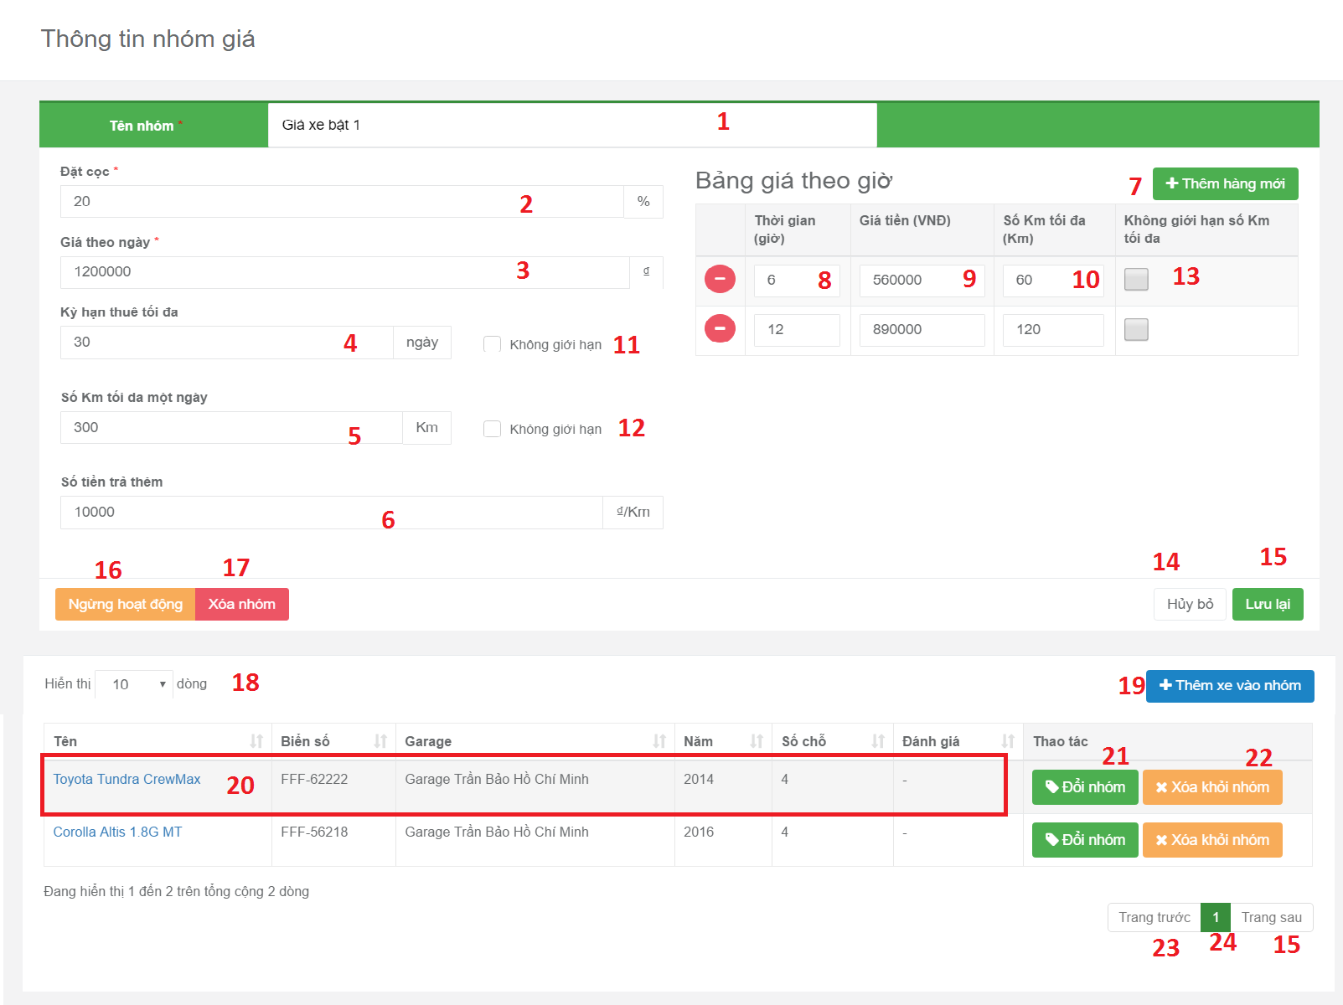

Figure 56 : Edit vehicle group information UI design

**Fields**

|  |  |  |  |  |  |  |
| --- | --- | --- | --- | --- | --- | --- |
| No | Field Name | Description | Read Only | Mandatory | Control Type | Data Type |
| 1 | Vehicle group name | Allow user input name of vehicle group | No | Yes | Text box | String |
| 2 | Deposit | Input deposit for booking vehicle | No | Yes | Text box | Number |
| 3 | Price per day | Input money per day | No | Yes | Text Box | Number |
| 4 | Limit time | Input number day for rent vehicle | No | Yes | Text Box | Number |
| 5 | Limit Km | Input number km for rent vehicle | No | Yes | Text Box | Number |
| 6 | Money will pay by over the limit km. | Input money by over the limit km | No | Yes | Text Box | Number |
| 8 | Time(hours) | Input time (hour) to apply price for hours | No | No | Text Box | Number |
| 9 | Price for hour | Input price per hour to apply price for hours | No | No | Text Box | Number |
| 10 | Limit Km of price for hour | Input limit KM to apply price for hours | No | No | Text Box | Number |
| 18 | Filter number of record in data table | Choose the number will be displayed in data table | Yes | No | Drop down list | Number |
| 24 | Current Page Of Table | Current page of table | Yes | No | Text Box | String |

**Buttons/Hyperlinks**

|  |  |  |  |  |
| --- | --- | --- | --- | --- |
| No | Function | Description | Validation | Outcome |
| 7 | Add new field to input price per hour of vehicle group | Show text box to input money per hour | N/A | Show text box field allow user input price per hour |
| 11 | Disable Limit time | Disable limit time field | N/A | limit time field will be disabled |
| 12 | Disable Limit Km | Disable Limit Km | N/A | Limit Km field will be disabled |
| 13 | Disable Limit Km of price for hour | Disable Limit Km of price for hour | N/A | Limit Km of price for hour field will be disabled |
| 16 | Deactivate vehicle group | Vehicle group will be deactivated. | N/A | Vehicle group will be deactivated. |
| 17 | Delete vehicle group | Vehicle group will be deleted | N/A | Vehicle group will be deleted |
| 14 | Cancel edit vehicle group | Disable all field to edit vehicle group | N/A | User can not edit vehicle group |
| 15 | Update vehicle group | Send request to controller | N/A | Vehicle group will be updated |
| 19 | Add vehicle to this vehicle group | Add vehicle to vehicle group | N/A | Show pop up allow user choose then add vehicle to vehicle group |
| 21 | Switch vehicle to another vehicle group | Change vehicle group of vehicle | N/A | Show pop up allow user choose new vehicle group of vehicle |
| 22 | Delete vehicle from vehicle group | Delete vehicle from vehicle group | N/A | Delete vehicle from vehicle group |
| 20 | View vehicle in detail | View information of vehicle | N/A | Redirect to vehicle detail page |
| 23 | Show Previous Record Of Table | Show previous record of table | N/A | Show previous record of table |
| 25 | Show Next Record Of Table | Show next record of table | N/A | Show next record of table |

### Admin’s dashboard

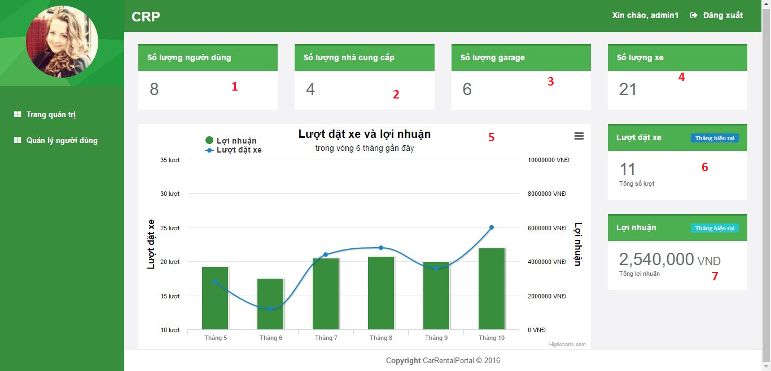

Figure 57: Admin’s dashboard UI design

**Fields**

|  |  |  |  |  |  |  |
| --- | --- | --- | --- | --- | --- | --- |
| No | Field Name | Description | Read Only | Mandatory | Control Type | Data Type |
| 1 | numberOfUser | Show number of user | Yes | No | Textbox | String |
| 2 | numberOfProvider | Show number of provider | Yes | No | Textbox | String |
| 3 | numberOfGarage | Show number of garage | Yes | No | Textbox | String |
| 4 | numberOfVehicle | Show number of vehicle | Yes | No | Textbox | String |
| 5 | numberOfBookingAndProfit | Show graph display number of booking and profit | Yes | No | Graph | String |
| 6 | numberOfBooking | Show number of booking | Yes | No | Textbox | String |
| 7 | profit | Show number of profit | Yes | No | Textbox | String |

### Manage user page <Excluded>

## Database Design

### Entity relationship diagram



Figure 58 : Entity Relationship Diagram

### Entity Dictionary

|  |  |
| --- | --- |
| Entity dictionary | |
| Entity Name | **Description** |
| User | Abstract entity, represent user in system |
| Provider | User with provider role |
| Customer | User with customer role |
| Vehicle | Represent vehicle in system |
| VehicleImage | Represent image of vehicle |
| VehicleModel | Represent vehicle model |
| VehicleBrand | Represent vehicle brand |
| Category | Represent vehicle category |
| Garage | Represent garage |
| GarageWorkingTime | Describe working time constraints of garage each day of week |
| Location | Represent location inside a country |
| Nation | Represent nation |
| VehicleGroup | Represent group of vehicles with the same rental constraints |
| PriceGroup | Describe rental constraints of a vehicle group |
| PriceGroupItem | Describe rental constraints of each daily rental option of price group |
| BookingReceipt | Represent booking receipt in system |

Table 45 : Entity dictionary

#### User

|  |  |  |  |
| --- | --- | --- | --- |
| **Attribute** | **Domain** | **Allows null** | **Description** |
| Id | nvarchar(128) | No | Unique identifier of user. |
| Email | varchar(256) | No | Email of user. |
| EmailConfirmed | bit | No | Status indicating whether email has been confirmed. |
| PasswordHash | nvarchar(MAX) | Yes | Encoded password of user. |
| SecurityStamp | nvarchar(MAX) | Yes | Stamp used to authenticate user’s cookies and session. |
| PhoneNumber | nvarchar(MAX) | Yes | Phone number of user. |
| PhoneNumberConfirmed | bit | No | Status indicating whether phone number has been confirmed. |
| TwoFactorEnabled | bit | No | Status indicating whether two-factor sign-in is enabled. |
| LockoutEndDateUtc | datetime | Yes | Date until which this user is locked out if lockoutEnable is true. |
| LockoutEnable | bit | No | Status indicating whether lockout is enabled. |
| AccessFailedCount | int | No | Number of failed access for this account. |
| UserName | nvarchar(256) | Yes | Username |
| FullName | nvarchar(200) | Yes | Full name of user |
| IsProviderUntil | datetime | Yes | Date until which this user has provider role. |
| AvatarURL | varchar(200) | Yes | URL of user’s avatar |

Table 46: User entity – Attributes

#### Role

|  |  |  |  |
| --- | --- | --- | --- |
| **Attribute** | **Domain** | **Allows null** | **Description** |
| Id | nvarchar(128) | No | Unique identifier of AspNetRole |
| Name | nvarchar(256) | No | Name of role |

Table 47: Role entity - Attributes

#### Vehicle

|  |  |  |  |
| --- | --- | --- | --- |
| **Attribute** | **Domain** | **Allows null** | **Description** |
| ID | int | No | Unique identifier of vehicle |
| LicenseNumber | varchar(50) | No | License number of vehicle |
| Name | nvarchar(100) | No | Name of vehicle |
| ModelID | int | No | Model of vehicle |
| Year | int | No | Year in which this vehicle was produced |
| GarageID | int | No | ID of Garage containing this vehicle |
| VehicleGroupID | int | Yes | ID of VehicleGroup containing this vehicle |
| TransmissionType | int | No | Transmission type of vehicle |
| TransmissionDetail | nvarchar(100) | Yes | Detailed description about transmisson of vehicle |
| FuelType | int | Yes | Fuel type of vehicle |
| Engine | nvarchar(100) | Yes | Description about engine of vehicle |
| Color | int | No | Color of vehicle |
| Description | nvarchar(1000) | Yes | Description about vehicle |
| NumOfComment | int | No | Number of customer’s feedback this vehicle has received |
| Star | decimal(2, 1) | No | Rating of vehicle |
| IsDeleted | bit | No | Status indicating whether this vehicle was deleted |

Table 48: Vehicle entity – Attributes

#### VehicleImage

|  |  |  |  |
| --- | --- | --- | --- |
| **Attribute** | **Domain** | **Allows null** | **Description** |
| ID | varchar(100) | No | Unique identifier of image returned by cloudinary |
| VehicleID | int | No | ID of Vehicle which this image belongs to |
| URL | varchar(200) | No | URL of image |

Table 49: VehicleImage entity - Attributes

#### VehicleModel

|  |  |  |  |
| --- | --- | --- | --- |
| **Attribute** | **Domain** | **Allows null** | **Description** |
| ID | int | No | Unique identifier of vehicle model |
| Name | nvarchar(50) | No | Name of role |
| BrandID | int | No | ID of Brand of this model |
| NumOfDoor | int | No | Number of door on this vehicle |
| NumOfSeat | int | No | Number of seat in this vehicle |

Table 50: VehicleModel entity – Attributes

#### VehicleBrand

|  |  |  |  |
| --- | --- | --- | --- |
| **Attribute** | **Domain** | **Allows null** | **Description** |
| ID | int | No | Unique identifier of vehicle brand |
| Name | nvarchar(50) | No | Name of brand |

Table 51: VehicleBrand entity - Attributes

#### Category

|  |  |  |  |
| --- | --- | --- | --- |
| **Attribute** | **Domain** | **Allows null** | **Description** |
| ID | int | No | Unique identifier of category |
| Name | nvarchar(50) | No | Name of category |

Table 52: VehicleBrand entity - Attributes

#### Garage

|  |  |  |  |
| --- | --- | --- | --- |
| **Attribute** | **Domain** | **Allows null** | **Description** |
| ID | int | No | Unique identifier of garage |
| OwnerID | nvarchar(128) | No | ID of AspNetUser owing this garage |
| Name | nvarchar(100) | No | Name of garage |
| LocationID | int | No | ID of Location of garage |
| Address | nvarchar(200) | No | Address of garage |
| Email | varchar(256) | No | Email of garage |
| Phone1 | varchar(50) | No | Primary phone number of garage |
| Phone2 | varchar(50) | Yes | Secondary phone number of garage |
| NumOfComment | int | No | Number of customer’s feedback this garage has received |
| Star | decimal(2, 1) | No | Rating of garage |
| Description | nvarchar(1000) | Yes | Description of garage |
| Policy | nvarchar(1000) | Yes | Policy of garage |
| IsActive | bit | No | Status indicating whether this garage is active. |
| IsDeleted | bit | No | Status indicating whether this garage was deleted. |

Table 53: Garage entity - Attributes

#### GarageWorkingTime

|  |  |  |  |
| --- | --- | --- | --- |
| **Attribute** | **Domain** | **Allows null** | **Description** |
| GarageID | int | No | ID of Garage which this working time constraint is applied to. |
| DayOfWeek | int | No | Day of week which this working time constraint represents. |
| OpenTimeInMinute | int | No | Opening time of this garare in this day of week. |
| CloseTimeInMinute | int | No | Closing time of this garage in this day of week. |

Table 54: GarageWorkingTime entity - Attributes

#### Location

|  |  |  |  |
| --- | --- | --- | --- |
| **Attribute** | **Domain** | **Allows null** | **Description** |
| ID | int | No | Unique identifier of location. |
| Name | nvarchar(50) | No | Name of location. |
| NationID | int | No | ID of Nation to which this location belongs. |

Table 55: Location entity - Attributes

#### Nation

|  |  |  |  |
| --- | --- | --- | --- |
| **Attribute** | **Domain** | **Allows null** | **Description** |
| ID | int | No | Unique identifier of nation |
| Name | nvarchar(50) | No | Name of nation |

Table 56: Nation entity - Attributes

#### VehicleGroup

|  |  |  |  |
| --- | --- | --- | --- |
| **Attribute** | **Domain** | **Allows null** | **Description** |
| ID | int | No | Unique identifier of vehicle group |
| OwnerID | nvarchar(128) | No | ID of AspNetUser whom this group belongs to |
| Name | nvarchar(50) | No | Name of group |
| IsActive | bit | No | Status indicating whether this group is active |
| WithDriverPriceGroupID | int | No | ID of default PriceGroup which is applied for driver-included rent. |

Table 57: VehicleGroup entity - Attributes

#### PriceGroup

|  |  |  |  |
| --- | --- | --- | --- |
| **Attribute** | **Domain** | **Allows null** | **Description** |
| ID | int | No | Unique identifier of price group. |
| DepositPercentage | decimal(3, 2) | No | Percentage of total rental price which customer has to pay to provider when booking. |
| PerDayPrice | float | No | Pricing of daily rental. |
| MaxRentalPeriod | int | Yes | Maximum days a rental can last. |
| MaxDistancePerDay | int | Yes | Maximum km that customer can travel in 1 days without being charged extra fee with the rented vehicle. |
| ExtraChargePerKm | int | Yes | Extra fee for every 1 km outside allowed travel distance. |

Table 58: PriceGroup entity - Attributes

#### PriceGroupItem

|  |  |  |  |
| --- | --- | --- | --- |
| **Attribute** | **Domain** | **Allows null** | **Description** |
| PriceGroupID | int | No | ID of PriceGroup to which this hourly rental option belongs. |
| MaxTime | int | No | Rental duration of this rental option. |
| Price | float | No | Rental price of this rental option. |
| MaxDistance | int | Yes | Maximum km that customer can travel without being charged extra fee with the rented vehicle using this rental option. |

Table 59: PriceGroupItem entity - Attributes

#### BookingReceipt

|  |  |  |  |
| --- | --- | --- | --- |
| **Attribute** | **Domain** | **Allows null** | **Description** |
| ID | int | No | Unique identifier of receipt. |
| CustomerID | String | No | ID of AspNetUser who is the customer of this receipt. |
| RentalPrice | float | No | Total rental price. |
| Deposit | float | No | Deposit paid by customer to provider when booking. |
| BookingFee | float | No | Fee paid by customer to system when booking. |
| Distance | int | Yes | Maximum distance customer can travel without being charged extra fee with the rented vehicle. |
| Star | int | Yes | Rating from customer for this rental period. |
| Comment | nvarchar(200) | Yes | Feedback from customer about this rental reriod. |
| BookingTime | datetime | No | Time when this booking is made. |
| StartTime | datetime | No | Time when rental period starts. |
| EndTime | datetime | No | Time when rental period ends. |
| GarageID | int | No | ID of Garage to which this booking belongs. |
| GarageName | nvarchar(100) | No | Name of Garage at booking moment. |
| GarageAddress | nvarchar(200) | No | Address of Garage at booking moment. |
| GaragePhone | varchar(50) | No | Phone1 of Garage at booking moment. |
| GarageEmail | varchar(50) | No | Email of Garage at booking moment. |
| VehicleID | int | No | ID of booked Vehicle. |
| LicenseNumber | varchar(50) | No | License number of Vehicle at booking moment. |
| VehicleName | nvarchar(100) | No | Name of Vehicle at booking moment. |
| TransmissionDetail | nvarchar(200) | Yes | TransmissionDetail of Vehicle at booking moment. |
| Engine | nvarchar(200) | Yes | Engine of Vehicle at booking moment. |
| Color | int | No | Color of Vehicle at booking moment. |
| IsCanceled | bit | No | Status indicating whether this booking has been canceled. |
| IsPending | bit | No | Status indicating whether this booking has not been paid. |

Table 60: BookingReceipt entity - Attributes

## Algorithms

### Recommender Engine

#### Introduction

As a car rental solution, CRP has to be able to introduce the most suitable vehicles to customers. This will helps improving not only the customers’ but also the providers’ satisfaction, and ultimately gaining more transactions, as well as interest for our application. Consequently, a recommender engine is necessary.

#### Common approaches

Two common approaches on designing recommender solution are *Collaborative filtering* and *Content-based filtering*.

Collaborative filtering methods are based on collecting and analyzing a large amount of information on users’ behaviors, activities or preferences and predicting what users will like based on their similarity to other users. [3]

Content-based filtering methods are based on a description of the item and a profile of the user’s preference. In a content-based recommender system, keywords are used to describe the items and a user profile is built to indicate the type of item this user likes. In other words, these algorithms try to recommend items that are similar to those that a user liked in the past (or is examining in the present). [4]

Collaborative approach does not require analyzing the content of item that it recommend since it is based entirely on the user’s information. However, exactly because it depends solely on the data generated by users, it suffers the three common problem of computing, namely *cold* *start* (Lack of user’s interaction in the beginning), *scalability* (Scale badly when the number of user and their interaction increase), and *sparsity* (The number of item is much bigger than the number of user). Considering the low-number-of-transaction nature of car rental service when compares to other kind of services, scalability and sparsity issues can be evaded.

Content-based approach works well even under scarce user’s interaction environment since its recommendations are based on the items’ description. Its issue of not being able to recommend items with different content type (For instance, car and phone) is also not a problem, since CRP only has one type of item.

#### Solution’s approaches

CRP’s recommender design take a hybrid approach between content-based and collaborative. We score vehicles base on how each of them is similar to the vehicles the customer has booked in the past and how many other customers that have booked this vehicle also have booked a similar vehicle as this customer in the past. Vehicles with higher score will have higher priority in recommendation.

Since our system’s recommended targets, namely vehicles, have many attributes that we can take advantage of (Brand, number of seat, color…), we initially tackles the problem using content-based methods. These includes *Vector space model* and *tf-idf.*

##### Represent items using vector space model

We first abstract the vehicles and their attributes by applying *Vector space model* [5], an item presentation algorithm.

Each vehicle is modeled as a vector (Refer to as *master vector* from now) in a multi-dimension space (Refer to as *vector space* from now), with each dimension corresponds to an attribute. If a vehicle has an attribute, the component vector (Refer to as *attribute vector* from now) corresponding to that attribute will has non-zero length.



Figure 59 – Example for 3-dimensional vector space

There are several weighting scheme that can be used to calculate the attribute vector’s length. Amongst them, the most popular one is *tf-idf* (Term frequency – Inverse document frequency)[6], which. In our solution, tf-idf is applied with *binary scheme* (Further explanation will be given in *solution’s design* section).

##### Customer profile

A customer profile is another vector in the *vector space* which indicate a particular customer’s interest in vehicle, like which color or which fuel type that he has more affinity with.

In vector space model, the angle between 2 vectors determine the similarity between them. This means the smaller the angle between a vehicle’s *master vector* and a customer profile, the more similar that vehicle is to the customer’s reference.



Figure 60 – Example for customer profile vector

It is common to use the cosine of this angle to represent their similarity, since their values are between 1 and -1. This form allows us to tell at how many percent a customer will like a vehicle (Positive value), or dislike it (Negative value). Our recommender engine will find the cosine between each vehicle’s *master vector* and a customer profile, then recommend vehicles with the highest cosine value to that customer.

##### Mix in collaborative element

To further improve the diversity of our solution’s recommendation, we apply collaborative methods into our content-based solution. Our collaborative approach work under the assumption that other customers that has booked the same vehicle with this customer (Refer to as neighbor from now) will have similar vehicle reference; and the more *neighbors* a vehicle has, the more similar it is to this customer’s reference.

Our collaborative approach introduces new attributes into the *vector space*. Each of these new attribute represent a neighbor and whether the item has been booked by this neighbor before.

|  | Neighbor 1 | Neighbor 2 | Neighbor 3 | Neighbor 4 |
| --- | --- | --- | --- | --- |
| Vehicle 1 | Yes | Yes | No | No |
| Vehicle 2 | No | Yes | No | No |
| Vehicle 3 | Yes | Yes | Yes | No |

Table 61 – Example of vehicle with 4 neighbor attributes

#### Solution’s design

##### How to calculate cosine of angle between 2 vectors

Cosine of the angle θ between 2 vectors $a=\left[a_{1},a_{2},…,a_{n}\right]$ and $b=\left[b_{1},b_{2},…,b_{n}\right]$ in n-dimension *vector space* can be calculated as follow:

$$\cos{θ}=\frac{a∙b}{\left\|a\right\|\left\|b\right\|}$$

where $a∙b$ is dot product of 2 vectors, $\left\|a\right\|$ and $\left\|b\right\|$ is the norm of each vector.

The dot product can be calculated as follow:

$$a∙b=\sum_{i=1}^{n}{a_{i}b_{i}}$$

The norm of a vector $v=\left[v_{1},v,…,v_{n}\right]$ can be calculated as follow:

$$\left\|v\right\|=\sqrt{\sum_{i=1}^{n}{v_{i}^{2}}}$$

##### Apply tf-idf weighting scheme

Applying tf-idf, length, or ‘weight’ of each *attribute vector* of $v=\left[v_{1},v,…,v_{n}\right]$ can be calculated as follow:

$$v_{i}={tf}_{i}∙{idf}_{i}$$

idf (Inverse document frequency) can be calculated as follow:

$${idf}_{i}=\log{\frac{\left|D\right|}{\left|{df}_{i}\right|+1}}$$

with $\left|D\right|$ being the total number of item and $\left|{df}_{i}\right|$ being the total number of item that has attribute i.

The scheme to calculate tf will be discussed in the next section.

##### Binary representation of attributes

In our approach, raw attributes can only either appear or does not appear in an item. This leads to representing them as binary values. Under this form, we can apply *binary tf weighting scheme* of *tf-idf*, where tf weight equals the raw binary value.

|  | 4-seat | 7-seat | Gasoline | Diesel | Neighbor 1 | Neighbor 2 |
| --- | --- | --- | --- | --- | --- | --- |
| Vehicle 1 | 1 | 0 | 1 | 0 | 1 | 1 |
| Vehicle 2 | 1 | 0 | 0 | 1 | 0 | 1 |
| Vehicle 3 | 0 | 1 | 1 | 0 | 1 | 1 |
| Vehicle 4 | 0 | 1 | 1 | 0 | 1 | 0 |
| Vehicle 5 | 1 | 0 | 0 | 1 | 0 | 0 |

Table 62 – Example tf values of vehicles with 6 binary attributes

With this approach, there is also no need to apply normalization to eliminate item’s size bias (For document-like item, the total number of ‘word’ in them varies, meaning bigger document will more likely to have more ‘hit’(tf) for each search term/attribute. However, with binary attributes, an item either ‘has’ or ‘does not have’ an attribute. In other words, tf is limited to 1 and 0, and therefore has no such bias).

| **attribute** | | 4-seat | 7-seat | Gasoline | Diesel | Neighbor 1 | Neighbor 2 |
| --- | --- | --- | --- | --- | --- | --- | --- |
| **tf** | Vehicle 1 | 1 | 0 | 1 | 0 | 1 | 1 |
| Vehicle 2 | 1 | 0 | 0 | 1 | 0 | 1 |
| Vehicle 3 | 0 | 1 | 1 | 0 | 1 | 1 |
| Vehicle 4 | 0 | 1 | 1 | 0 | 1 | 0 |
| Vehicle 5 | 1 | 0 | 0 | 1 | 0 | 0 |
| **df** | | 3 | 2 | 3 | 2 | 3 | 3 |
| **idf (With D = 5)** | | 0.097 | 0.222 | 0.097 | 0.222 | 0.097 | 0.097 |
| **weight** | Vehicle 1 | 0.097 | 0 | 0.097 | 0 | 0.097 | 0.097 |
| Vehicle 2 | 0.097 | 0 | 0 | 0.222 | 0 | 0.097 |
| Vehicle 3 | 0 | 0.222 | 0.097 | 0 | 0.097 | 0.097 |
| Vehicle 4 | 0 | 0.222 | 0.097 | 0 | 0.097 | 0 |
| Vehicle 5 | 0.097 | 0 | 0 | 0.222 | 0 | 0 |

Table 63 – Example weight of 5 vehicles with 6 binary attributes

##### Build the customer profile

We can build a user profile by using that user’s booking history as reference. Every booking has all the necessary data to construct an item vector similar to vehicle vector.

| # | Vehicle | 4-seat | 7-seat | Neighbor 1 | Neighbor 2 | Star |
| --- | --- | --- | --- | --- | --- | --- |
| 1 | Vehicle 1 | 1 | 0 | 1 | 1 | 2 |
| 2 | Vehicle 5 | 1 | 0 | 0 | 0 | 1 |
| 3 | Vehicle 3 | 0 | 1 | 1 | 1 | 4 |
| 4 | Vehicle 2 | 1 | 0 | 0 | 1 | 5 |
| 5 | Vehicle 3 | 0 | 1 | 1 | 1 | - |

Table 64 – Example of 5 bookings with 4 attributes

The bookings also have star-rating, which we can utilize to determine whether the customer liked or dislike the booking. In our approach, we assume that a rating lower than 3-star indicates *dislike* (-1), higher than 3-star indicates *like* (1) and equals 3 or empty rating means *neutral* (0).

| # | Vehicle | 4-seat | 7-seat | Neighbor 1 | Neighbor 2 | Star | Like |
| --- | --- | --- | --- | --- | --- | --- | --- |
| 1 | Vehicle 1 | -1 | 0 | -1 | -1 | 2 | -1 |
| 2 | Vehicle 5 | 1 | 0 | 0 | 0 | 1 | -1 |
| 3 | Vehicle 3 | 0 | 1 | 1 | 1 | 4 | 1 |
| 4 | Vehicle 2 | 1 | 0 | 0 | 1 | 5 | 1 |
| 5 | Vehicle 3 | 0 | 0 | 0 | 0 | - | 0 |

Table 65 – Example tf of 5 bookings with 4 attributes applying like-dislike scheme

tf of each of the customer profile’s *attribute vector* can be calculated as tf of sum of tf of every booking’s attribute vector of the same dimension. Since these sum are no longer binary, we calculate customer profile’s ${tf}_{i}$ of dimension i using *log normalization* scheme instead:

$${tf}_{i}=tf\left(\sum_{j}^{m}{{tf}_{j}}\right)=\left\{\begin{aligned}1+\log{\sum_{j}^{m}{{tf}_{j}}}, if \sum_{j}^{m}{{tf}_{j}}>0 \\ -\left(1+\log\left(-\sum_{j}^{m}{{tf}_{j}}\right)\right), if \sum_{j}^{m}{{tf}_{j}}<0 \\ 0, otherwise\end{aligned}\right.$$

In this equation, m is the total of booking. This equation has been modified from the original scheme to accomplice negative value. The customer profile’s vector can be calculated using our default tf-idf weighting scheme.

| **Attribute** | # | Vehicle | 4-seat | 7-seat | Neighbor 1 | Neighbor 2 |
| --- | --- | --- | --- | --- | --- | --- |
| **Booking’s tf** | 1 | Vehicle 1 | -1 | 0 | -1 | -1 |
| 2 | Vehicle 5 | -1 | 0 | 0 | 0 |
| 3 | Vehicle 3 | 0 | 1 | 1 | 1 |
| 4 | Vehicle 2 | 1 | 0 | 0 | 1 |
| 5 | Vehicle 3 | 0 | 0 | 0 | 0 |
| **df** | | | 3 | 1 | 2 | 3 |
| **idf (D=5)** | | | 0.097 | 0.398 | 0.222 | 0.097 |
| **Customer profile** | **tf** | | -1 | 1 | 0 | 1 |
|  | **weight** | | -0.097 | 0.398 | 0 | 0.097 |

Table 66 – Example weight for attribute vectors of a customer profile

##### Calculate vehicle’s score

As mentioned, the score used to recommend vehicle will be the cosine between the vehicle master vector and the customer profile.

$$\cos{θ}=\frac{a∙b}{\left\|a\right\|\left\|b\right\|}=\frac{\sum_{i=1}^{n}{a_{i}b_{i}}}{\sqrt{\sum_{i=1}^{n}{a_{i}^{2}}}∙\sqrt{\sum_{i=1}^{n}{b_{i}^{2}}}}$$

| Attribute | | | 4-seat | 7-seat | Neighbor 1 | Neighbor 2 |
| --- | --- | --- | --- | --- | --- | --- |
| **Customer profile** | | | -0.097 | 0.398 | 0 | 0.097 |
| **Vehicle** | **tf** | Vehicle 1 | 1 | 0 | 1 | 1 |
| Vehicle 2 | 1 | 0 | 0 | 1 |
| Vehicle 3 | 0 | 1 | 1 | 1 |
| Vehicle 4 | 0 | 1 | 1 | 0 |
| Vehicle 5 | 1 | 0 | 0 | 0 |
| **df** | | 3 | 2 | 3 | 3 |
| **idf (D=5)** | | 0.097 | 0.222 | 0.097 | 0.097 |
| **weight** | Vehicle 1 | 0.097 | 0 | 0.097 | 0.097 |
| Vehicle 2 | 0.097 | 0 | 0 | 0.097 |
| Vehicle 3 | 0 | 0.222 | 0.097 | 0.097 |
| Vehicle 4 | 0 | 0.222 | 0.097 | 0 |
| Vehicle 5 | 0.097 | 0 | 0 | 0 |
| **Score** | Vehicle 1 | 0 | | | |
| Vehicle 2 | 0 | | | |
| Vehicle 3 | 0.889907 | | | |
| Vehicle 4 | 0.866331 | | | |
| Vehicle 5 | -0.23042 | | | |

Table 67 – Example score for 5 vehicles with 4 attributes

A positive value shows us the probability the customer will like the vehicle, while a negative one shows us the probability the customer will dislike the vehicle.

#### Algorithm’s time complexity

Considering a *vector space* with n attributes, k vehicles, and a customer with m bookings in her booking history; assuming all n attributes of an item (either a vehicle or a booking) has been ready before-hand, C#’s Math.Log10(double) and Math.Sqrt(double) have O(1) time complexity, we can estimate the time complexity of this recommender algorithm as follow.

##### Build customer profile

| **Step** | **Complexity** |
| --- | --- |
| Calculate each attribute vector $a_{i}$ of the profile $a$ | O(m) |
| * Calculate ${idf}_{i}$ | O(m) |
| * Calculate | O(m) |
| * Calculate | O(1) |
| * Calculate ${tf}_{i}$ | O(m) |
| * Calculate $\sum_{j}^{m}{{tf}_{j}}$ | O(m) |
| * Calculate ${tf}_{i}=\left\{\begin{aligned}1+\log{\sum_{j}^{m}{{tf}_{j}}}, if \sum_{j}^{m}{{tf}_{j}}>0 \\ -\left(1+\log\left(-\sum_{j}^{m}{{tf}_{j}}\right)\right), if \sum_{j}^{m}{{tf}_{j}}<0 \\ 0, otherwise\end{aligned}\right.$ | O(1) |
| * Calculate $a_{i}={tf}_{i}∙{idf}_{i}$ | O(1) |
| **Total** | **O(nm)** |

Table 68 – Time complexity of **Build customer profile** step

##### Build vehicle vectors

| **Step** | **Complexity** |
| --- | --- |
| Calculate each vehicle vector $v$ | O(nk) |
| * Calculate each attribute vector $v_{i}$ of $v$ | O(k) |
| * Calculate ${idf}_{i}$ | O(k) |
| Calculate | O(k) |
| Calculate | O(1) |
| * Calculate $v_{i}={tf}_{i}∙{idf}_{i}$ | O(1) |
| **Total** | **O(nk2)** |

Table 69 – Time complexity of **Build vehicle vectors** step

##### Score vehicles

| **Step** | **Complexity** |
| --- | --- |
| Calculate norm | O(n) |
| Calculate each vehicle’s score | O(n) |
| * Calculate norm | O(n) |
| * Calculate dot product $a∙v=\sum_{i=1}^{n}{a_{i}v_{i}}$ | O(n) |
| * Calculate vehicle’s score | O(1) |
| **Total** | **O(nk)** |

Table 70 – Time complexity of **Score vehicles** step

##### Overall time complexity

The overall time complexity of our algorithm is **O(n(k2 + k + m))**. This complexity has 2 pain points. The first being k2, which can somehow be reduced by applying normal filtering first to lessen the number of vehicle in vector space. The second pain point is the number of collaborative attributes in n.

n is the sum between the content-based attributes presented naturally on every vehicle and the collaborative attributes which are the neighbors a vehicle has. The more booking the customer makes, the more neighbors he may have, and the bigger n will become. However, as a car rental solution, our transactions tend to be big in value but small in quantity. The average number of booking a single customer makes may just stop at a few dozen. Further conclusion can only be drawn with concrete statistics, however.

Conclusively, this algorithm’s scalability is quite poor, but this is common and is still very acceptable as a recommendation solution, especially those follow collaborative approach. In the future that the system will increase in size, there will be a need for either an upgrade of hardware and software to increase computing power, or the development of a new engine.

### Rental payment procedure

CRP not only helps customer to place booking but also helps provider to take advance payment for each booking.

To place a booking, customer must first pay an *AdvanceFee* to the system. This includes the booking *Deposit*, which is advance payment part of total *RentalPrice*, and *BookingFee*, which is the fee paid for our service.

*AdvanceFee = Deposit + BookingFee*

Provider can specify how many percent of the total *RentalPrice* customer has to pay in advance using VehicleGroup’s *DepositPercentage*.

*Deposit = RentalPrice * DepositPercentage*

The rest of the *RentalPrice* can be paid later either at the start or the end of rental period, depending on provider’s rental policy.

The *BookingFee* is calculated base on *RentalPrice*. As out solution is new, we propose that the *BookingFee* should be low (1% of *RentalPrice*). We can raise *BookingFee* later as our service becomes more mature and successful.

# システムの展開とテスト

## はじめに

### 概要

本節、物理データベースの詳細とその記述は表れています。その上、CRPのテストの方法やテストプランやテストケースも記載されています。

### テストアプローチ

* ゴール: 要求を満たすため、すべてのシステムが正常に実行されていること。
* 方法: システムテスト, ブラックボックステスト。

## データベース関係ダイアグラム

### ウェブアプリケーション物理的なダイアグラム

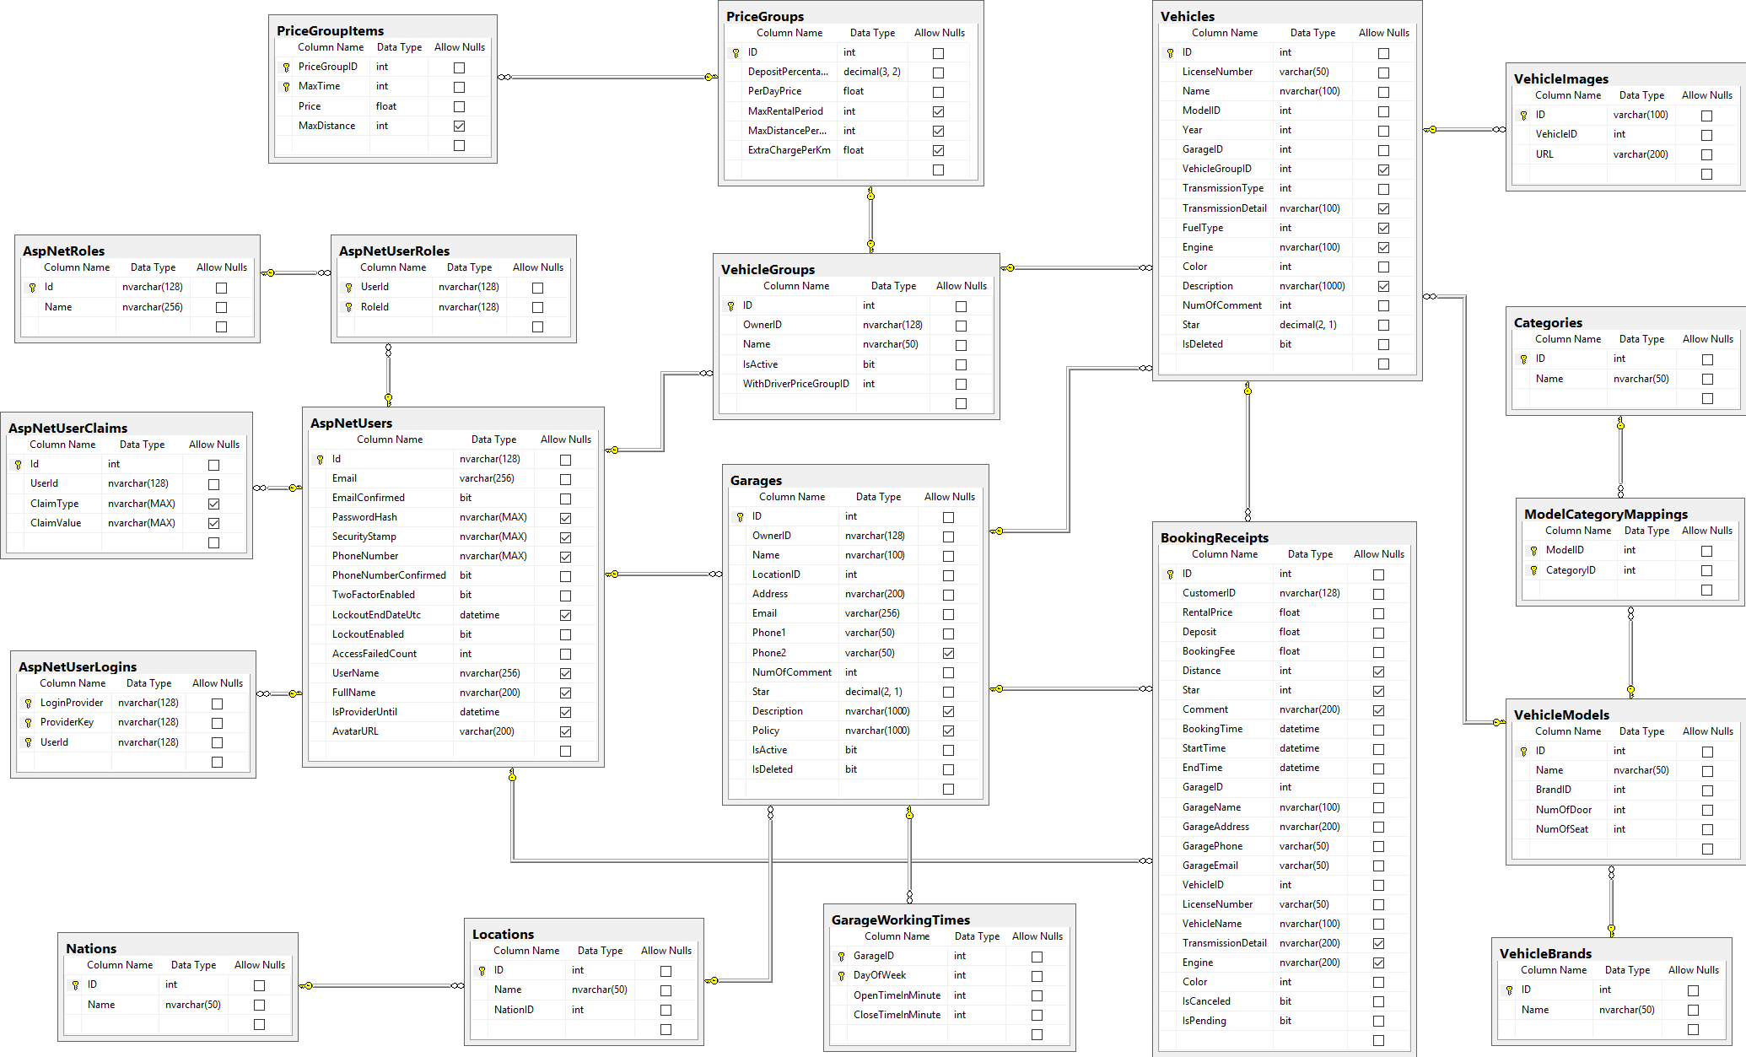

Figure 61: ウェブサイトアプリケーション物理的なダイアグラム

### 2.2 ウェブアプリケーションデータ辞書

|  |  |  |
| --- | --- | --- |
|  | データ辞書 | |
| 数字 | **実体名** | **記述** |
| 01 | AspNetUsers | システムでユーザを含有しています |
| 02 | AspNetRoles | システムでロールを含有しています |
| 03 | AspNetUserRoles | システムでユーザがロールに関係付けることを含有しています |
| 04 | AspNetUserClaims | システムでユーザのデータを含有しています |
| 05 | AspNetUserLogins | システムでユーザのログインする管理を含有しています |
| 06 | Vehicles | システムで乗り物を含有しています |
| 07 | VehicleImages | システムで乗り物のイメージを含有しています |
| 08 | VehicleModels | システムで乗り物モデルを含有しています |
| 09 | VehicleBrands | システムで乗り物ブランドを含有しています |
| 10 | Categories | システムで乗り物のタイプを含有しています |
| 11 | ModelCategoryMappings | システムで乗り物モデルが乗り物のタイプに関係付けることを含有しています |
| 12 | VehicleGroups | システムで乗り物のグループを含有しています |
| 13 | PriceGroups | システムで乗り物の賃料を含有しています |
| 14 | PriceGroupItems | システムで時間によって乗り物の賃料を含有しています |
| 15 | Garages | システムでガレージを含有しています |
| 16 | GarageWorkingTimes | システムでガレージのスケジュールを含有しています |
| 17 | Locations | システムでロケーションを含有しています |
| 18 | Nations | システムで国家を含有しています |
| 19 | BookingReceipts | システムで予約のレシートを含有しています |

Table 71 : データ辞書

#### AspNetUsers

|  |  |  |
| --- | --- | --- |
| **属性** | **ドメイン** | **記述** |
| Id | nvarchar(128) | AspNetUserのユニークな識別子 |
| Email | varchar(256) | ユーザのメール |
| EmailConfirmed | bit | 電子メールが確認されたかどうかを示すステータス。 |
| PasswordHash | nvarchar(MAX) | ユーザーの暗号化されたパスワード。 |
| SecurityStamp | nvarchar(MAX) | ユーザーのクッキーとセッションを認証するために使用されるスタンプ。 |
| PhoneNumber | nvarchar(MAX) | ユーザの電話番号 |
| PhoneNumberConfirmed | bit | 電話番号が確認されたかどうかを示すステータス。 |
| TwoFactorEnabled | bit | 二因子ログインが使用可能かどうかを示すステータス。 |
| LockoutEndDateUtc | datetime | lockoutEnableがtrueの場合、このユーザーがロックアウトされるまでの日。 |
| LockoutEnable | bit | ロックアウトが使用可能かどうかを示すステータス。 |
| AccessFailedCount | int | このアカウントのアクセスに失敗した回数。 |
| UserName | nvarchar(256) | ユーザの名 |
| FullName | nvarchar(200) | ユーザのフルネーム |
| IsProviderUntil | datetime | このユーザーがプロバイダロールを持つまでの日付。 |
| AvatarURL | nvarchar(200) | ユーザのアバターのURL |

Table 72 : AspNetUsers テーブル

#### AspNetRoles

|  |  |  |
| --- | --- | --- |
| **属性** | **ドメイン** | **記述** |
| Id | nvarchar(128) | AspNetRoleのユニークな識別子 |
| Name | nvarchar(256) | ロールの名 |

Table 73 : AspNetRoles テーブル

#### AspNetUserRoles

|  |  |  |
| --- | --- | --- |
| **属性** | **ドメイン** | **記述** |
| UserId | nvarchar(128) | ユーザーの唯一の識別子 |
| RoleId | nvarchar(128) | ローレの唯一の識別子 |

Table 74 : AspNetUserRolesテーブル

#### AspNetUserClaims

|  |  |  |
| --- | --- | --- |
| **属性** | **ドメイン** | **記述** |
| Id | int | ユニークな識別子のクレーム |
| UserId | nvarchar(128) | クレームが属するAspNetUserのID |
| ClaimType | nvarchar(MAX) | クレームのドメイン |
| ClaimValue | nvarchar(MAX) | クレームのバリュー |

Table 75 : AspNetUserClaimsテーブル

#### AspNetUserLogins

|  |  |  |
| --- | --- | --- |
| **属性** | **ドメイン** | **記述** |
| LoginProvider | nvarchar(128) | 第三者ログインプロバイダの名 |
| ProviderKey | nvarchar(128) | 第三者のサービスが提供するユーザのログインキー |
| UserId | nvarchar(128) | このログインを使用してログインできるAspNetUserのID |

Table 76 : AspNetUserLoginsテーブル

#### Vehicles

|  |  |  |
| --- | --- | --- |
| **属性** | **ドメイン** | **記述** |
| ID | int | 乗り物のユニークな識別子 |
| LicenseNumber | varchar(50) | 乗り物のライセンス番号 |
| Name | nvarchar(100) | 乗り物の名 |
| ModelID | int | 乗り物のモデル |
| Year | int | この乗り物が生産されたの年 |
| GarageID | int | この乗り物を含むガレージのID |
| VehicleGroupID | int | この乗り物を含む乗り物のグルプのID |
| TransmissionType | int | 乗り物のギアドメイン |
| TransmissionDetail | nvarchar(100) | 乗り物のギアに関する詳細記述 |
| FuelType | int | 乗り物の燃料ドメイン |
| Engine | nvarchar(100) | 乗り物のエンジンに関する詳細記述 |
| Color | int | 乗り物の色 |
| Description | nvarchar(1000) | 乗り物の記述 |
| NumOfComment | int | この乗り物が受け取った顧客の数 |
| Star | decimal(2, 1) | 乗り物の評価 |
| IsDeleted | bit | この乗り物が削除されたかどうかを示すステータス |

Table 77 : Vehiclesテーブル

#### VehicleImages

|  |  |  |
| --- | --- | --- |
| **属性** | **ドメイン** | **記述** |
| ID | varchar(100) | イメージのユニークな識別子 |
| VehicleID | int | このイメージが属する乗り物のID |
| URL | varchar(200) | イメージのURL |

Table 78 : VehicleImagesテーブル

#### VehicleModels

|  |  |  |
| --- | --- | --- |
| **属性** | **ドメイン** | **記述** |
| ID | int | 乗り物モデルのユニークな識別子 |
| Name | nvarchar(50) | ロールの名 |
| BrandID | int | このモデルのブランドのID |
| NumOfDoor | int | この乗り物のドア |
| NumOfSeat | int | この乗り物のシート |

Table 79 : VehicleModelsテーブル

#### VehicleBrands

|  |  |  |
| --- | --- | --- |
| **属性** | **ドメイン** | **記述** |
| ID | int | 乗り物ブランドのユニークな識別子 |
| Name | nvarchar(50) | ブランドの名 |

Table 80 : VehicleBrandsテーブル

#### Categories

|  |  |  |
| --- | --- | --- |
| **属性** | **ドメイン** | **記述** |
| ID | int | カテゴリの唯一の識別子 |
| Name | nvarchar(50) | カテゴリの名前 |

Table 81 : Categoriesテーブル

#### ModelCategoryMappings

|  |  |  |
| --- | --- | --- |
| **属性** | **ドメイン** | **記述** |
| ModelID | int | モデルの唯一の識別子 |
| CategoryID | int | カテゴリーの唯一の識別子 |

Table 82 : ModelCategoryMappingsテーブル

#### Garages

|  |  |  |
| --- | --- | --- |
| **属性** | **ドメイン** | **記述** |
| ID | int | ガレージの唯一の識別子 |
| OwnerID | nvarchar(128) | ガレージのユーザーの唯一の識別子 |
| Name | nvarchar(100) | ガレージの名前 |
| LocationID | int | ガレージの場所の唯一の識別子 |
| Address | nvarchar(200) | ガレージの住所 |
| Email | varchar(256) | ガレージのメール |
| Phone1 | varchar(50) | ガレージの主電話番号 |
| Phone2 | varchar(50) | ガレージの電話番号 |
| NumOfComment | int | 顧客からコメントの量 |
| Star | decimal(2, 1) | ガレージの評価 |
| Description | nvarchar(1000) | ガレージの説明 |
| Policy | nvarchar(1000) | ガレージの規則 |
| IsActive | bit | ガレージの状態 |
| IsDeleted | bit | ガレージの削除したの |

Table 83 : Garagesテーブル

#### GarageWorkingTimes

|  |  |  |
| --- | --- | --- |
| **属性** | **ドメイン** | **記述** |
| GarageID | int | ガレージの唯一の識別子 |
| DayOfWeek | int | 作業時間制約によって表される曜日。 |
| OpenTimeInMinute | int | ガレージの開館時間 |
| CloseTimeInMinute | int | ガレージの閉館時間 |

Table 84 : GarageWorkingTimesテーブル

#### Locations

|  |  |  |
| --- | --- | --- |
| **属性** | **ドメイン** | **記述** |
| ID | int | 場所の唯一の識別子 |
| Name | nvarchar(50) | 場所の名前 |
| NationID | int | 国家の唯一の識別子 |

Table 85 : Locationsテーブル

#### Nations

|  |  |  |
| --- | --- | --- |
| **属性** | **ドメイン** | **記述** |
| ID | int | 国家の唯一の識別子 |
| Name | nvarchar(50) | 国家の名前 |

Table 86 : Nationsテーブル

#### VehicleGroups

|  |  |  |
| --- | --- | --- |
| **属性** | **ドメイン** | **記述** |
| ID | Int | 乗り物グループの唯一の識別子 |
| OwnerID | nvarchar(128) | 乗り物グループのユーザーの唯一の識別子 |
| Name | nvarchar(50) | 乗り物グループの名前 |
| IsActive | Bit | 乗り物グループの状態 |
| WithDriverPriceGroupID | Int | 既定運転手の唯一の識別子 |

Table 87 : VehicleGroupsテーブル

#### PriceGroups

|  |  |  |
| --- | --- | --- |
| **属性** | **ドメイン** | **記述** |
| ID | int | 価格グループの唯一の識別子 |
| DepositPercentage | decimal(3, 2) | 保証金の割合 |
| PerDayPrice | float | 1日当たりの価格 |
| MaxRentalPeriod | int | 借りられる最大時間 |
| MaxDistancePerDay | int | 1日当たりの借りられる最大距離 |
| ExtraChargePerKm | float | １ｋｍ当たりの追加の費用 |

Table 88 : PriceGroupsテーブル

#### PriceGroupItems

|  |  |  |
| --- | --- | --- |
| **属性** | **ドメイン** | **記述** |
| PriceGroupID | int | 価格グループの唯一の識別子 |
| MaxTime | int | 借りられる最大時間 |
| Price | float | 価格 |
| MaxDistance | int | 借りられる最大距離 |

Table 89 : PriceGroupItemsテーブル

#### BookingReceipts

|  |  |  |
| --- | --- | --- |
| **属性** | **ドメイン** | **記述** |
| ID | int | 予約のレシートの唯一の識別子 |
| CustomerID | nvarchar(128) | 顧客の唯一の識別子 |
| RentalPrice | float | 合計借りる費 |
| Deposit | float | 保証金 |
| BookingFee | float | 予約費 |
| Distance | int | 距離 |
| Star | int | 評価 |
| Comment | nvarchar(200) | コメント |
| BookingTime | datetime | 予約する時刻 |
| StartTime | datetime | 予約の始まる時間 |
| EndTime | datetime | 予約の終わる時間 |
| GarageID | int | ガレージの唯一の識別子 |
| GarageName | nvarchar(100) | ガレージの名前 |
| GarageAddress | nvarchar(200) | ガレージの住所 |
| GaragePhone | varchar(50) | ガレージの電話番号 |
| GarageEmail | varchar(50) | ガレージのメール |
| VehicleID | int | 乗り物の唯一の識別子 |
| LicenseNumber | varchar(50) | 乗り物のライセンス番号 |
| VehicleName | nvarchar(100) | 乗り物の名前 |
| TransmissionDetail | nvarchar(200) | 情報の変速機. |
| Engine | nvarchar(200) | 乗り物のエンジン |
| Color | int | 乗り物の色 |
| IsCanceled | bit | 予約の状態 |
| IsPending | bit | 払ったの |

Table 90 : BookingReceiptsテーブル

## パフォーマンス対策

一般的に、結果はユーザが要求を提出した後、5秒未満を現されます。

## テスト計画

### テストする機能

システムテストはコアワークフローに基づいて行うことになります。

テストする機能:

* 乗り物を探索します
* 顧客：
  + 乗り物を借ります
  + サービスを評価します
  + 予約を取り消します
* プロバイダー
  + 新しい乗り物グループを作成します
  + 乗り物グループを削除します
  + 新しいガレージを作成します
  + ガレージを削除します
  + 新しい乗り物を作成します
  + 乗り物のイメージをアップロードします
  + 乗り物のイメージを削除します
  + 自己予約します

### テストされない機能

* ログインします
* 登録します
* 個人の情報を更新します
* 管理者の機能
* プロバイダー登録
* ガレージを更新します
* 乗り物グループを更新します

## コミュニケーションダイアグラムとシステムテストのテストケース

### コミュニケーションダイアグラム

Figure 62 : ＜ゲスト＞ログイン <Excluded>



Figure 63 : ＜ゲスト、顧客＞乗り物を探索すこと



Figure 64 : ＜顧客＞乗り物を借りること



Figure 65 : ＜顧客、プロバイダー＞プロバイダー登録



Figure 66 : ＜プロバイダー＞ガレージ管理



Figure 67 : ＜プロバイダー＞乗り物グループ管理



Figure 68 : ＜プロバイダー＞乗り物管理

### ウェブシステムのテストケース

#### 乗り物を探索する

|  |  |  |  |  |  |  |  |
| --- | --- | --- | --- | --- | --- | --- | --- |
| **ID** | **説明** | **テストケース順序** | **出力** | **インターテストケース依存性** | **結果** | テスト期日 | 注釈 |
| TC001 | 基本探索するベージから高度探索するベージにリダイレクトする | １．「Tìm kiếm」ボタンをクリックして | 高度探索するベージにリダイレクトする | なし | 合格 | 22/11/2016 | なし |
| TCO02 | 「Hồ Chí Minh」に乗り物を探索する | １．「Địa điểm」のテキストボックスに「Hồ Chí Minh」を選んで | 「Hồ Chí Minh」に借りられる乗り物が表示される | なし | 合格 | 22/11/2016 | なし |
| TCO03 | 8席がある乗り物を探索する | １.「8 chỗ」を選んで | 8席がある乗り物が表示される | なし | 合格 | 22/11/2016 | なし |
| TCO04 | 「Audi A4 Avant」を探索する | １．「Ｄòng xe」のテキストボックスに「Audi A4 Avant」を選んで | 「Audi A4 Avant」だけが表示される | なし | 合格 | 22/11/2016 | なし |

Table 91: 「乗り物を探索する」テストケース

#### ＜顧客＞乗り物を借りる

|  |  |  |  |  |  |  |  |
| --- | --- | --- | --- | --- | --- | --- | --- |
| **ID** | **説明** | **テストケース順序** | **出力** | **インターテストケース依存性** | **結果** | テスト期日 | 注釈 |
| TC005 | 乗り物のガレージの連絡予報が表示される | １．「Nhấn vào đây để lấy thông tin liên lạc」ボタンをクリックして | 乗り物のガレージの連絡予報のポップアップが表示する | なし | 合格 | 22/11/2016 | なし |
| TC006 | 予約の情報を見ると支払う | １．「Đặt」ボタンをクリックして | 予約を確認するベージにリダイレクトする | なし | 合格 | 22/11/2016 | なし |
| TC007 | 予約をキャンセルする | 「Thay đổi」ボタンをクリックして  「Hủy đơn hàng」ボタンをクリックして | 乗り物の情報ベージにリダイレクトする | なし | 合格 | 22/11/2016 | なし |
| TC008 | 予約を支払う | １．支払うの方法を選べて  ２．「Thanh toán」ボタンをクリックして | 「Ngân lượng」ベージにリダイレクトする | なし | 合格 | 22/11/2016 | なし |
| TC009 | 5分以上に「Thanh toán」ボタンをクリックさないとき、乗り物の情報のベージに振り返りましす。 | １．乗り物の情報のベージに「Đặt xe」ボタンをクリックして  ２．5分以上に「Thanh toán」ボタンをクリックさない | 乗り物の情報のベージに振り返る。 | なし | 合格 | 22/11/2016 | なし |
| TC010 | 「Thanh toán」ボタンをクリックする後に5分以上に支払ないとき、予約が取り消される | １．「Thanh toán」ボタンをクリックして  ２．5分以上に支払ない | 予約が取り消される | なし | 合格 | 22/11/2016 | なし |

Table 92:「乗り物を借りる」テストケース

#### ＜顧客＞サービスを評価する

|  |  |  |  |  |  |  |  |
| --- | --- | --- | --- | --- | --- | --- | --- |
| **ID** | **説明** | **テストケース順序** | **出力** | **インターテストケース依存性** | **結果** | **テスト期日** | **注釈** |
| TC011 | 「Đánh giá」テキストボックスがブランクされる場合 | １．「Đánh giá」テキストをクリックする。  ２．「Gửi」ボータンをクリックする。 | エラー「Hãy nhập」を通知する | なし | 合格 | 19/11/2016 | なし |
| TC012 | 「Đánh giá」テキストボックスに「abc」を入力する場合 | １．「Đánh giá」テキストをクリックする。  ２．「Đánh giá」テキストボックスに「abc」を入力する。  ３．「Gửi」ボータンをクリックする。 | エラー「Hãy nhập ít nhất 20 kí tự trở lên.」を通知する | なし | 合格 | 19/11/2016 | なし |
| TC013 | 「Đánh giá」テキストボックスに201字を入力する場合 | １．「Đánh giá」テキストをクリックする。  ２．「Đánh giá」テキストボックスに201字を入力する。 | 入力できない。 | なし | 合格 | 19/11/2016 | なし |
| TC014 | 「Đánh giá」テキストボックスに20字を入力する場合 | １．「Đánh giá」テキストをクリックする。  ２．「Đánh giá」テキストボックスに「Tôi thấy dịch vụ tốt」を入力する。  ３．「Gửi」ボータンをクリックする。 | 「Gởi đánh giá thành công.」を通知する | なし | 合格 | 19/11/2016 | なし |

Table 93:「サービスを評価する」テストケース

#### ＜顧客＞予約を取り消す

|  |  |  |  |  |  |  |  |
| --- | --- | --- | --- | --- | --- | --- | --- |
| **ID** | **説明** | **テストケース順序** | **出力** | **インターテストケース依存性** | **結果** | **テスト期日** | **注釈** |
| TC015 | 「Hủy đặt xe」ポップアップで「Đóng」ボータンをクリックする場合 | １．「Hủy đặt xe」テキストをクリックする。  ２．「Đóng」ボータンをクリックする。 | 「Hủy đặt xe」ポップアップが閉じられる | なし | 合格 | 19/11/2016 | なし |
| TC016 | 「Hủy đặt xe」ポップアップで「Hủy」ボータンをクリックする場合 | １．「Hủy đặt xe」テキストをクリックする。  ２．「Hủy」ボータンをクリックする。 | 「Hủy đặt xe」ポップアップが閉じられる。そして、「Hủy đặt xe thành công.」を通知しながら状態が「Đã hủy」になる | なし | 合格 | 19/11/2016 | なし |

Table 94: 「予約を取り消す」テストケース

#### ＜プロバイダー＞新しい乗り物グループを作成する

|  |  |  |  |  |  |  |  |
| --- | --- | --- | --- | --- | --- | --- | --- |
| **ID** | **説明** | **テストケース順序** | **出力** | **インターテストケース依存性** | **結果** | テスト期日 | 注釈 |
| TC017 | 新しい乗り物グループのポップアップが表示される | １．「Thêm nhóm mới」ボタンをクリックして | 新しい乗り物グループのポップアップが表示する | なし | 合格 | 22/11/2016 | なし |
| TC018 | 乗り物グループを作成することをキャンセルする | 「Đóng」ボタンをクリックして | 乗り物グループのポップアップが表示されない | なし | 合格 | 22/11/2016 | なし |
| TC019 | 間違いデータを入力する（乗り物グループの名前が空白） | １．「Thêm nhóm mới」ボタンをクリックして  ２．乗り物グループの名前が入力さない  ３．預金のテキストボックスに４００を入力して  ４．１ひ当たりの費のテキストボックスに８００を入力して  ５．最大期限のテキストボックスに５を入力して  ６．１日当たりの最大距離のテキストボックスに７０を入力して  ７．余分費のテキストボックスに１００を入力して | 「Tên vehicle group không được trống」エラーメッセージが表示する | なし | 合格 | 22/11/2016 | なし |
| TC020 | 間違いデータを入力する（乗り物グループの預金が空白） | １．「Thêm nhóm mới」ボタンをクリックして  ２．乗り物グループの名前のテキストボックスに[GarageA]を入力して  ３．預金のテキストボックスが入力さない  ４．１ひ当たりの費のテキストボックスに８００を入力して  ５．最大期限のテキストボックスに５を入力して  ６．１日当たりの最大距離のテキストボックスに７０を入力して  ７．余分費のテキストボックスに１００を入力して | 「Số tiền đặt cọc không được trống」エラーメッセージが表示する | なし | 合格 | 22/11/2016 | なし |
| TC021 | 間違いデータを入力する（乗り物グループの１ひ当たりの費が空白） | １．「Thêm nhóm mới」ボタンをクリックして  ２．乗り物グループの名前のテキストボックスに[GarageA]を入力して  ３．預金のテキストボックスに５を入力して  ４．１ひ当たりの費のテキストボックスが入力さない  ５．最大期限のテキストボックスに５を入力して  ６．１日当たりの最大距離のテキストボックスに７０を入力して  ７．余分費のテキストボックスに１００を入力して | 「Giá theo ngày không được trống」エラーメッセージが表示する | なし | 合格 | 22/11/2016 | なし |
| TC022 | 正しいデータを入力して、新しい乗り物グループを作成する | １．「Thêm nhóm mới」ボタンをクリックして  ２．乗り物グループの名前のテキストボックスに[GarageA]を入力して  ３．預金のテキストボックスに５を入力して  ４．１ひ当たりの費のテキストボックスに５を入力して  ５．最大期限のテキストボックスに５を入力して  ６．１日当たりの最大距離のテキストボックスに７０を入力して  ７．余分費のテキストボックスに１００を入力して | 新しい乗り物グループが追加された | なし | 合格 | 22/11/2016 | なし |
| TC023 | 間違いデータを入力する（乗り物グループの名前は２００字のほうが長いだ） | １．「Thêm nhóm mới」ボタンをクリックして  ２．乗り物グループの名前のテキストボックスに２００字のほうが長い名前を入力して  ３．預金のテキストボックスに５を入力して  ４．１ひ当たりの費のテキストボックスに５を入力して  ５．最大期限のテキストボックスに５を入力して  ６．１日当たりの最大距離のテキストボックスに７０を入力して  ７．余分費のテキストボックスに１００を入力して | 「Tên vehicle group không lớn hơn 200 kí tự」エラーメッセージが表示する | なし | 合格 | 22/11/2016 | なし |

Table 95:「新しい乗り物グループを作成する」テストケース

#### ＜プロバイダー＞乗り物グループを削除する <Excluded>

#### ＜プロバイダー＞新しいガレージを作成する

|  |  |  |  |  |  |  |  |
| --- | --- | --- | --- | --- | --- | --- | --- |
| ID | 説明 | テストケース順序 | 出力 | インターテストケース依存性 | 結果 | テスト期日 | 注釈 |
| TC026 | 新しいガレージのポップアップが表示される | １．「Tạo garage mới」ボタンをクリックして | 新しいガレージのポップアップが表示する | なし | 合格 | 22/11/2016 | なし |
| TC027 | ガレージを作成することをキャンセルする | 「Đóng」ボタンをクリックして | ガレージのポップアップが表示されない | なし | 合格 | 22/11/2016 | なし |
| TC028 | 間違いデータを入力する（ガレージの名前が空白） | １．「Tạo garage mới」ボタンをクリックして  ２．ガレージの名前が入力さない  ３．場所のテキストボックスに「An Giang」を入力して  ４．住所のテキストボックスに「ＡＡＡ」を入力して  ５．メールのテキストボックスにsss@mail.comを入力して  ６．電話番号のテキストボックスに９０９０９０を入力して  ７．説明のテキストボックスに[aa]を入力して | 「Tên garage không được trống」エラーメッセージが表示する | なし | 合格 | 22/11/2016 | なし |
| TC029 | 間違いデータを入力する（ガレージの住所が空白） | １．「Tạo garage mới」ボタンをクリックして  ２．ガレージの名前が入力さない  ３．場所のテキストボックスに「An Giang」を入力して  ４．住所のテキストボックスに「ＡＡＡ」を入力して  ５．メールのテキストボックスにsss@mail.comを入力して  ６．電話番号のテキストボックスに９０９０９０を入力して  ７．説明のテキストボックスに[aa]を入力して | 「Địa chỉ garage」エラーメッセージが表示する | なし | 合格 | 22/11/2016 | なし |
| TC030 | 間違いデータを入力する（ガレージのメールが空白） | １．「Tạo garage mới」ボタンをクリックして  ２．ガレージの名前が入力さない  ３．場所のテキストボックスに「An Giang」を入力して  ４．住所のテキストボックスに「ＡＡＡ」を入力して  ５．メールのテキストボックスにsss@mail.comを入力して  ６．電話番号のテキストボックスに９０９０９０を入力して  ７．説明のテキストボックスに[aa]を入力して | 「Email không được trống」エラーメッセージが表示する | なし | 合格 | 22/11/2016 | なし |
| TC031 | 正しいデータを入力して、新しいメールを作成する | １．「Tạo garage mới」ボタンをクリックして  ２．ガレージの名前テキストボックスに「garage A」を入力して  ３．場所のテキストボックスに「An Giang」を入力して  ４．住所のテキストボックスに「ＡＡＡ」を入力して  ５．メールのテキストボックスにsss@mail.comを入力して  ６．電話番号のテキストボックスに９０９０９０を入力して  ７．説明のテキストボックスに[aa]を入力して | 新しいガレージが追加された | なし | 合格 | 22/11/2016 | なし |
| TC032 | 間違いデータを入力する（ガレージの電話番号が空白） | １．「Tạo garage mới」ボタンをクリックして  ２．ガレージの名前が入力さない  ３．場所のテキストボックスに「An Giang」を入力して  ４．住所のテキストボックスに「ＡＡＡ」を入力して  ５．メールのテキストボックスにsss@mail.comを入力して  ６．電話番号のテキストボックスに９０９０９０を入力して  ７．説明のテキストボックスに[aa]を入力して | 「Số điện thoại không được trống」エラーメッセージが表示する | なし | 合格 | 22/11/2016 | なし |
| TC033 | 間違いデータを入力する（ガレージのメールは形式と違いる） | １．「Tạo garage mới」ボタンをクリックして  ２．ガレージの名前テキストボックスに「garage A」を入力して  ３．場所のテキストボックスに「An Giang」を入力して  ４．住所のテキストボックスに「ＡＡＡ」を入力して  ５．メールのテキストボックスにｓｓｓｓを入力して  ６．電話番号のテキストボックスに９０９０９０を入力して  ７．説明のテキストボックスに[aa]を入力して | 「Email không đúng format」エラーメッセージが表示する | なし | 合格 | 22/11/2016 | なし |

Table 96:「新しいガレージを作成する」テストケース

#### ＜プロバイダー＞ガレージを削除する <Excluded>

#### ＜プロバイダー＞新しい乗り物を作成する

|  |  |  |  |  |  |  |  |
| --- | --- | --- | --- | --- | --- | --- | --- |
| **ID** | **説明** | **テストケース順序** | **出力** | **インターテストケース依存性** | **結果** | **テスト期日** | **注釈** |
| TC036 | ガレージと乗り物のトランスミッションタイプと乗り物の色と乗り物のイメージがブランクされる | １．プロバイダーは「Thêm xe mới」ボータンをクリックする。  ２．ガレージと乗り物のトランスミッションタイプと乗り物の色と乗り物のイメージがブランクする  ３．「OK」ボータンをクリックする | ステップ３には、エラー「Vui lòng chọn garage xe」と「Vui lòng chọn loại hộp số」と「Vui lòng chọn màu xe」と「Bạn phải upload ít nhất 4 hình」を通知する | なし | 合格 | 19/11/2016 | なし |
| TC037 | 全部でブランクされる | １．プロバイダーは「」ボータンをクリックする。  ２．「OK」ボータンをクリックする | ステップ２には、エラー「Tên xe không được để trống」と「Biển số xe không được để trống」と「Vui lòng chọn dòng xe」と「Năm sản xuất của xe không được để trống」と「Vui lòng chọn garage xe」と「Vui lòng chọn loại hộp số」と「Vui lòng chọn màu xe」と「Bạn phải upload ít nhất 4 hình」を通知する | なし | 合格 | 19/11/2016 | なじ |
| TC038 | 成功に乗り物を造る | １．乗り物の情報を入力する。  ２．「OK」ボータンをクリックする | 「Tạo xe thành công」を通知しながら乗り物のリストをリロードする | なし | 合格 | 19/11/2016 | なじ |

Table 97:「新しい乗り物を作成する」テストケース

#### ＜プロバイダー＞乗り物のイメージをアップロードする

|  |  |  |  |  |  |  |  |
| --- | --- | --- | --- | --- | --- | --- | --- |
| **ID** | **説明** | **テストケース順序** | **出力** | **インターテストケース依存性** | **結果** | **テスト期日** | **注釈** |
| TC039 | イメージは ３つだけある場合 | １．プロバイダーは「Thêm xe mới」ボータンをクリックする。  ２．乗り物の情報を入力してイメージを３つアップロードする。  ３．「OK」ボータンをクリックする | ステップ３には、エラー「Bạn phải upload ít nhất 4 hình」を通知する | なし | 合格 | 19/11/2016 | なし |
| TC040 | イメージは ４つある場合 | １．プロバイダーは「Thêm xe mới」ボータンをクリックする。  ２．乗り物の情報を入力してイメージを４つアップロードする。  ３．「OK」ボータンをクリックする | 「Tạo xe thành công」を通知しながら乗り物のリストをリロードする | なし | 合格 | 19/11/2016 | なじ |
| TC041 | イメージは １０ある場合 | １．プロバイダーは「Thêm xe mới」ボータンをクリックする。  ２．乗り物の情報を入力してイメージを １０アップロードする。  ３．「OK」ボータンをクリックする | 「Tạo xe thành công」を通知しながら乗り物のリストをリロードする | なし | 合格 | 19/11/2016 | なじ |
| TC042 | イメージは １１ある場合 | １．プロバイダーは「Thêm xe mới」ボータンをクリックする。s  ２．乗り物の情報を入力してイメージを １１アップロードする。  ３．「OK」ボータンをクリックする | イメージを最初の１０アップロードする。そして「Tạo xe thành công」を通知しながら乗り物のリストをリロードする | なし | 合格 |  |  |

Table 98:「乗り物のイメージをアップロードする」テストケース

#### ＜プロバイダー＞乗り物のイメージを削除する <Excluded>

#### ＜プロバイダー＞自己予約する

|  |  |  |  |  |  |  |  |
| --- | --- | --- | --- | --- | --- | --- | --- |
| **ID** | **説明** | **テストケース順序** | **出力** | **インターテストケース依存性** | **結果** | **テスト期日** | **注釈** |
| TC045 | 予約がない間 | １．「Tạo đặt xe」ボータンをクリックする。  ２．適当の時間を選択する  ３．「Tạo」ボータンをクリックする。 | 乗り物のリストをリロードしながら「Tạo đặt xe mới thành công」を通知する | なし | 合格 | 19/11/2016 | なし |
| TC046 | 顧客の予約がある間 | １．「Tạo đặt xe」ボータンをクリックする。  ２．説明の要求に時間を選択する。  ３．「Tạo」ボータンをクリックする。 | エラー「Xe đã được đặt trong khoảng thời gian này」を通知する | なし | 合格 | 19/11/2016 | なし |
| TC047 | 自己予約がある間 | １．「Tạo đặt xe」ボータンをクリックする。  ２．説明の要求に時間を選択する。  ３．「Tạo」ボータンをクリックする。 | エラー「Xe đã được đặt trong khoảng thời gian này」を通知する | なし | 合格 | 19/11/2016 | なし |

Table 99:「自己予約する」テストケース

# 番６のレポート。ソフトウェアユーザーズマニュアル

## インストレーションガイド

### サーバ側の環境を設定

#### ハードウェア要件

**スムーズにウェブサイトを実行するてめには、以下の要件を備えたコンピュータが必要になります:**

* オペレーティングシステム: ウィンドウXPまたはウィンドウのそれ以降のバージョン。
* プロセッサ：１GHｚ以上。
* メモリ：2GB以上。
* ハードウェア：2GB以上のハードドライブスペース。
* Wi-Fiインターネット(> 2Mbps)。

#### ソフトウェア要件

* + - ウェブサーバー ：Internet information system – IIS 8 With MVC5 enable
    - Microsoft Windows Server 2014 (Server Pack 1 64 bit): オペレイティングシ
    - .Net Framework 4.6
    - SQL Server 2014

### サーバ側で展開

#### 展開パッケージの準備

* データベースファイル： CRPDB.bak
* サーバーでのフォルダにソースコードファイル（CRP）をコピーする。



* + 例えば：D:\Capstone Project\CarRentalPortal\CRP\CRP

#### サーバの構成前に展開

* **データベースの構成：**



* + - **Alias Name:** LocalSQL
    - **Port No:** 1433
    - **Protocol:** TCP/IP
    - **Server: ユーザのサーバ名**

**<connectionStrings>**

**<add name="DefaultConnection" connectionString="Data Source=LocalSQL;Initial Catalog=CRPDB;Integrated Security=True" providerName="System.Data.SqlClient" />**

**<add name="CRPEntities" connectionString="metadata=res://*/Models.Entities.CRP.csdl|res://*/Models.Entities.CRP.ssdl|res://*/Models.Entities.CRP.msl;provider=System.Data.SqlClient;provider connection string=&quot;data source=LocalSQL;initial catalog=CRPDB;integrated security=True;MultipleActiveResultSets=True;App=EntityFramework&quot;" providerName="System.Data.EntityClient" />**

**</connectionStrings>**

* Catalog: データベース名。

#### サーパ側でウェブアプリケーションの展開

* **データベース展開：**
* ＳＱＬ Server 2014 にCRPDB.bakをアタックしてください。
* **ソースコードの展開：**
* オーペンIISマネージャ
* 「Default Web Site」にマウスを右クリックします。「Add Application」を選びます。



* + Alias: Aliasを入力してください。例えば：CRP
  + Application pool: ASP.NET v4.0 を選んでください
  + Physical path:サーバーのソースコードファイルを選んでください（D:\Capstone Project\CarRentalPortal\CRP\CRP）



* “OK”ボタンをクリックしてください。
* データベース管理システムで「IIS APPPOOL\DefaultAppPool」を造って「User Mapping」に「db_datareader」と「db_datawrite」をチェックする





* 「Application Development Features」の中で「CGI」以外全部をチェックする



* オーペン：http://localhost/CRP



### クライアント側の環境の設定

#### コンピュータのための設定

* クライアントデバイスは、ウェブサイトを起動するには、以下のブラウザのいずれかを持っている必要があります：
  + Google Chrome(ダウンロードリンク):
    - <http://www.google.com/Chrome>
  + Coc Coc（コックコック）：
    - <http://www.coccoc.com/>

## ユーザーガイド

### ログイン <Excluded>

### ホームページ <Excluded>

### サーチページ



Figure 69 : ベーシックサーチ

|  |  |
| --- | --- |
| ステップ | 説明 |
| 1 | 探して乗り物の結果. この結果はフィルタによると変わります |
| 2 | フィルタをリセットしたいとき、「Xóa bộ lọc」をクリックして |
| 3 | シートを選んで |
| 4 | 価格を選んで |
| 5 | ソートのタイプを選んで |
| 6 | もっと詳細情報で探したいなら、「Lọc chi tiết hơn về xe」タブをクリックして |
| 7 | 評価のソートで探したいなら、「Lọc theo đánh giá」タブをクリックして |
| 8 | 写真を動かして |
| 9 | 乗り物の名前をクリックして、乗り物のディテールページを行きます。 |

Table 100 : ベーシックサーチ



Figure 70 : アドバンスサーチ

|  |  |
| --- | --- |
| ステップ | 説明 |
| 1 | 乗り物のブランドを選んで |
| 2 | スライダーに右に引かされて、最小の年が上げます |
| 3 | スライダーに左に引かされて、最小の年が下げます |
| 4 | ギアを選んで |
| 5 | 燃料タイプを選んで |
| 6 | 乗り物の種類を選んで |
| 7 | 乗り物の色を選んで |

Table 101 : アドバンスサーチ



Figure 71 : 評価サーチ

|  |  |
| --- | --- |
| ステップ | 説明 |
| 1 | 乗り物の評価を選んで |
| 2 | ガレージの評価を選んで |

Table 102 : 評価サーチ

### 乗り物の情報



Figure 72 : 一般的な情報

|  |  |
| --- | --- |
| ステップ | 説明 |
| 1 | [必要ない]　乗り物の情報を見たいなら、「Thông tin xe」をクリックします |
| 2 | [必要ない]　評価を見たいなら、「Đánh giá」をクリックします |
| 3 | [必要ない]　店の情報を見たいなら、「Cửa hàng」をクリックします |
| 4 | [必要ない]　オーだの履歴を見たいなら、「Lịch đặt xe」をクリックします |
| 5 | [必要ない]　 「Nhấn vào để lấy thông tin liên lạc」をクリックして、 プロバイダーのメール、主要電話番号と副電話番後を見えます |

Table 103 : 一般的な情報



Figure 73 : 予約のスケジュール

|  |  |
| --- | --- |
| ステップ | 説明 |
| 1 | カレンダーの中に日がしろですから、ユーザはその日を借れます |
| 2 | [必要ない]　月でカレンダーが表示したいから、「Tháng」クリックします |
| 3 | [必要ない]　週でカレンダーが表示したいから、「Tuần」クリックします |
| 4 | [必要ない]　オーだの履歴を見たいなら、「Lịch đặt xe」をクリックします |
| 5 | [必要ない]　「」をクリックして、カレンダーの今日は表示されます |
| 6 | [必要ない]　カレンダーの前のページと次のページを表示します。 |

Table 104 : 予約のスケジュール

­

Figure 74 : レンタルの費

|  |  |
| --- | --- |
| ステップ | 説明 |
| 1 | 借りるパッケージを選んで |
| 2 | 日パッケージを選んだから、何日を入力しなければなりません |
| 3 | 始まる時間を選んで |
| 4 | 借りる費を表示されます。この費は１日当たりや１時当たりを表示されて、日や時で増加します |
| 5 | 預金を表示されて、日や時で増加します。 |
| 6 | サービス費を表示されて、日や時で増加します。 |
| 7 | 合計費を表示されて、日や時で増加します。 |
| 8 | 最大距離を表示されます。レンタルの距離はこの距離のほうが長いですから、余分費を払わなければなりません |
| 9 | １日当たりや１時当たりの費を表示されます |
| 10 | 「Đặt xe」ボタンをクリックして、払い確認ページへ行きます |

Table 105 : レンタルの費

### 予約確認



Figure 75 : 予約確認

|  |  |
| --- | --- |
| ステップ | 説明 |
| 1 | 国内現金カードやビザカードやNganLuong電子ウォレットを選んで |
| 2 | 国内現金カードを選んだから、現金を選んで |
| 3 | 「Thanh toán」ボタンをクリックします。   * このページで選ぶ時間は５分のほうが長いですから、この乗り物の情報ページに帰ります。 * NganLuongページで払う時間は5分のほうが長いですから、エラーを出ます。 |
| 4 | キャンセルしたいなら、「Hủy đơn hàng」ボタンをクリックします |
| 5 | 変わりたいなら、「Thay đổi」ボタンをクリックします |

Table 106 : 予約確認

### レシートページ



Figure 76 : レシートページ

|  |  |
| --- | --- |
| ステップ | 説明 |
| 1 | 払い後に予約の情報を表示されます。「Quay trở về Homepage」ボタンをクリックして、ホームページへ行きます。 |

Table 107 : レシートページ

### フィードバック



Figure 77 : 予約のヒストリ



Figure 78 : フィードバック

|  |  |
| --- | --- |
| ステップ | 説明 |
| 1 | 「Lịch sử đặt xe」をクリックして |
| 2 | 「Tình trạng」のカルマは「Đã hủy」や「Đã kết thúc」ですから、「Thao tác」ボタンをクリックして |
| 3 | 「Đánh giá」をクリックして |
| 4 | 星の数は多くされて、評価が上げます。 |
| 5 | 詳細評価を入力して |
| 6 | 「Gửi」ボタンをクリックして、評価を出します |
| 7 | 「Đóng」ボタンをクリックして、評価を閉まる |

Table 108 : フィードバック

### プロバイダー登録



Figure 79 : パッケージ選択



Figure 80 : 支払形式

|  |  |
| --- | --- |
| ステップ | 説明 |
| 1 | 「Đăng ký」ボタンをクリックして |
| 2 | 国内現金カードやビザカードやNganLuong電子ウォレットを選んで |
| 3 | 国内現金カードを選んだから、現金を選んで |
| 4 | 「Thanh toán」ボタンをクリックして |
| 5 | キャンセルしたいなら、「Hủy đơn hàng」ボタンをクリックします |

Table 109 : プロバイダー登録

### ＜プロバイダー＞ガレージ作成



Figure 81 : ガレージ管理ページ



Figure 82 : ガレージ作成ポップアップ

|  |  |
| --- | --- |
| ステップ | 説明 |
| 1 | 「Quản lý garage」をクリックして |
| 2 | 「Tạo garage mới」ボタンをクリックして |
| 3 | ガレージの名を入力して |
| 4 | 場所を選んで |
| 5 | 住所を入力して |
| 6 | メールを入力して |
| 7 | 電話番号を入力して |
| 8 | [必要ない]　電話番号を入力して |
| 9 | [必要ない]　ガレージの説明を入力して |
| 10 | 休みの日ではないから、営業時間を入力して |
| 11 | 休みの日ではないから、終業時間を入力して |
| 12 | 休みの日ですから、「Nghỉ」ボスをチェックして |
| 13 | 政策を入力して |
| 14 | 「Tạo Garage」ボタンをクリックします |
| 15 | キャンセルしたいなら、「Thoát」ボタンをクリックします |

Table 110 : ガレージ作成

### ＜プロバイダー＞ガレージを閉じる <Excluded>

### ＜プロバイダー＞ガレージを削除する <Excluded>

### ＜プロバイダー＞ガレージに乗り物を置く <Excluded>

### ＜プロバイダー＞他のガレージへ移動する <Excluded>

### ＜プロバイダー＞グループ作成



Figure 83 : グループ管理ページ

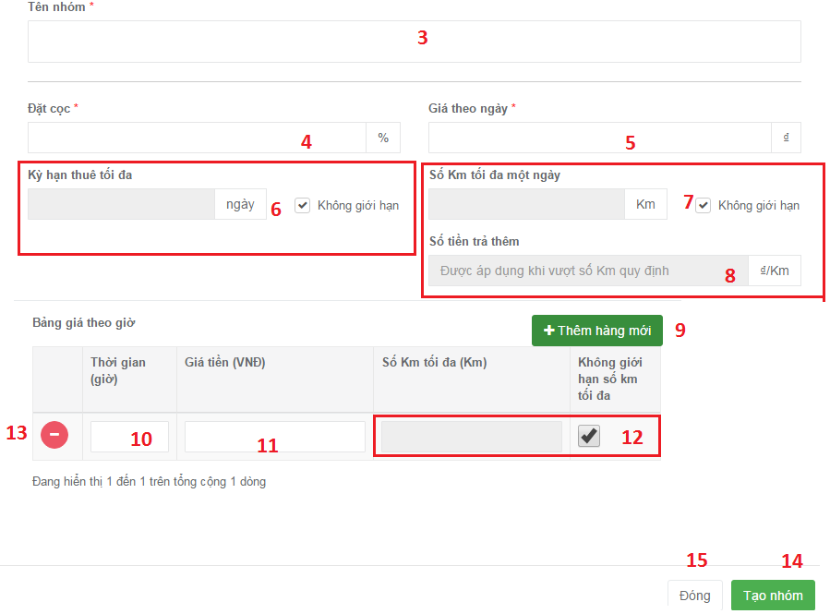

Figure 84 : グループ作成ポップアップ

|  |  |
| --- | --- |
| ステップ | 説明 |
| 1 | 「Quản lý nhóm giá」をクリックして |
| 2 | 「Thêm nhóm mới」ボタンをクリックして |
| 3 | グルプの名を入力して |
| 4 | 預金を入力して |
| 5 | １日当たりの費を入力して |
| 6 | [必要ない]　無制限なチェックボックスをチェックしなくて、借りる日の極限を入力して |
| 7 | [必要ない]　 無制限なチェックボックスをチェックしなくて、１日当たりの距離の極限を入力して |
| 8 | [必要ない]　余分費を入力します。レンタルの距離は距離の極限のほうが長いですから、余分費を払わなければなりません。 |
| 9 | [必要ない]　価格表を造りたいなら、「Thêm hàng mới」ボタンをクリックして、新しい行を造ります。 |
| 10 | [必要ない]　時を入力して |
| 11 | [必要ない]　費を入力して |
| 12 | [必要ない]　 無制限なチェックボックスをチェックしなくて、１日当たりの距離の極限を入力して |
| 13 | [必要ない]　 行を消したいなら、「－」ボタンをクリックします |
| 14 | 「Tạo nhóm」ボタンをクリックして、新しいグルプを造ります。 |
| 15 | キャンセルしたいなら、「Đóng」ボタンをクリックします |

Table 111 : グループ作成

### ＜プロバイダー＞グループを閉じる <Excluded>

### ＜プロバイダー＞グループを削除する <Excluded>

### ＜プロバイダー＞グループに乗り物を置く <Excluded>

### ＜プロバイダー＞他のグループへ移動する <Excluded>

### ＜プロバイダー＞このグループから削除する <Excluded>

### ＜プロバイダー＞乗り物作成



Figure 85 : 乗り物管理ページ



Figure 86 : 乗り物作成ポップアップ

|  |  |
| --- | --- |
| ステップ | 説明 |
| 1 | 「Quản lý xe」をクリックして |
| 2 | 「Thêm xe mới」ボタンをクリックして |
| 3 | 乗り物の名を入力して |
| 4 | ライセンス番号を入力して |
| 5 | 乗り物のブランドを選んで |
| 6 | 乗り物の年を選んで |
| 7 | ガレージを選んで |
| 8 | [必要ない]　乗り物のグルプを選んで |
| 9 | ギアを選んで |
| 10 | [必要ない]　ギアの情報を入力して |
| 11 | [必要ない]　 燃料タイプを選んで |
| 12 | [必要ない]　エンジンの情報を入力して |
| 13 | 乗り物の色を選んで |
| 14 | [必要ない]　この乗り物を入力して |
| 15 | イメージをアップロードして |
| 16 | 「Ok」ボタンをクリックします |
| 17 | キャンセルしたいなら、「Thoát」ボタンをクリックします |

Table 112 : 乗り物作成

### ＜プロバイダー＞乗り物を削除する <Excluded>

### ＜プロバイダー＞フィードバックを見る <Excluded>

### ＜プロバイダー＞自己予約する



Figure 87 : 乗り物管理ページの予約情報



Figure 88 : 選択ポップアップ

*プロバイダーは特別の時間に貸されないと、このを造ってください。

|  |  |
| --- | --- |
| ステップ | 説明 |
| 1 | 「Quản lý đặt xe」をクリックして |
| 2 | 始め借りる時間を入力して |
| 3 | 終わり借りる時間を入力して |
| 4 | 「Tạo」ボタンをクリックします |
| 5 | キャンセルしたいなら、「Đóng」ボタンをクリックします |

Table 113 : 自己予約する

### ＜プロバイダー＞借りる情報を見る



Figure 89 : 予約情報管理ページ



Figure 90 : ガレージ詳細ページ



Figure 91 : 乗り物詳細ページ

|  |  |
| --- | --- |
| ステップ | 説明 |
| 1 | * 「Quản lý đặt xe」をクリックして * 「Quản lý garage」をクリックして * 「Quản lý xe」をクリックして |
| 2 | * [必要ない]　「」チェックボックスをクリックして、テープルはガレージで示す。 * ガレージの名をくっりくして * 乗り物の名をクリックして |
| 3 | * [必要ない]　「２」をチェックしたら、ガレージを選んで * 「Thông tin đặt xe」タブをクリックして * 「Thông tin đặt xe」タブをクリックして |
| 4 | [必要ない]　全部示す |
| 5 | [必要ない]　過去で示す |
| 6 | [必要ない]　 到来で示す |
| 7 | [必要ない]　 「Hiện hóa đơn đã hủy」チェックボックスをクリックして、テープルはキャンセル領収書を示す。 |
| 8 | [必要ない]　 「Hiện hóa đơn tự đặt」チェックボックスをクリックして、テープルは自己予約を示す。 |
| 9 | [必要ない]　 領収書の情報を見たいなら、「」ボタンをクリックします |

Table 114 : 借りる情報を見る

### ＜プロバイダー＞ダッシュボード <Excluded>

# Appendix

1. UML 2.0 standard

<http://www.omg.org/spec/UML/2.0>

1. Sashimi – Modified Waterfall Model:

<http://www.waterfall-model.com/sashimi-waterfall-model>

1. Collaborative filtering approach

[https://en.wikipedia.org/wiki/Recommender_system#Collaborative_filtering](https://en.wikipedia.org/wiki/Recommender_system%23Collaborative_filtering)

1. Content-based approach

[https://en.wikipedia.org/wiki/Recommender_system#Content-based_filtering](https://en.wikipedia.org/wiki/Recommender_system%23Content-based_filtering)

1. Vector space model

<https://en.wikipedia.org/wiki/Vector_space_model>

1. tf-idf

<https://en.wikipedia.org/wiki/Tf%E2%80%93idf>